Blood and Iron: Over the Hills and Far Away
A Victorian Steampunk Scenario of Adventure and Intrigue using a variation of the Victoriana system.

“Not through speeches and majority decisions will the great questions of the day be decided... but by iron and blood.”
Otto Von Bismarck

Game by Dudley Martin

Game Blurb:
February 1866, the Taiping rebellion is flaring up again. Intelligence assets have captured plans regarding a massive assault on British and Imperial Chinese locations . The leaders of the Taiping Heavenly Kingdom and the Tao mages seek to destroy all their opposition in one fell swoop. This leaves an opening to set an ambush for them. With new abilities to counter their magiks, and new weapons to oppose them , this is your opportunity to deal them a sound defeat. A company of their leaders are traveling to oversee an attack on Hong Kong. Here is your opportunity. Stop them and you will have made great strides in this war. Can you take advantage of the situation? Can you turn the tide of the conflict? The Empire and your friends are relying on you!

Contents
Game Blurb: 2
System Basics 5
USING SKILLS 5
Characteristics 5
Effect and damage rolls 6
Combat: 7
INITIATIVE 7
What can I do as an action? 7
Melee & hand-to-hand attacks 7
Making the attack 7
Making the attack 7
Determining damage 8
ALL OUT DODGE 8
Taking cover 8
Diving for cover 8
EXPLOSIONS 9
Special Abilites 9
Sensate abilities 9
Miracles of Faith 10
THAUMATURGY SPELLS 10
New Thaumaturgy Spells 14
TAOIST SPELLS 16
Setting mood: 18
Opening Scene: In the House of the Proconsul (for all Tables together) 18
Scene 2: Travel to the Island of Ao Qin (for all tables) 21
Scene 3: To the Four Directions 22
Azure Dragon: east. Andrew- Enemies are Prawn related 22
Black Tortoise: north. Jack- Enemies are Crab related 22
White Tiger: west. Paddy- Enemies are Squid related 22
Vermillion Bird: south Dudley-Enemies are Sahaugin related. 22
25
Scene 4: Into the Depths (first challenge: Perception) 27
Scene 5: Battle Against the Sea (challenge two: combat) 29
Scene 6: Through the Underworld (challenge 3: survival) 31
Scene 7: The Final Battle 32
Epilouge 35

System Basics

USING SKILLS
Whenever your character tries to do something (called taking an action), there’s always the question of whether he’ll succeed or fail. Sometimes the task is so easy that it’s obvious; for instance, taking a step forward without falling down. In those cases you’ll just tell the Gamemaster what you’re doing, and no die roll is needed. But if you’re trying to take a step on the deck of a ship pitching wildly in a driving rainstorm, walking might be very difficult indeed. That’s where task resolution comes in. All tasks in Victoriana are resolved with the same formula: take the relevant characteristic and add to it the relevant skill, then add the result of an action roll of 3d6 to create an ‘action total’. Compare your total to the difficulty of the task. If you equal or exceed the difficulty value, you succeed!

Characteristics
Intellect: for memory recall, problem solving, manipulating tools & instruments

Resolution: for the ability to face danger, fear, and stress

Presence: for interactions with others.

Dexterity: for fighting, dodging, athletics, driving, running, and swimming

Body: for using physical power, resisting pain, disease, shock

Your (characteristic + skill) + 3 dice in an action roll
Vs. The difficulty of the task
DIFFICULTY TABLE (for most rolls use an average difficulty. Use higher or lower depending on situation and action)
Easy | 10
Average | 14
Exasperating | 18
Really? | 22
Very | 26
Extremely | 30
Ridiculously | 34
Impossibly | 38

When you roll your action dice you may roll all sixes, if so then rejoice! This is known as a special success. In combat attacks this generally means that you double the damage done, in
other action rolls the gamemaster will tell you how your special success manifests. Adversely if your dice roll comes up with three 1’s then the attempt automatically failed, this is known as a foul failure.
Example: Mad Eric is fending off a footpad; it’s his turn to attack. He’s using a sword cane, so we add his dexterity 3 and swordplay 4 for a total of 7; the gamemaster tells Mike (Eric’s player)
that he will need to beat a difficulty of 22 to hit the thug. Mike makes his action roll and the dice
come up with a 2,4, and a 6. That’s a total of 19 – Eric Misses!

Effect and damage rolls
Effect rolls follow some action rolls; usually they represent damage done by weapons, or define the effects of a spell. You usually roll a set amount of effect dice and add the results together, just like an action roll. The difference to action rolls is that there are no skill or characteristic
bonuses to effect rolls Once rolled add the results together, this is the effect total, or damage roll as it is often known.

Combat:

INITIATIVE
At the beginning of each round, each character rolls 2 dice and adds their initiative characteristic in an action roll. The character with the highest total acts first for that round
(they are also allowed to hold their action and act later in the round). The character
with the next highest total acts next and so on. Roll an additional die to break ties; high
number goes first.

What can I do as an action?
You can do one thing with each action. In its simplest terms if there is a dice roll required it counts as an action. This
could include:
Combat Actions...
Draw a weapon
Make a single melee attack
Make a single ranged attack
Throw a stone or bomb
Move up to your full combat movement
Non-combat actions…
Make a small speech to intimidate or impress
Perform an athletics feat, such as leaping, or breaking down a door.
Cast a spell
Command an embodiment
Invoke a demon
Maintaining a spell with a concentration roll
Untying a captive
Opening a closed but unlocked door
Get up after being knocked prone
Each one of these things would be considered a single action.

Melee & hand-to-hand attacks
Melee represents up close and personal duels and brawls, opponents might be using swords, clubs, chair legs, frying pans, fists, feet, and perhaps even skill.

As a general rule melee range is considered to be 4yds, the typical reach of an adult arm and a
sword. If you want to start a fight you have to be at least this close.

Making the attack
An opposed action roll between the attacker and defender represents melee combat.
The attacker combines his dexterity, an appropriate weapon skill and an action
roll. He may also have to add or subtract certain modifiers from this action total to
determine the final outcome. The defender combines his dexterity, his dodge! Skill and the result of an action roll, the defender might also have modifiers to his roll before obtaining a final total. The final totals are compared, if the attacker has the higher score then he hit, and
should roll damage, if the defender has the highest total then he evaded the attack – this time. In the event of a tie, the defender always evades.

Making the attack
Unlike melee combat, ranged combat is an unopposed action roll by the attacker against a target number defined by range and possibly a modifier from all out dodge! Attempts.
The attacker combines his dexterity, the appropriate weapon skill and an action
roll. The action total is compared to the difficulty as defined by the range if you equal
or exceed the difficulty of the shot you hit and roll damage.

RANGE & DIFFICULTY TO HIT
Range | Difficulty
Point blank (4yds or less) | 10
Close (10yds or less) | 14
Medium (50yds or less) | 18
Long (out to listed range of weapon) | 22
Extreme (beyond listed range) | 26
+ 2 per + 100yds

(It is suggested that for ease of con play that all rates of fire be limited to 1 or 2)

Determining damage
Once you have made a successful attack the next step is to determine the amount of damage your attack has done to your opponent. Damage rolls are effect rolls, and are dealt with as follows. The weapon used dictates the amount of damage you will do. Few people died from gunshots in this era, most died from infections in the wound days or weeks later. Once you have determined the amount of damage dice to be rolled, roll them and add the results together, this is your damage total. Every character or creature in Victoriana has a fortitude characteristic, some will also possess armour, whether worn or as a natural feature. The defender subtracts
both his fortitude rating, and the rating of any armour he is wearing from the damage
total, the rest is applied to his health scores.

ALL OUT DODGE
Use this action to make yourself harder to hit. As your first action you declare an all out dodge,
and in your initiative order for the first action you make a complementary roll on dexterity + dodge! With a difficulty of 14. The result of this complementary roll is added to each of your automatic defence rolls for that round. See complementary skills in the skills section for more information.

Taking cover
If you don’t want to waste an action racing around to facilitate an all out dodge, you can try
to take cover. By using the environment around you such as trees, walls, and even furniture, you can reduce your opponent’s chances of hitting you in ranged combat, see the modifiers section for examples. You cannot take cover from the environment in melee combat; you and your opponent are too closely engaged to be able to do so, but you can use portable items such as furniture as improvised shields if your gamemaster allows.

Diving for cover
This variant of all out dodge can be used to avoid sudden and unexpected area effect attacks such as explosions and some spells. You make an action roll using athletics against a difficulty based on the distance (base of 14 for 1yd + 1 difficulty for every extra 1yd). If the roll is failed, you didn’t dodge fast and/or far enough and were caught by the attack effects. Diving for cover is usually a free action and once performed is the last action of the round for that character as he then picks himself up from the debris. However a character with enough foresight (or paranoia) can specify diving for cover as an action (just in case), and
characters who do so may then continue to act in the round as normal.

EXPLOSIONS
Attacks that strike an area rather than a character (bombs, grenades, gas and other effects) are known as area effect attacks. The area affected depends on the damage dice of the attack being used, typically this is a 1 yard radius per damage dice of the weapon, and will always be described as part of its description or construction. The outcome of area effect attacks is determined by each defender in the area defending against a single attack total by diving for cover; those who fail take damage. Ground zero of an explosion or area effect takes the full damage of the attack, characters take 2 less points of damage for every yard they are away from the centre of the attack. Character who are outside the area of effect, take no damage at
all.

ENVIRONMENTAL INTENSITIES
Type | Mild | Intense | Deadly
Damage | 1-4 dice | 5-10 dice | 11-20 dice
Electricity | Battery | Generator | Lightning bolt
Illness | Measles | Cholera | Plague
Drug | Alcohol | Opium | Cocaine
Poison | Belladonna | Arsenic | Stonefish venom
Fire | Wood fire | Gas fire | Chemical fire

Special Abilites

Sensate abilities
Sensates have a strong connection to the natural world, and their gifts reflect their super sensitive
nature allowing them to see what others do not.
Ability Difficulty Description
Aura reading 14 A successful medium + presence roll allows the medium
to gauge the mood, temper & intentions of the observed
person. Aura reading is only applied to individuals, not
to groups. One aura reading can be conducted with one
action.
Glimpse 26 By using this power the medium is hit with a powerful
and vivid vision of an event that is due to happen. The
medium has little control over what he sees (you cant try to
see the outcome of this years grand national), but you can
be confident that it is imminent, certainly within the next
week.
Know recent events 22 A successful action roll grants knowledge of recent events
occurring around the person or object being studied. The
nature of the knowledge gleaned from such an observation
is often incomplete and fragmented, often, information is
only trivial and not of obvious use.
Magic sense 18 The games master makes this roll whenever the character
comes within 10 yards of a spell effect; focus, magical
artefact or sorcerer. Magical creatures such as demons are
not detected by this ability. With success the character is
aware of a tingling sensation down the spine, warning the
character of magical presence. An excellent success might
yield information concerning the nature of the magical
presence.
Psychometry 22 The ability to gain information concerning an individual
from their personal effects. Information accessible usually
relates to the individual’s present welfare or location, but
information about the recent well being and transitions of
the items owner may also be gleaned.
Sense the supernatural 14 The medium can sense supernatural beings such as
demons, ghosts and the invisible within 10 yards. Exact
location cannot be discerned, although a good idea of
direction is furnished.
Sixth sense 14 An uncanny & instinctive knowledge of events around the
corner. With use of this ability a medium may finish the
sentences of others. Also sixth sense may be used to avoid

Miracles of Faith
Ability Difficulty Description
Heal 18 The medium can call upon the mercy of heaven
to heal a deadly wound or disease. Heals 3d6 points of damage completely.

THAUMATURGY SPELLS
Botheration
Resolve cost: 1 (18)
Range: touch
Duration: rounds
Once cast the target must be touched, and a opposed roll between resolution
+ thaumaturgy and resolution + concentration ensues. If successful the target
becomes totally confused. A bothered target cannot concentrate on even
simple tasks, represented by a –6 action roll modifier.
Darkness of ages
Resolve cost: 2 (22)
Range: 20 yds
Duration: minutes
Creates a billowing black cloud of absolute darkness. From outside the spells
5 yard radius the cloud appears to be thick roiling smoke. From within there
is absolute darkness, with no suggestion of smoke or a gas of any kind.
Ectoplasmic bonds
Resolve cost: 4 (24)
Range: 40 yds
Duration: hours
Tendrils of Ectoplasmic slime materialise to ensnare the target of this spell.
The bonds may stick a target to a surface such as a wall, floor or ceiling.
Breaking free from the slime requires a body + athletics (32) roll. Winning
breaks free, losing remains entangled. After 2 hours the slime starts to lose
coherence, and the difficulty drops by 4 each half hour from that point until
the end of the duration.
Farspeech
Resolve cost: 1 (20)
Range: sight
Duration: instant
This spell allows whispered conversation to be passed as far as the
eye can see. As long as the target can be seen they can hear the
caster’s words. This spell does not grant two-way communications.

Etheric bolt
Resolve cost: 4 (24)
Range: 20 yds
Duration: instant
Upon completion of the spell, an etheric bolt of green energy forms
around the casters hand, which may then be fired with dexterity + thaumaturgy
in the same manner as mundane ranged attacks. The bolt does
4 dice of lethal damage. Etheric bolt is not resisted with resolution; the
rules for dodging ranged attacks apply. One casting provides one bolt.
Etheric bludgeon
Resolve cost: 2 (22)
Range: 20 yds
Duration: instant
Upon completion of the spell, a pale bolt of energy forms around the
casters hand, which may then be fired with dexterity + thaumaturgy in
the same manner as mundane ranged attacks. The bolt does 4 dice of stun
damage. The bolt is not resisted with resolution; the rules for dodging
ranged attacks apply. One casting provides one bolt.
Firespark
Resolve cost: 1 (20)
Range: self
Duration: instant
A small gas flame appears from the finger or thumb of the caster. The
flame lasts several seconds and is sufficient to light a pipe, cigarette,
lamp, candle or fire.
Etheric barrage
Resolve cost: 6* (26)
Range: 100 yds
Duration: rounds
This spell channels energy around the sorcerer and then through him into
a seething stream of fire, which may then be fired with dexterity + thaumaturgy
in the same manner as mundane ranged attacks. The caster can
throw any amount of barrages from one casting, but each bolt after the
first costs an additional 2 resolve. Should the Thaumaturge foul with any
roll when using this spell, the caster will suffer a full strength barrage hit
himself.
Each barrage does 6 dice of lethal damage. Barrages are not resisted with
resolution; the rules for dodging ranged attacks apply. One casting provides
unlimited bolts for the duration.

Flight of the wyvern
Resolve cost: 3 (22)
Range: self
Duration: minutes
The caster can command ethereal forces to counterbalance the forces of
gravity, thereby granting the power of flight. The caster gains a flying
combat speed of 16 yards/round. As the air is not a native element to
mankind, flight is slow and unsteady at first, with manoeuvres relying on
intellect alone. Frequent flyers however, may study the speciality: flight
skill.
Levitate
Resolve cost: 2 (20)
Range: 10 yds
Duration: rounds
The caster can command ethereal forces to counterbalance the forces
of gravity, allowing the levitation of himself, or other persons and
objects. No object may be raised higher that 6 yards from the ground,
and no more objects than the casters intellect may be raised at one time.
Levitation simply moves objects upwards; it confers no further movement
ability.
Gaslight
Resolve cost: 1 (18)
Range: 4 yds
Duration: minutes
Creates a small ball of light in the caster’s hand. The light has the power of a good gas lamp and illuminates approx. 5 yards radius. The ball can float and may be mentally directed by the caster to any position within range.

Groom
Resolve cost: 1 (18)
Range: self
Duration: instant
This spell washes, refreshes, oils and combs hair, trims the moustache,
even dusts down and presses the caster’s clothes. Observers will see
the caster improving in appearance as if tended to by invisible hands,
with creases and folds in clothing ironing out while still worn.
Hair of the dog
Resolve cost: 2 (26)
Range: touch
Duration: hours
The caster must incant the formula to this spell loudly in Latin, upon
completion all the targets hangover symptoms are gone. The spell expels
headache, dizziness, lethargy, curried eyes, and bowel trouble. Note that
none of the above symptoms can be dispelled unless they are symptoms
of a hangover.
Heal
Resolve cost: 4 (22)
Range: touch
Duration: instant
This spell instantly knits flesh and dispels infection, healing 4d6 health.
The application of this spell has made the guild renowned as miracle
healers. Diseases cannot be treated with heal, they must be treated with
cure
Cure
Resolve cost: 6 (26)
Range: touch
Duration: instant
This spell instantly cleanses the target of any resident diseases or infections
that might be afflicting them. Poisons and physical wounds cannot
be treated with cure.
Instant beauty
Resolve cost: 2 (22)
Range: touch
Duration: hours
Increases the desirability of the recipient. No discernible change occurs, but others find the recipient attractive anyway, possibly being puzzled as to why. Presence increases by 2 for the duration.

Magic tobacconist
Resolve cost: 1 (18)
Range: self
Duration: instant
Allows the caster to magically produce a fine cigar or cigarette.
Alternatively the spell might be used to magically fill a pipe bowl.
Power of steam
Resolve cost: 3 (22)
Range: touch
Duration: minutes
The caster may confer the motive power of a steam train into a vehicle. When travelling in such a manner multi hued steam pours from the vehicle, often obscuring sight (-2 to driving rolls).
If applied to a person, their running speed is doubled and they gain +2 body. However, they also go bright red as magical steam gushes from ears, mouth, nose and through the seams of clothing. Living creatures take 1d6 stun each minute as a result of the unnatural exertions the body undergoes in this state.
Scholar’s guard
Resolve cost: 1 (20)
Range: touch
Duration: hours
The caster traces an imaginary perimeter with pointed finger. The perimeter may be up to 3 yards radius. Anything stepping through the perimeter sets off a magical alarm. The nature of the highly audible alarm is left to the caster.
Second sight
Resolve cost: 2 (20)
Range: self
Duration: rounds
Allows the caster to see supernatural effects clearly. Such phenomena include: possessing demons appear as if fully manifested through second sight. Spells effects appear as glowing energy and their nature may be discerned with scrutinise rolls. Creatures such as ghosts are always visible through second sight. While second sight is active, mundane sight is dim and darkened – all perception tests relating to the mundane world are at –4 modifier.

Spyglass eyes
Resolve cost: 1 (20)
Range: self
Duration: minutes
Allows the caster to see with up to x20 magnification, as if using a powerful
spyglass. The spyglass effect may be turned on or off during the
duration.
Steely skin
Resolve cost: 5 (24)
Range: touch
Duration: minutes
The spell weaves an invisible shroud of magical energy about the recipient,
granting an armour value of 10, which is added to any other armour worn.
The emperor’s new spell
Resolve cost: 4 (24)
Range: self
Duration: minutes
Renders the caster totally invisible to normal sight. Some creatures and use
of second sight spell will detect the caster. The spell will only render the body
invisible, clothes and items are not invisible unless swallowed or otherwise
enclosed in a body cavity.
True door
Resolve cost: 2 (20)
Range: touch
Duration: hours
This spell is cast upon a portal such as a door, window, box lid or other such scalable opening. The magic of the spell permeates the material of the portal and knits it together with strong, magic glue. The portal can no longer be opened normally, and must be forced.

New Thaumaturgy Spells

Indomitable Mind

Range: Self

Duration: Hours

This spell enables the caster to resist any outside influences on their mind. When defending against mental intrusion, Charm magic, or other mental attacks the caster adds +5 to their Resolution.

Shadow Step

Range: Self

Duration: 5 Rounds
Shadow step creates a sphere 80 feet in diameter around the caster. Within this sphere, the caster can move instantaneously from one shadow to another.
Etheric Targeting
Range: Sight
Duration: Rounds
With this spell is active a sorcerer can automatically hit
any target of his choice with Etheric or magical energy
attacks. He needs only to be able to see the target to
guarantee a hit. This means he need not roll to hit using
Dexterity + Thaumaturgy as in the spells description.
However, if the target can get out of sight, the sorcerer
cannot target him automatically.
Endure Weather
Range: Self
Duration: Hours
This spell enables the caster to be comfortable in
any natural weather regardless of his attire. This
only allows, for example, an Anglo-English lady to
be comfortable wearing a wool dress in the Indian
heat; it does not grant protection against fire or
electricity.
Tongues
Range: Hearing
Duration: Hours
This spell enables the caster to understand any
language and allows anyone to understand the caster
for the duration of the spell.

Magic Spectacles
Range: Self
Duration: Hours
This practical spell allows the caster to tint his
spectacles in order to block the glare of the sun. The
glass in the caster’s spectacles turns a smoky grey that
swirls through the glass. Mechanically, this spell has
little practical value, but the Gamemaster may provide
penalties when sun glare would be a factor. This spell
would lessen or negate sun glare in those cases.

Magical Autopsy
Range: Touch
Duration: Hours
By examining the remains of a deceased creature, you can determine the creature's cause of death as well as the approximate time of death. The spell specifies the method of violent deaths as well as other specific details (i.e. stab wound to the heart from a large creature, asphyxiation by an exceptionally strong killer, blunt force trauma, etc.), as well as pinpointing exact causes of death resulting from natural causes.

Eavesdropper's Ear
Range: self
Duration: minutes
Allows the caster to hear with up perfect clarity up to kilometer away, as if using a powerful
Ear horn. The effect may be turned on or off during the duration.

Animal Sight
Range: up to 10 Kilometers
Duration: minutes
Allows the caster to see through the eyes of an animal the caster has bonded with. The effect may be turned on or off during the duration.

Defensive Field
Range: Self
Duration: 4 rounds
Allows the caster to shield themselves from any and all damage for four rounds. Roll Fortitude+ 3d6 and add the result to your armour for 4 rounds.

Postcognition
Range: Self/touch
Duration: Concentration
Postcognition is the ability to visually perceive information about past events of a particular object, person, or anything in between without any guessing based on deductive reasoning and current knowledge. You enter a sort of trance while this spell lasts and can see an event from the past that unfolded in the area where you stand, or from the object, or the person that you touch. This spell has variable degree of success; sometimes you will see scene with perfect clarity while at other times it will be only snippets of information that will need to be cobbled together (GM decision).

TAOIST SPELLS
Create Sparks
Chi cost: 2 (12)
Range: Self
Duration: Four melee rounds.
By setting up a magical interference between the Chi in the body and the Chi of the environment, the caster can generate sparks at the tips of his fingers. Although these are relatively harmless (at a touch they can inflict one point of damage per melee round maximum), they can be used as illumination, start fires or to ignite any flammable substance by touch.
Invoke Chi Zoshiki (invisibility)
Chi cost: 9 (25)
Range: Self
Duration: Four melee rounds
The character uses Chi to cloud the minds of observers, so that character can stand in full view, stare into the eyes of the enemy, and simply cease to exist!
Circle of Non-Ignition
Range: 120 feet (36.6m)
Duration: Three minutes.
Cost: 12 (25)
Creates a circle about 25 feet (7.6 m) in diameter, where fires can't be started. It becomes impossible to light a match, fire a bullet, or run a steam engine.
Summon Dragon of Lightning
Chi cost: 10 (27) (To summon)
Range: 120 feet (36.6m)
Duration: Six melee rounds
The Tao Master summons a dragon of electrical energy which can be made to attack enemies. With a Resolution + Tao Magic (diff 20) roll to attack if it hits the dragon will do 6d6 + 10 damage and can attack once per round. Targets can roll dodge to avoid damage. The dragon can be disrupted by a Thaumaturges etheric bolt spell cast against it. This will release the stored energy and will do 4d6 to those close to the explosion.
Shield the Fleet
Chi cost: 10 (27)
Range: 120 feet (36.6m)
Duration: 10 minutes
The Tao Master summons a powerful field of magical force that is resistant to all damage. It is used by the pirates to protect their ships from European firepower.
Crush the Mortal Frame
Chi cost: 5 (20)
Range: 120 feet (36.6m)
Duration: Four melee rounds
The Tao Mage focuses their powers of telekinesis on harming an enemy by crushing them. They are helpless as long as they maintain focus on the spell. The spell does 5d6 damage per round (ignoring fortitude and armour) and is resisted with a resolution + constitution roll (diff 20) for half damage. The spell can be disrupted if the Tao Mage is attacked and damaged while focusing on the spell.

Setting mood:
This game takes place during a time of change and growth. In this world, the British Empire is expanding with the aid of steam power.
The gap between rich and poor is even more pronounced and should be played up. The rich will be light, airy, and clean, while the poor will be dark, dingy and filled with sooty smoke. Poverty abounds and the chances for advancement are not possible, while the upper classes live well beyond their means and utilize the poor as stepping stones to fame and fortune.
This game is all about the story and letting the players become part of that story. Encourage the players to describe their actions and to get into character with their roles. The story is loosely described, but should not be held to strictly. Allow the players to be inventive and if that leads them in different directions use the information here to modify the game and lay to that direction.
Above all have fun.

Opening Scene: In the House of the Proconsul (for all Tables together)
Players have been sent to speak to the British Proconsul Commander Herbert Melchick in Hong Kong.
A former British Military officer now charged with overseeing British interests in the Orient.
British Proconsul Commander Herbert Melchick
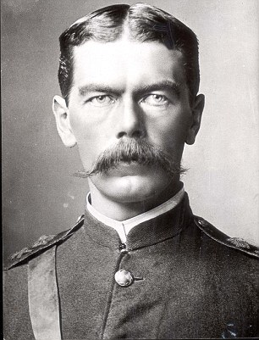
The proconsul will greet the players and turn the conversation over to Egg Chen. Egg will discuss with them the current situation. His research has shown that the Tao Mages and the Taiping Heavenly Kingdom have made a decision to finish off the British colony once and for all. They are planning an all-out attack on British holdings. Intelligence has been received ( from reliable sources) that most importantly a group of their leaders will be coming from the north to oversee the destruction of Hong Kong.
The Proconsul informs you the they should have a moderate force with them, but with military assistance and the weapons and counter magic available, you should be able to defeat them.
There is an ideal location in the mountains north of Hong Kong where they will have to travel. It will serve as an excellent ambush location. The military forces are under the overall command of General Harland Palethorpe. He is already on site and is arranging the various units in their defensive positions. You will coordinate with him when you arrive on site. Your position will be that of a special mobile force outside of the military chain of command. Your orders are to do what is necessary to finish the enemy off. You have abilities and powers that give you an advantage in this. Travel to the location and get any additional information from the general. Good Luck! The Empire and Hong Kong are counting on you!
Spy in area . Can they find it before they warn the enemy?

Military elements available. Only some Parts of them,
4500 total numbers
18th Regiment of Bengal Cavalry
60th King’s Royal Rifles
19th Punjab Infantry
Madras Sappers and Miners
23rd Punjab Pioneers
7th Royal Wyvern Cavalry
Royal Regiment of Artillery

*They will also have the aerial frigate HMS Vanguard to provide emergency fire support. (Unknown to the players, the orders have instead gone to HMS Troutbridge, an aging frigate with an untested crew. They have been involved more in smuggling, gambling, and using their ship as a pleasure ship, then a ship of war. There is a high chance of friendly fire (accidently of course) and limited effect on the enemy.)
Special equipment
Anti supernatural ammunition ( limited amounts)
Invisibility tarps
Artillery ( mortars and cannon ) with a variety of ammunition
Explosives ( dynamite and gunpowder) to set traps
4 wagon mounted Gatling guns
Explosive rockets (160)
Protective wards ( to defeat Tao mage ability to cause gunpowder to not function )

The PCs are assigned to guard a single vital spot (a significant mountain pass) from impending or possible attack from the pirates and the Tao mages. They must plan their defensive strategy, set up watches, set traps, and so on, and then deal with the enemy when it arrives.
The intelligence the PCs was given turns out to be faulty, but acting on the new information could result in greater danger - but so could not acting on it, and the PCs must choose or create a compromise. Their Choice to utilize site of ambush or to go out and try to stop the opposing army from moving through the valley razing villages and burning men, women , and children.
The enemy Force is unexpectedly much larger and more significant than their intelligence told them. They are massively outnumbered and no further reinforcements are available.
The PCs must figure out how to use local resources in order to defend themselves or have a chance against the enemy force.

There are innocents nearby that the PCs must keep safe while dealing with the adventure. Unaffiliated villagers.

Can be fluid as to how they decide to deal with the situation. They will still have surprise and can work that in their favor. They can also attempt to recruit from the locals ( and potentially the bandits) to increase their forces and level the numbers.

*Time will be given for any questions to be answered.

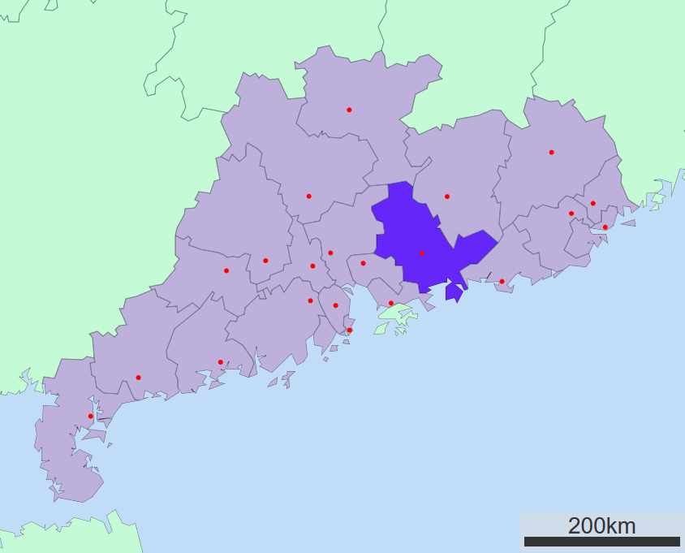
General Harland Palethorpe
A career Army officer. He fought in the Crimean war and fortunately does have combat experience. Unfortunately, he has never faced this enemy and is highly overconfident about your chances of defeating them. Used to conventional forces, he will panic when faced with Tao Mages. This will make the situation more difficult for the PCs.
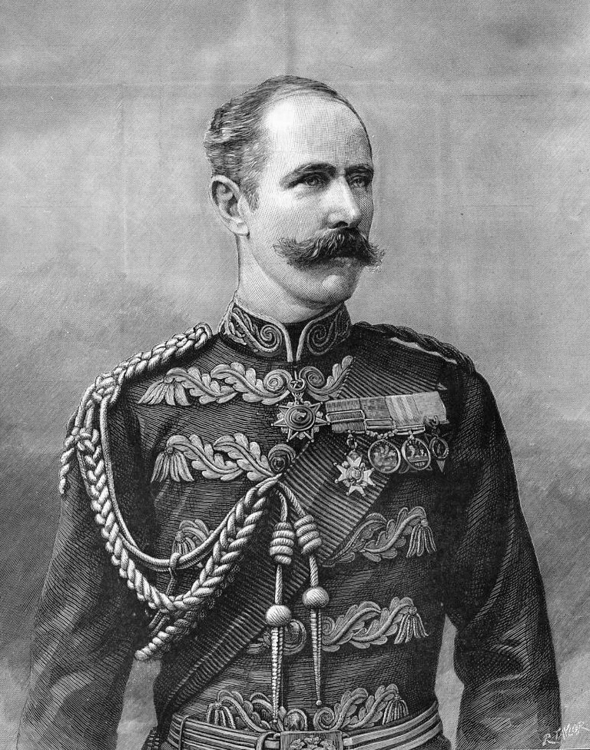

Scene 2: Jinsu Pass, Guangdong Province: Ambush Location

The characters will have some time to explore their locations and to check out the defenses. The military forces are deployed along the alogn ridgelines or have created defensive positons behind sandbags and wooden barricades. They have a sufficent supply of ammunition , including some anti-supernatural ammunition for their maxim guns or rifles. Artillary has been
There is a lookout location already constructed at the peak of one of the mountains on the soiuthern area of the valley. This gives a good view (when not obscured by fog) to see the area, the river, and the various villages of the valley area. It gives good oversight of the one road and oass through the area to Hong Kong. Fortunately the high winds of the are makeairship travel difficult, limiting the enemy to ground movement.
Statistics for defense forces if needed
Maxim machine gun: (roll 3d6 diff 6 to target) deals 3d6 damage over area. Characters can roll a Dex+Dodge diff 22 for half damage.
Hotchkiss Revolving Cannon: (roll 3d6 diff 8 to target) deals 5d6 damage over area. Characters can roll a Dex+Dodge diff 25 for half damage.
British Officer: Mental competence: 10 Physical competence: 10 Init: 10+2d6
Health: 55/7 inc greatcoat
Skill picks: Perception (10) , Dodge (10), Intimidate (8)
Combat picks: Sabre(16) for 4d6+6 lethal, Pistol (15) 5d6 Lethal
British Soldiers with carbines : Mental competence: 6 Physical competence: 10 Init: 8+2d6
Health: 35/7 inc greatcoat
Skill picks: Perception (10)
Combat picks: Carbine (16) for 5d6 lethal, Bayonet (16) for 2d6 lethal
British Cavalry Officer: Mental competence: 10 Physical competence: 10 Init: 10+2d6
Health: 65/10 inc Curiass
Skill picks: Perception (10) , Dodge (10), Intimidate (8), Ride (15)
Combat picks: Sabre(16) for 5d6+6 lethal, Pistol (15) 5d6 Lethal
Defense Forces

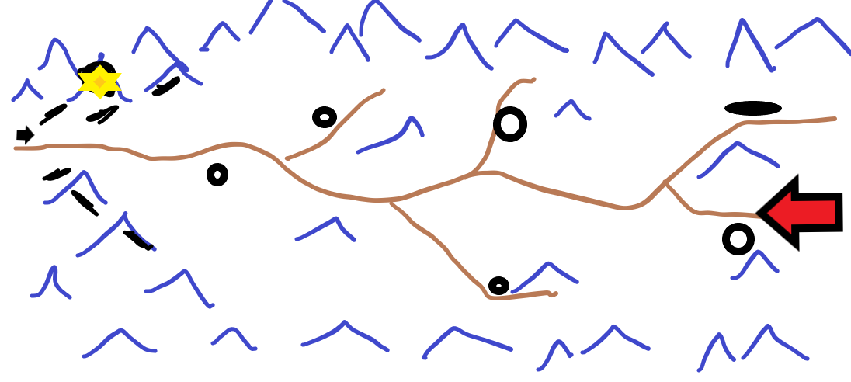
Map Key-For PCs
Yellow star-Command post.
Black arrow-artillery
Black lines -entrenched forces
Black circles-villages
Brown line-roads
Red arrow-direction of enemy force
The first few days are quiet, allowing the pcs to explore the area and make any adjustments to the defense.

Minor Event One: Traveling salesman
A cabbage salesman is trying to cross through the pass to sell his produce in Hong Kong. The players may cause problems. Have fun with it.
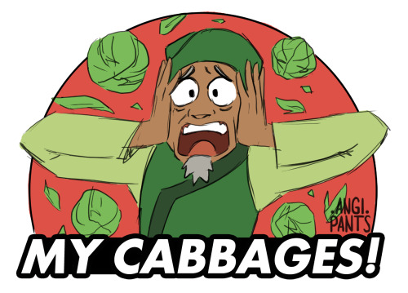

Minor Event Two: Bandits
Reports come in of a group of bandits encamped a few mountains over. They have no affiliation with either the imperial government or the Taiping heavenly kingdom. They can be attacked and driven off or can be left alone, or even recruited.
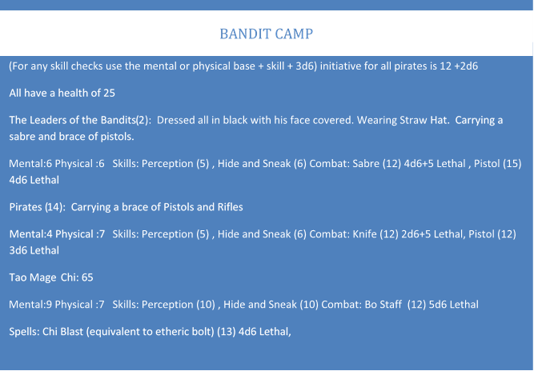

Minor Event Three: Spies
The players will need to state that they are posting a watch and are keeping an eye out for those observing their activities. You can give them a roll of Perception + Intellect diff 20 to determine that they are being watched. The spy has a hide and sneak + dexterity of 25. They will need to beat that to locate him. If stopped it will give the British forces a surprise round in the ambush.

Scene 3: Refugees

As the sun sets a large dragon is seen flying over the farthest village breathing flames. A large army will be seen moving across the landscape through the darkness razing villages. The players can hold their positions and listen to the ever increasing cries of pain and horror or go out to meet them.

Scene 4: First attack
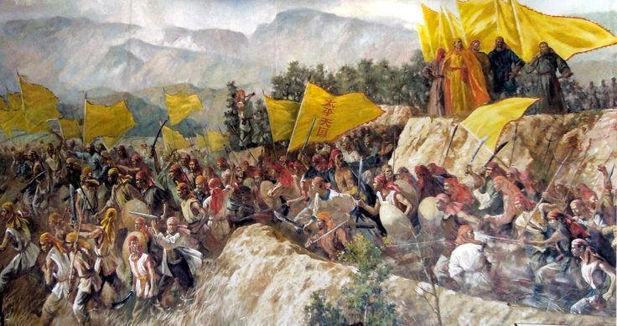
If the party still has surprise they get a free round to attack the enemy. It is a far superior force with this being the lead element. There are a few Tao Mages, but most are infantry. This should be a good warmup battle.
*Allow the players to be creative with this challenge.

*In all the battles manipulate the number of enemies for something reasonable for the players to deal with. Unless of course they decide to attack the force unaided. A handful against 10,000 does not work well even for PCs.

Army Officer: Mental competence: 10 Physical competence: 10 Init: 10+2d6
Health:30/7 inc greatcoat
Skill picks: Perception (10) , Dodge (10), Intimidate (8) Bureaucracy (10)
Combat picks: Pistol (15) 3d6 Lethal,
army soldiers (10) : Mental competence: 6 Physical competence: 10 Init: 8+2d6
Health: 25/7 inc greatcoat
Skill picks: Perception (10) Feats of Strength (10)
Combat picks: Rifle (12) 5d6
Tao Mages Mental competence: 16 Physical competence: 6
Health: 15/7 inc greatcoat /magic protection 25
Skill picks: Thaumaturgy (16), occult (18), Necromancy (16), medicine (14), astronomy (16),
Combat picks: etheric bolt (18) for 4d lethal, etheric bludgeon (18) for 4d stun
*Special power: Can use a single Necromantic burst to raise all dead as Zombie to attack party.
Use physical competence and only attacks are either a bite (12) 2d6 lethal or bash (12) 5d6 stun
Health is set at 40 with 5 armour. (only use this if time permits and party is still strong)

Taiping Heavenly kingdom Army forces

Scene 5: The Main Attack

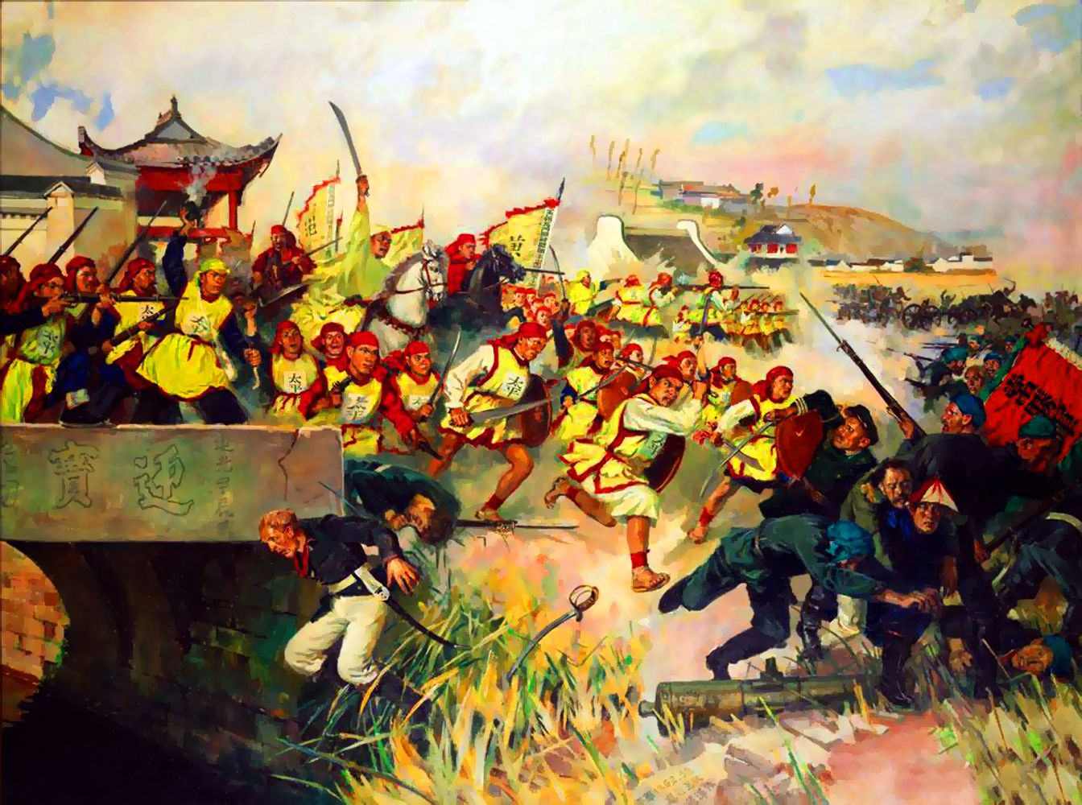
The massive force of the army attacks. They have split up to attack the various fortified positions. This will tie down most of the British forces leaving the players to deal with the unknown elements, the tao mages and the dragon.
(For any skill checks use the mental or physical base + skill + 3d6) initiative for all pirates is 12 +2d6
All have a health of 25
The Leaders of the Pirates (6): Dressed all in black with his face covered. Wearing Straw Hat. Carrying a sabre and brace of pistols.
Mental:6 Physical :6 Skills: Perception (5) , Hide and Sneak (6) Combat: Sabre (12) 4d6+5 Lethal , Pistol (15) 4d6 Lethal
Pirates (100): Carrying a brace of Pistols.
Mental:4 Physical :7 Skills: Perception (5) , Hide and Sneak (6) Combat: Knife (12) 2d6+5 Lethal, Pistol (12) 3d6 Lethal
Tao Mages (15) Chi: 65
Mental:9 Physical :7 Skills: Perception (10) , Hide and Sneak (10) Combat: Bo Staff (12) 5d6 Lethal
Spells: Chi Blast (equivalent to etheric bolt) (13) 4d6 Lethal,
Tao Mages and Pirates

Scene 7: The Final Battle
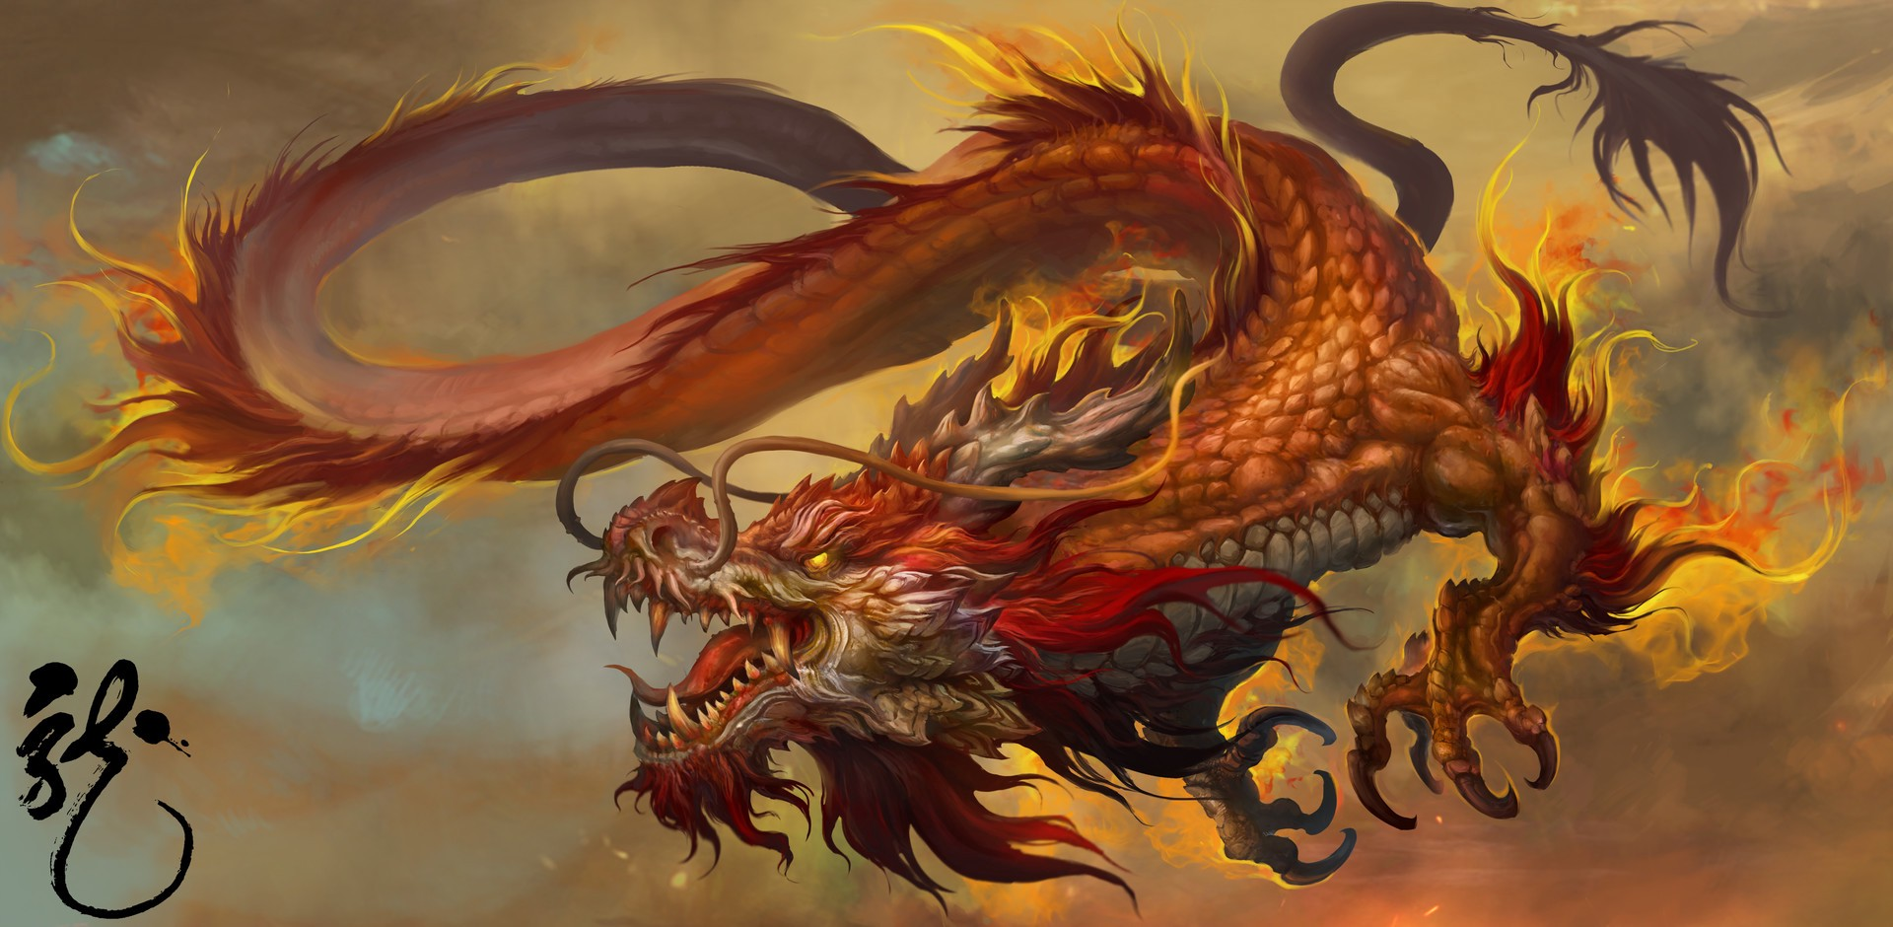
Play this as a very action movie type scene. Try to make sure everyone can be involved (and should be involved as the opponents are dangerous). As this is the final battle have fun with it and get the players excited.

Soon an exceptionally large dragon comes into view. It seems to be glowing with some sort of strange energy. It lets loose a howl and charges the players. All attempts to harm it from the other soldiers does no damage (unless the players are struggling, then let them help out).
This is a large and powerful foe, that will (hopefully) require teamwork to take it down.
But it does have weaknesses:
- The previous battles have filled the area with the smell of blood and death, limiting its use of this sense.
- While large, that has slowed it down somewhat, making it easier for the characters to dodge its attacks.
- Too large to dodge attacks
- If wounded will howl (sonic blast ) instead of clawing.
- Limited magical attacks.

Initiative: 15+2d6
Health: 400/ 20 Armour (regenerates 10 health per round)
Mental:15
Physical: 20
Perception (20)
Howl Sonic Blast (20) 6 Stun, Claw (10) 6 dice + 12 Lethal
Fire Breath (20) 8d6 over an area (dexterity +athletics diff 25 to save for half damage.) Ignores armour.
Magical abilities (use once a combat)
Wave of cold (15) 4 dice cold damage ( can be dodged or resisted with resolution +thaumaturgy)
Energy wave (15) 6 dice energy damage and a dexterity + athletics roll (diff 15) to avoid being knocked down.

- Weakness: Faith based weapons (blessed) or powers, and silver weapons. Cause Double damage which cannot be regenerated. Magic and Psychic powers do normal damage.

*Note if the party is relatively weak. Allow the military forces to be able to assist in damaging the dragon. They can also take the brunt of the damage if the party is low on health.
Dragon

Epilogue
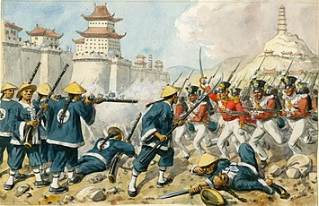
After defeating the Dragon, the coordination of all remaining soldiers vanishes leaving them easy prey for the remaining soldiers to finish off. The snow falls amongst the bloody ruins of the mountain pass as the morning bells start to ring in the villages behind your position. You have survived the night and live on another day.

