Blood and Iron: Paths of Steam and Sorcery -
A Victorian Steampunk Scenario of Adventure and Intrigue using a variation of the Victoriana system.

“Not through speeches and majority decisions will the great questions of the day be decided... but by iron and blood.”
Otto Von Bismarck

Game by Dudley Martin

Game Blurb:
The year is 1862. Britannia rules the waves and the skies through the force of her ironclad Battleships and aerial Dreadnaughts. The Royal Guild of Thaumaturges uses the Royal Academy to train those who would use their powers for the good of the Empire. In concert these powers of metal and magic have expanded the Empire and have heralded a golden age of prosperity and peace. But darker forces work on the continent and they threaten that peace and prosperity. You have been summoned to aid in stopping one such plan. Can you afford to fail? The Empire depends on you…

Contents
Game Blurb: 2
System Basics 4
USING SKILLS 4
Characteristics 4
Effect and damage rolls 5
Combat: 5
INITIATIVE 5
What can I do as an action? 5
Melee & hand-to-hand attacks 6
Making the attack 6
Making the attack 6
Determining damage 6
ALL OUT DODGE 7
Taking cover 7
Diving for cover 7
EXPLOSIONS 7
Special Abilites 8
Sensate abilities 8
Miracles of Faith 9
THAUMATURGY SPELLS 9
Setting mood: 13
The Characters (Read to players before they choose their character) 13
Opening Scene: In the House of Lord Gibbons 15
Information for players on Contessa Victoria 17
Scene 2: Encounter at the Airship docks 18
Scene 3: A brief Interlude on the Airship 19
Scene 4: Let’s visit the Prussian embassy 20
Scene 5: Truths, Lies and Weapons of Mass Destruction 24
The Final Battle 25

System Basics

USING SKILLS
Whenever your character tries to do something (called taking an action), there’s always the question of whether he’ll succeed or fail. Sometimes the task is so easy that it’s obvious; for instance, taking a step forward without falling down. In those cases you’ll just tell the Gamemaster what you’re doing, and no die roll is needed. But if you’re trying to take a step on the deck of a ship pitching wildly in a driving rainstorm, walking might be very difficult indeed. That’s where task resolution comes in. All tasks in Victoriana are resolved with the same formula: take the relevant characteristic and add to it the relevant skill, then add the result of an action roll of 3d6 to create an ‘action total’. Compare your total to the difficulty of the task. If you equal or exceed the difficulty value, you succeed!

Characteristics
Intellect: for memory recall, problem solving, manipulating tools & instruments

Resolution: for the ability to face danger, fear, and stress

Presence: for interactions with others.

Dexterity: for fighting, dodging, athletics, driving, running, and swimming

Body: for using physical power, resisting pain, disease, shock

Your (characteristic + skill) + 3 dice in an action roll
Vs. The difficulty of the task
DIFFICULTY TABLE (for most rolls use an average difficulty. Use higher or lower depending on situation and action)
Easy | 10
Average | 14
Exasperating | 18
Really? | 22
Very | 26
Extremely | 30
Ridiculously | 34
Impossibly | 38

When you roll your action dice you may roll all sixes, if so then rejoice! This is known as a special success. In combat attacks this generally means that you double the damage done, in
other action rolls the gamemaster will tell you how your special success manifests. Adversely if your dice roll comes up with three 1’s then the attempt automatically failed, this is known as a foul failure.
Example: Mad Eric is fending off a footpad; it’s his turn to attack. He’s using a sword cane, so we add his dexterity 3 and swordplay 4 for a total of 7; the gamemaster tells Mike (Eric’s player)
that he will need to beat a difficulty of 22 to hit the thug. Mike makes his action roll and the dice
come up with a 2,4, and a 6. That’s a total of 19 – Eric Misses!

Effect and damage rolls
Effect rolls follow some action rolls; usually they represent damage done by weapons, or define the effects of a spell. You usually roll a set amount of effect dice and add the results together, just like an action roll. The difference to action rolls is that there are no skill or characteristic
bonuses to effect rolls Once rolled add the results together, this is the effect total, or damage roll as it is often known.

Combat:

INITIATIVE
At the beginning of each round, each character rolls 2 dice and adds their initiative characteristic in an action roll. The character with the highest total acts first for that round
(they are also allowed to hold their action and act later in the round). The character
with the next highest total acts next and so on. Roll an additional die to break ties; high
number goes first.

What can I do as an action?
You can do one thing with each action. In its simplest terms if there is a dice roll required it counts as an action. This
could include:
Combat Actions...
Draw a weapon
Make a single melee attack
Make a single ranged attack
Throw a stone or bomb
Move up to your full combat movement
Non-combat actions…
Make a small speech to intimidate or impress
Perform an athletics feat, such as leaping, or breaking down a door.
Cast a spell
Command an embodiment
Invoke a demon
Maintaining a spell with a concentration roll
Untying a captive
Opening a closed but unlocked door
Get up after being knocked prone
Each one of these things would be considered a single action.

Melee & hand-to-hand attacks
Melee represents up close and personal duels and brawls, opponents might be using swords, clubs, chair legs, frying pans, fists, feet, and perhaps even skill.

As a general rule melee range is considered to be 4yds, the typical reach of an adult arm and a
sword. If you want to start a fight you have to be at least this close.

Making the attack
An opposed action roll between the attacker and defender represents melee combat.
The attacker combines his dexterity, an appropriate weapon skill and an action
roll. He may also have to add or subtract certain modifiers from this action total to
determine the final outcome. The defender combines his dexterity, his dodge! Skill and the result of an action roll, the defender might also have modifiers to his roll before obtaining a final total. The final totals are compared, if the attacker has the higher score then he hit, and
should roll damage, if the defender has the highest total then he evaded the attack – this time. In the event of a tie, the defender always evades.

Making the attack
Unlike melee combat, ranged combat is an unopposed action roll by the attacker against a target number defined by range and possibly a modifier from all out dodge! Attempts.
The attacker combines his dexterity, the appropriate weapon skill and an action
roll. The action total is compared to the difficulty as defined by the range if you equal
or exceed the difficulty of the shot you hit and roll damage.

RANGE & DIFFICULTY TO HIT
Range | Difficulty
Point blank (4yds or less) | 10
Close (10yds or less) | 14
Medium (50yds or less) | 18
Long (out to listed range of weapon) | 22
Extreme (beyond listed range) | 26
+ 2 per + 100yds

(It is suggested that for ease of con play that all rates of fire be limited to 1 or 2)

Determining damage
Once you have made a successful attack the next step is to determine the amount of damage your attack has done to your opponent. Damage rolls are effect rolls, and are dealt with as follows. The weapon used dictates the amount of damage you will do. Few people died from gunshots in this era, most died from infections in the wound days or weeks later. Once you have determined the amount of damage dice to be rolled, roll them and add the results together, this is your damage total. Every character or creature in Victoriana has a fortitude characteristic, some will also possess armour, whether worn or as a natural feature. The defender subtracts
both his fortitude rating, and the rating of any armour he is wearing from the damage
total, the rest is applied to his health scores.

ALL OUT DODGE
Use this action to make yourself harder to hit. As your first action you declare an all out dodge,
and in your initiative order for the first action you make a complementary roll on dexterity + dodge! With a difficulty of 14. The result of this complementary roll is added to each of your automatic defence rolls for that round. See complementary skills in the skills section for more information.

Taking cover
If you don’t want to waste an action racing around to facilitate an all out dodge, you can try
to take cover. By using the environment around you such as trees, walls, and even furniture, you can reduce your opponent’s chances of hitting you in ranged combat, see the modifiers section for examples. You cannot take cover from the environment in melee combat; you and your opponent are too closely engaged to be able to do so, but you can use portable items such as furniture as improvised shields if your gamemaster allows.

Diving for cover
This variant of all out dodge can be used to avoid sudden and unexpected area effect attacks such as explosions and some spells. You make an action roll using athletics against a difficulty based on the distance (base of 14 for 1yd + 1 difficulty for every extra 1yd). If the roll is failed, you didn’t dodge fast and/or far enough and were caught by the attack effects. Diving for cover is usually a free action and once performed is the last action of the round for that character as he then picks himself up from the debris. However a character with enough foresight (or paranoia) can specify diving for cover as an action (just in case), and
characters who do so may then continue to act in the round as normal.

EXPLOSIONS
Attacks that strike an area rather than a character (bombs, grenades, gas and other effects) are known as area effect attacks. The area affected depends on the damage dice of the attack being used, typically this is a 1 yard radius per damage dice of the weapon, and will always be described as part of its description or construction. The outcome of area effect attacks is determined by each defender in the area defending against a single attack total by diving for cover; those who fail take damage. Ground zero of an explosion or area effect takes the full damage of the attack, characters take 2 less points of damage for every yard they are away from the centre of the attack. Character who are outside the area of effect, take no damage at
all.

ENVIRONMENTAL INTENSITIES
Type | Mild | Intense | Deadly
Damage | 1-4 dice | 5-10 dice | 11-20 dice
Electricity | Battery | Generator | Lightning bolt
Illness | Measles | Cholera | Plague
Drug | Alcohol | Opium | Cocaine
Poison | Belladonna | Arsenic | Stonefish venom
Fire | Wood fire | Gas fire | Chemical fire

Special Abilites

Sensate abilities
Sensates have a strong connection to the natural world, and their gifts reflect their super sensitive
nature allowing them to see what others do not.
Ability Difficulty Description
Aura reading 14 A successful medium + presence roll allows the medium
to gauge the mood, temper & intentions of the observed
person. Aura reading is only applied to individuals, not
to groups. One aura reading can be conducted with one
action.
Glimpse 26 By using this power the medium is hit with a powerful
and vivid vision of an event that is due to happen. The
medium has little control over what he sees (you cant try to
see the outcome of this years grand national), but you can
be confident that it is imminent, certainly within the next
week.
Know recent events 22 A successful action roll grants knowledge of recent events
occurring around the person or object being studied. The
nature of the knowledge gleaned from such an observation
is often incomplete and fragmented, often, information is
only trivial and not of obvious use.
Magic sense 18 The games master makes this roll whenever the character
comes within 10 yards of a spell effect; focus, magical
artefact or sorcerer. Magical creatures such as demons are
not detected by this ability. With success the character is
aware of a tingling sensation down the spine, warning the
character of magical presence. An excellent success might
yield information concerning the nature of the magical
presence.
Psychometry 22 The ability to gain information concerning an individual
from their personal effects. Information accessible usually
relates to the individual’s present welfare or location, but
information about the recent well being and transitions of
the items owner may also be gleaned.
Sense the supernatural 14 The medium can sense supernatural beings such as
demons, ghosts and the invisible within 10 yards. Exact
location cannot be discerned, although a good idea of
direction is furnished.
Sixth sense 14 An uncanny & instinctive knowledge of events around the
corner. With use of this ability a medium may finish the
sentences of others. Also sixth sense may be used to avoid

Miracles of Faith
Ability Difficulty Description
Heal 18 The medium can call upon the mercy of heaven
to heal a deadly wound or disease. Heals 3d6 points of damage completely.

THAUMATURGY SPELLS
Botheration
Resolve cost: 1 (18)
Range: touch
Duration: rounds
Once cast the target must be touched, and a opposed roll between resolution
+ thaumaturgy and resolution + concentration ensues. If successful the target
becomes totally confused. A bothered target cannot concentrate on even
simple tasks, represented by a –6 action roll modifier.
Darkness of ages
Resolve cost: 2 (22)
Range: 20 yds
Duration: minutes
Creates a billowing black cloud of absolute darkness. From outside the spells
5 yard radius the cloud appears to be thick roiling smoke. From within there
is absolute darkness, with no suggestion of smoke or a gas of any kind.
Ectoplasmic bonds
Resolve cost: 4 (24)
Range: 40 yds
Duration: hours
Tendrils of Ectoplasmic slime materialise to ensnare the target of this spell.
The bonds may stick a target to a surface such as a wall, floor or ceiling.
Breaking free from the slime requires a body + athletics (32) roll. Winning
breaks free, losing remains entangled. After 2 hours the slime starts to lose
coherence, and the difficulty drops by 4 each half hour from that point until
the end of the duration.
Farspeech
Resolve cost: 1 (20)
Range: sight
Duration: instant
This spell allows whispered conversation to be passed as far as the
eye can see. As long as the target can be seen they can hear the
caster’s words. This spell does not grant two-way communications.

Etheric bolt
Resolve cost: 4 (24)
Range: 20 yds
Duration: instant
Upon completion of the spell, an etheric bolt of green energy forms
around the casters hand, which may then be fired with dexterity + thaumaturgy
in the same manner as mundane ranged attacks. The bolt does
4 dice of lethal damage. Etheric bolt is not resisted with resolution; the
rules for dodging ranged attacks apply. One casting provides one bolt.
Etheric bludgeon
Resolve cost: 2 (22)
Range: 20 yds
Duration: instant
Upon completion of the spell, a pale bolt of energy forms around the
casters hand, which may then be fired with dexterity + thaumaturgy in
the same manner as mundane ranged attacks. The bolt does 4 dice of stun
damage. The bolt is not resisted with resolution; the rules for dodging
ranged attacks apply. One casting provides one bolt.
Firespark
Resolve cost: 1 (20)
Range: self
Duration: instant
A small gas flame appears from the finger or thumb of the caster. The
flame lasts several seconds and is sufficient to light a pipe, cigarette,
lamp, candle or fire.
Etheric barrage
Resolve cost: 6* (26)
Range: 100 yds
Duration: rounds
This spell channels energy around the sorcerer and then through him into
a seething stream of fire, which may then be fired with dexterity + thaumaturgy
in the same manner as mundane ranged attacks. The caster can
throw any amount of barrages from one casting, but each bolt after the
first costs an additional 2 resolve. Should the Thaumaturge foul with any
roll when using this spell, the caster will suffer a full strength barrage hit
himself.
Each barrage does 6 dice of lethal damage. Barrages are not resisted with
resolution; the rules for dodging ranged attacks apply. One casting provides
unlimited bolts for the duration.

Flight of the wyvern
Resolve cost: 3 (22)
Range: self
Duration: minutes
The caster can command ethereal forces to counterbalance the forces of
gravity, thereby granting the power of flight. The caster gains a flying
combat speed of 16 yards/round. As the air is not a native element to
mankind, flight is slow and unsteady at first, with manoeuvres relying on
intellect alone. Frequent flyers however, may study the speciality: flight
skill.
Levitate
Resolve cost: 2 (20)
Range: 10 yds
Duration: rounds
The caster can command ethereal forces to counterbalance the forces
of gravity, allowing the levitation of himself, or other persons and
objects. No object may be raised higher that 6 yards from the ground,
and no more objects than the casters intellect may be raised at one time.
Levitation simply moves objects upwards; it confers no further movement
ability.
Gaslight
Resolve cost: 1 (18)
Range: 4 yds
Duration: minutes
Creates a small
ball of light in
the caster’s hand.
The light has the
power of a good
gas lamp and illuminates
approx
5 yards radius.
The ball can float
and may be mentally
directed by
the caster to any
position within
range.

Groom
Resolve cost: 1 (18)
Range: self
Duration: instant
This spell washes, refreshes, oils and combs hair, trims the moustache,
even dusts down and presses the caster’s clothes. Observers will see
the caster improving in appearance as if tended to by invisible hands,
with creases and folds in clothing ironing out while still worn.
Hair of the dog
Resolve cost: 2 (26)
Range: touch
Duration: hours
The caster must incant the formula to this spell loudly in Latin, upon
completion all the targets hangover symptoms are gone. The spell expels
headache, dizziness, lethargy, curried eyes, and bowel trouble. Note that
none of the above symptoms can be dispelled unless they are symptoms
of a hangover.
Heal
Resolve cost: 4 (22)
Range: touch
Duration: instant
This spell instantly knits flesh and dispels infection, healing 4d6 health.
The application of this spell has made the guild renowned as miracle
healers. Diseases cannot be treated with heal, they must be treated with
cure
Cure
Resolve cost: 6 (26)
Range: touch
Duration: instant
This spell instantly cleanses the target of any resident diseases or infections
that might be afflicting them. Poisons and physical wounds cannot
be treated with cure.
Instant beauty
Resolve cost: 2 (22)
Range: touch
Duration: hours
Increases the desirability of the recipient. No discernible change occurs, but others find the recipient attractive anyway, possibly being puzzled as to why. Presence increases by 2 for the duration.

Magic tobacconist
Resolve cost: 1 (18)
Range: self
Duration: instant
Allows the caster to magically produce a fine cigar or cigarette.
Alternatively the spell might be used to magically fill a pipe bowl.
Power of steam
Resolve cost: 3 (22)
Range: touch
Duration: minutes
The caster may confer the motive power of a steam train into a vehicle. When travelling in such a manner multi hued steam pours from the vehicle, often obscuring sight (-2 to driving rolls).
If applied to a person, their running speed is doubled and they gain +2 body. However, they also go bright red as magical steam gushes from ears, mouth, nose and through the seams of clothing. Living creatures take 1d6 stun each minute as a result of the unnatural exertions the body undergoes in this state.
Scholar’s guard
Resolve cost: 1 (20)
Range: touch
Duration: hours
The caster traces an imaginary perimeter with pointed finger. The perimeter may be up to 3 yards radius. Anything stepping through the perimeter sets off a magical alarm. The nature of the highly audible alarm is left to the caster.
Second sight
Resolve cost: 2 (20)
Range: self
Duration: rounds
Allows the caster to see supernatural effects clearly. Such phenomena include: possessing demons appear as if fully manifested through second sight. Spells effects appear as glowing energy and their nature may be discerned with scrutinise rolls. Creatures such as ghosts are always visible through second sight. While second sight is active, mundane sight is dim and darkened – all perception tests relating to the mundane world are at –4 modifier.

Spyglass eyes
Resolve cost: 1 (20)
Range: self
Duration: minutes
Allows the caster to see with up to x20 magnification, as if using a powerful
spyglass. The spyglass effect may be turned on or off during the
duration.
Steely skin
Resolve cost: 5 (24)
Range: touch
Duration: minutes
The spell weaves an invisible shroud of magical energy about the recipient,
granting an armour value of 10, which is added to any other armour worn.
The emperor’s new spell
Resolve cost: 4 (24)
Range: self
Duration: minutes
Renders the caster totallyinvisible to normal sight. Some creatures and use
of second sight spell will detect the caster. The spell will only render the body
invisible, clothes and items are not invisible unless swallowed or otherwise
enclosed in a body cavity.
True door
Resolve cost: 2 (20)
Range: touch
Duration: hours
This spell is cast upon a portal such as a door, window, box lid or other such scalable opening. The magic of the spell permeates the material of the portal and knits it together with strong, magic glue. The portal can no longer be opened normally, and must be forced.

Setting mood:
This game takes place during a time of change and growth. In this world the British Empire is expanding with the aid of steam power.
The gap between rich and poor is even more pronounced and should be played up. The rich will be light, airy, and clean, while the poor will be dark, dingy and filled with sooty smoke. Poverty abounds and the chances for advancement are not possible, while the upper classes live well beyond their means and utilize the poor as stepping stones to fame and fortune.
This game is all about the story and letting the players become part of that story. Encourage the players to describe their actions and to get into character with their roles. The story is loosely described, but should not be held to strictly. Allow the players to be inventive and if that leads them in different directions use the information here to modify the game and lay to that direction.
Above all have fun.

The Characters (Read to players before they choose their character)
Lady Isabella Wintergreen: An upper class Adventuress with an interest in the Occult. She is somewhat of an outcast in polite society because she flaunts the status quo and does what she wants. She is an extremely public figure who delights in seeing her adventures posted in the daily papers. Deadly with her knives and a crack shot, Lady Isabella is not one to be toyed with.
Lady Fiona Cleary Toher: Lady Fiona is an oddity, she has been through the Thaumaturgical Academy and received her Doctorate. In an organization that is heavily biased towards men this is a feat that is impressive and shows the depth of her determination. She is skilled with her Thaumaturgy using it to defend herself and to maintain a proper level of decorum despite any adventures she may be involved in. She is also skilled at the reading of auras, giving herself an advantage in a society hostile towards her.
Alanna: Born to a quiet middle class family in the midlands, Alanna was sent off to a boarding school in Liverpool and was changed by her exposure to the harsh conditions which the poorer classes existed in. She could not sit idly by and thus joined Workers Revolutionary Party. In this she was trained to take up arms in aid of her brothers and sisters. She took to this new life in a way that she had never known before. She devoured the literature and became very skilled in the manufacture and use of explosives. She has also trained as a carriage driver to blend in with the general population, to find the right moment to make the will of the people known.
Diana Lann: Raised in an industrial school she has been trained to work on steam engines since she was old enough to dodge the movements in the weaving engine. Usually covered in oil and grease she is most at home when working on an engine whether it is an industrial steam plant or a small steam powered lawn trimmer. Not one for social niceties, her normal response to being disturbed is to smack it with her oversized wrench. She is fine as long as her interests are kept on any machinery or new technology.
Captain Caleb Tobias Paladine III: A military officer from a noteworthy family, Caleb is awaiting a further promotion to be assigned by Horseguards. His career thus far has been unspectacular. He joined after the Crimean War and has not had the opportunity to prove himself in battle. He was considering a transfer to India to help in the small conflicts against recalcitrant locals, but has been called to special duties. He hopes his training and skill will be of some use and aid in his promotion.
Gabriel Travers Esquire: In every society there are those who excel in the reallocation of other peoples possessions. Gabriel is one such individual. He maintains more identities and games (read cons) throughout the streets of London then most would be able to keep straight. An expert at disguise, confidence tricks and a skilled Thaumaturgist, he is capable of dealing with almost any situation with a smile on his face.

Opening Scene: In the House of Lord Gibbons
Players have been summoned to Sir Bertram William Gibbons’ estate in Hampstead Heath. (Be sure to note the clean air here is very different from in London.) They have all been collected by coach and are traveling together. They did not have the option to deny the summons. On arriving they are escorted to a large and well-appointed office. After being offered refreshments the Butler leaves and shortly after they receive their drinks their host appears. He is a rotund gentleman who immediately gets down to business.
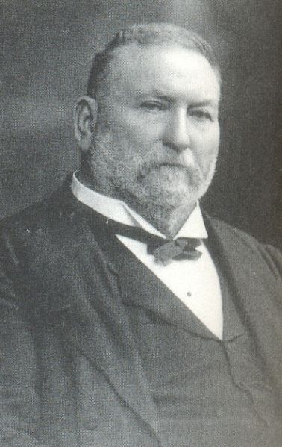
Lord Gibbons is the current Lord High Chancellor of the Exchequer. He is one of the major powers of the British Government and is not a person to cross.
Lord William Bertram Gibbons
“Welcome Ladies and Gentlemen, you have my greatest appreciation in answering my summons. You are no doubt wondering why I have sent for you?” he said, he tones dripping with false sincerity. “Very well then, I shall cut right to the heart of the matter. “ said Gibbons, his voice becoming hard and serious. He leaned forward and placed his hands on the desk. “We have a problem with a fugitive from justice. A certain woman has escaped from the country with potentially devastating secrets. She goes by the name Contessa Victoria and has been involved with a number of men throughout polite society and now she has fled to the continent. She needs to be captured and you will do this.” He sat back into his chair and waited for his agents to ask their inevitable questions. “
Some answers (give players the handout on the Contessa)
How long has she been gone/ where has she gone?
“She fled from England two days ago on a steamship to Paris. It is believed that she is either getting train to Berlin or will be meeting with the Prussian Embassy staff in a few days’ time”
Why was she not stopped before?
‘We found out the extent of her activities after she had already fled. We are working to get this accomplished quickly and quietly.’
Will answer most other questions with a statement directing them to ask it of Captain Davis.
He makes his way to the front of the desk and picks up a bell and rings it. The door to the library opens and the butler comes in. “Now, if you will excuse, I have other matters to attend to. Nathaniel and Captain Davis will see to any needs you may have. Thank you for your assistance and I wish you well. “With that he returns to his desk and began looking at the series of letters in front of him.
(Escorted out by the Butler , told of a meeting arranged with Captain Davis at an airship today in two hours and each is given a 500£ retainer by the Butler) The Butler will arrange any transportation to the airship docks. Give the group a chance to discuss matters before moving on to the next scene.

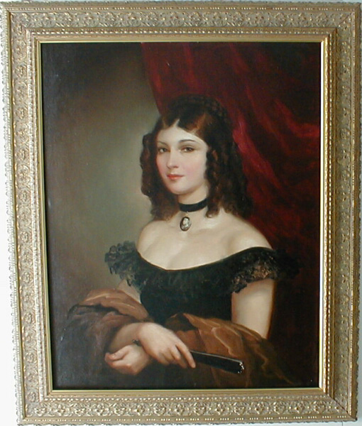

Information for players on Contessa Victoria

Contessa Victoria (Alexandra McLoughlin Heppenstall Von Purfürsling)
Gender: F Age: 25 Class: Noble Race: Eldren
Affiliation: Prussia (Father), English (Mother)
Description: 5'10", 130lbs, brown-tinted hair, sky-blue eyes
Known history: Rebellious daughter of a strict noble background. Leaving the safety of her former life, she has spent the last few years running an espionage ring under the aegis of the Prussian Chancellors’ office. Records reviewed after her disappearance show involvement over the past few years with numerous well connected businessmen, nobles and military officers. It is believed that she is responsible for a number of embarrassing diplomatic leaks as well as potential secrets to foreign enemies. In the last two weeks her life has taken some turns for the worst, with her flight from her well connected and hopelessly controlled noble lover, her plans to capture a British agent derailed by external influences and now being hunted by the British government for treason. She has fled to the continent where it is believed that she is seeking assistance in Paris, France before travelling to Berlin.

Scene 2: Encounter at the Airship docks
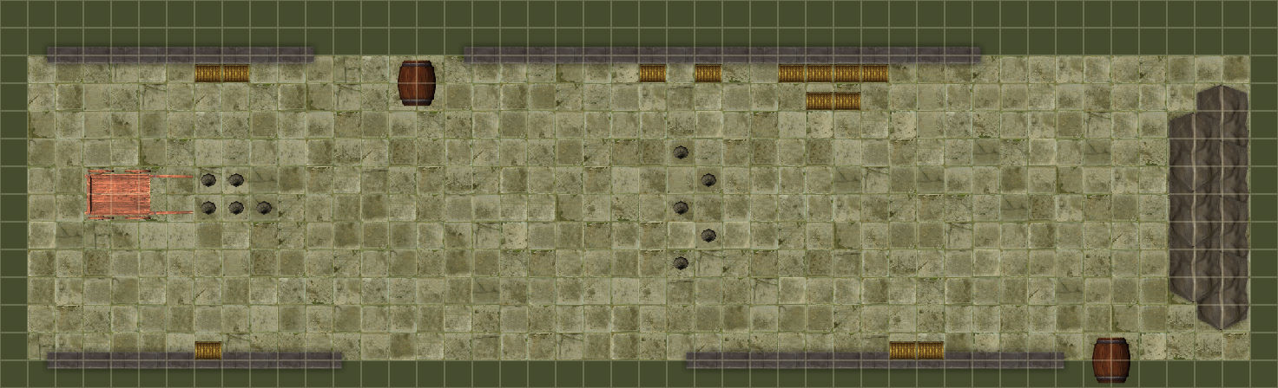

The party arrives at the airship docks just outside of London. The carriage stops in the thick fog near the entrance. The party dismounts and begins to walk towards to airship/ on either side of them are large warehouses, crates and barrels. The airship is not visible to them yet. Coming out the fog are five individuals who appear to be waiting for the party.
(For any skill checks use the mental or physical base + skill + 3d6) initiative for all assassins is 12 +2d6
All have a health of 25
The Leader of the Assassins: Dressed all in black with his face covered. Carrying a sabre.
Mental:6 Physical :6 Skills: Perception (5) , Hide and Sneak (6) Combat: Sabre (12) 4d6+5 Lethal
Quote ‘Abandon your quest or die!’ (Spoken in a German accent)
Five Assassins: Dressed all in black with his face covered. Carrying a Knife.
Mental:4 Physical :7 Skills: Perception (5) , Hide and Sneak (6) Combat: Knife (12) 2d6+5 Lethal
Sniper (perched in top of Warehouse to the left of party)
Mental:6 Physical :7 Skills: Perception (10) , Hide and Sneak (10) Combat: Steam-powered Sniper Rifle (12) 5d6 Lethal
Assassins

Scene 3: A brief Interlude on the Airship
After dealing with the assassins the party meets Captain Davis.
She has the airship prepped and ready to depart. As soon as they board, the airship takes off and they can talk amongst themselves. Give them time to talk about the encounter and to try to decide which path they will take in Paris investigating the Prussian embassy or trying to catch the Contessa on the train to Berlin.
Captain Davis is a professional Military Woman. She is there to assist with information or supplies. She is not there to do the job for the party.
She has a wireless radio to communicate with Gibbons and agents in Paris. If the party is slow and time is running out you can use Davis to direct them towards the final encounter and save time.
Captain Katherine Davis

After a suitable period of time (say 10 minutes max) have them arrive in Paris and land.

Scene 4: Let’s visit the Prussian embassy

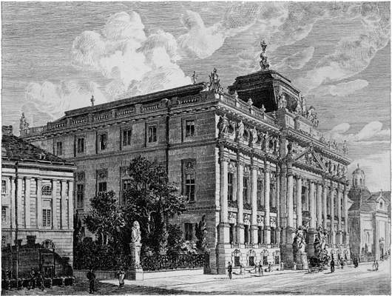
If the party decides to travel to the Embassy they are greeted at the gates by a Prussian Guard. They will need a suitable reason for trying to enter. He is easily fooled and will direct visitors to check in with Major Krupke in the embassy proper.
A young Prussian officer who is not happy being placed in an embassy. He would much rather be leading a charge against the French. He is very susceptible to feminine charms. This is one way to get entry to the Embassy.
Major Krupke

The players have a number of different options to gain entry from charming the secretary (Major Krupke) to breaking in and searching or some combination. They have the possibility to encounter the Contessa and her guards. In a luxurious suite in the interior of the building.
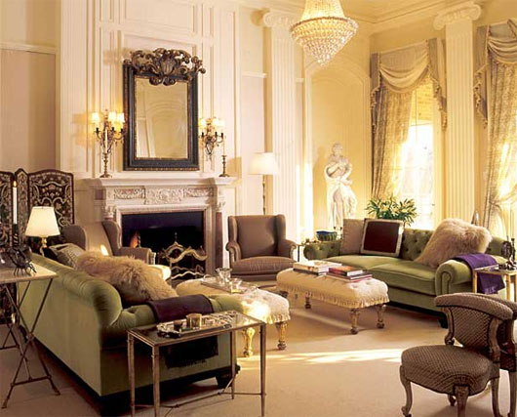

[Grab your reader’s attention with a great quote from the document or use this space to emphasize a key point. To place this text box anywhere on the page, just drag it.]
The room contains the Contessa, Her bodyguard, a ‘doctor’ and potentially the Ambassador himself. There will be at least 2 Prussian soldiers on guard outside.
The Contessa
*important note *The Contessa is to survive this conflict to get to the train. She is protected by a magical forcefield and will take any opportunity to escape. her guards will die to allow her to escape.
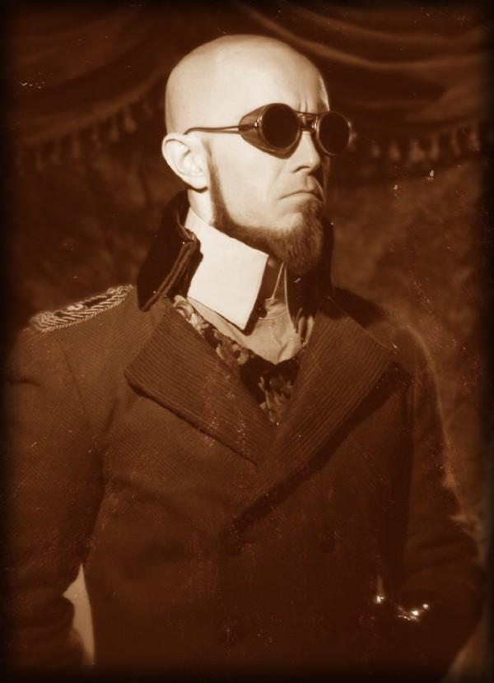
Of primary import are the Contessa’s guards.
The Professor is a Necromancer and Thaumaturge who is protecting the contessa and himself with a magical field. In this encounter they cannot be harmed.

The bodyguard is a silent figure in a Prussian uniform with its face covered. It will respond to danger very quickly and interpose itself between harm and the Contessa.
(For any skill checks use the mental or physical base + skill + 3d6) initiative for Bodyguard is 14 +2d6
It has a health of 85 and 20 Armour for the body and 15 for the head.
Mental:4 Physical :9 Skills: Perception (9) , Combat: Sabre (15) 4d6+9 Lethal, Pistol (15) 3d6 Lethal, hammerfist (16) 5d6 Stun
(The bodyguard is a cunning clockwork automaton. Secreted within its body is a large quantity of explosives. This can be detonated remotely by the Contessa or can be set by penetrating the armour of the head. This can work for the good of the party or against them. If it explodes in combat it deals damage equivalent to 6 sticks of dynamite or 72d6 of damage to an entire room. Players caught in the blast can roll the Constitution in Dice plus a 2 d6 bonus for describing how they would try to survive against a diff of 30 for ½ damage.)
The contessa’s guards
Professor Von Schoepke , the Contessa’s ‘Doctor’
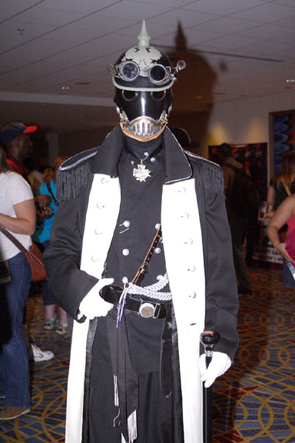
The Contessa’s Bodyguard

Scene 5: Truths, Lies and Weapons of Mass Destruction

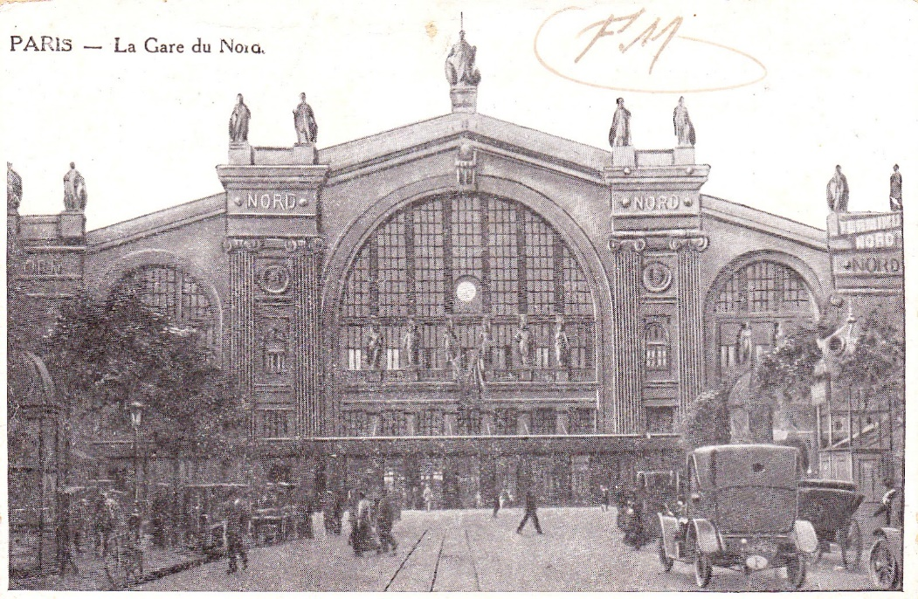

The party either surviving the embassy or coming directly to the train station arrive shortly before the train is bound to depart for Berlin. Tickets can be purchased for 1st class (a very nice car at the front of the train, and the most likely location of the Contessa), 2nd class (a decent few cars after 1st class) and 3rd class (giving a space in the cargo car with all the baggage.) The train station is not heavily guarded but the Contessa does travel with protection. Let the party decide how they will get on the train and where they will positon themselves. The final conflict will begin in the 1st class carriage.
Play this as a very action movie type scene. Try to make sure everyone can be involved (and should be involved as the opponents are dangerous). As this is the final battle have fun with it and get the players excited.

The Final Battle
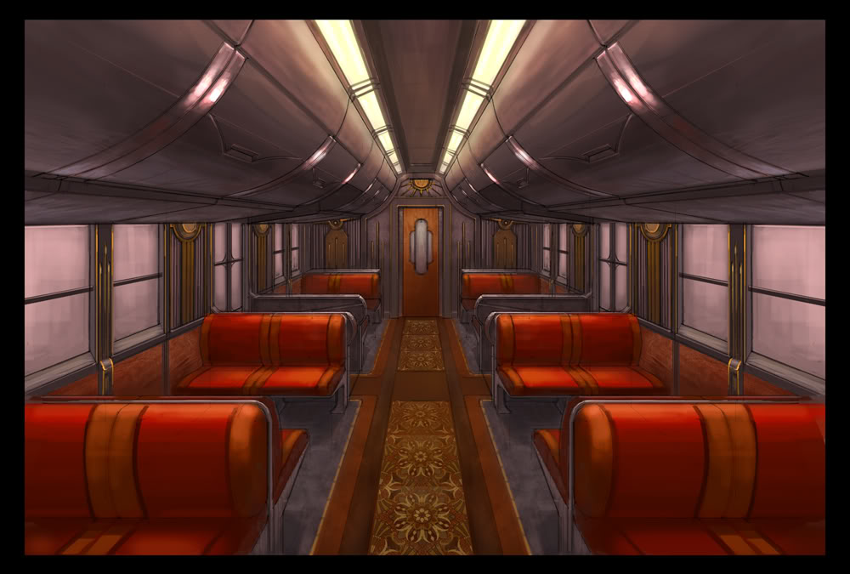
This image looks from the rear of the 1st class car. Through the door lies the engine. The Contessa and her group occupy the last four seats at the other end of the car. The Contessa sits against the right rear window with her bodyguard (another one if the last died in the Embassy- See statistics in the Embassy chapter. If the explosive is set off it destroys the entire car. Players can be thrown free of it with a successful agility+dodge versus difficulty 30(a good use for any remaining luck) to be blown clear and take ½ damage. ) in front of her. A Prussian Captain, A Prussian Thaumaturge and 4 Prussian soldiers accompany her. Also in the car are two civilians (If the party is finding it too easy one can be the professor from the embassy and a lone female who can be an assassin with knives.)
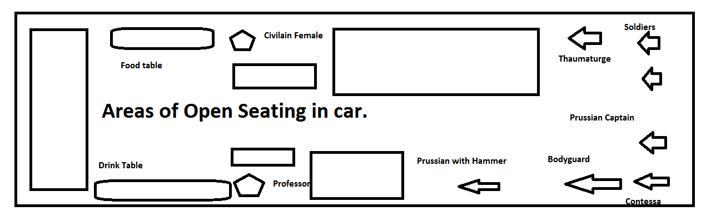
Prussian Captain: Mental competence: 10 Physical competence: 10
Health: 55/7 inc greatcoat
Skill picks: Perception (10) , Dodge (10), Intimidate (8)
Combat picks: Sabre(16) for 4d6+6 lethal, Pistol (15) 5d6 Lethal
Prussian Soldiers with carbines: Mental competence: 6 Physical competence: 10
Health: 35/7 inc greatcoat
Skill picks: Perception (10)
Combat picks: Carbine (16) for 5d6 lethal
Prussian Soldier with Massive Hammer: Mental competence: 6 Physical competence: 16
Health: 55/15 inc greatcoat
Skill picks: Feats of Strength (16)
Combat picks: Massive Warhammer (16) for 6d+12 stun
Prussian Thaumatuge: Mental competence: 16 Physical competence: 6
Health: 15/7 inc greatcoat
Skill picks: Thaumaturgy (16), occult (18), chemistry (16), medicine (14), astronomy (16),
Research (16), linguistics (16)
Combat picks: Walking stick (6) for 3d+3 stun, etheric bolt (16) for 4d lethal, etheric bludgeon (16) for 4d stun, power of steam (16), heal (16)
Prussian guard force

The Contessa can be captured and returned to England or can be killed. She will plead for her life and try to charm the Captain and Gabriel. She will offer large amounts of money and a position in Prussia. If they take this offer the game ends and with this:

You are received well in prussia. The government there wines and dines you along with the contessa. You are given everything that you wanted. on a trip to the contessa’s castle you train experiences a severe case of biothermic explosion causing severe cases of extreme death in all on board.

She is carrying letters from her lovers in Parliament which if released can be of great harm to the Government. The letters can be on the Contessa’s person or can be in her baggage. If they are returned with the Contessa or with proof of her death the party will receive payment of another 500£. A smaller payment of 250£ is made if just the papers are recovered.
Professor Von Schoepke: Mental competence: 16 Physical competence: 6
Health: 15/7 inc greatcoat /magic protection 25
Skill picks: Thaumaturgy (16), occult (18), Necromancy (16), medicine (14), astronomy (16),
Combat picks: etheric bolt (18) for 4d lethal, etheric bludgeon (18) for 4d stun
*Special power: Can use a single Necromantic burst to raise all dead as Zombie to attack party.
Use physical competence and only attacks are either a bite (12) 2d6 lethal or bash (12) 5d6 stun
Health is set at 40 with 5 armour. (only use this if time permits and party is still strong)
Professor Von Schoepke: IF HE IS INVOVLED IN THE FIGHT
Mental 9 Physical 12
Health: 15/7 inc greatcoat /magic protection 25
Skill picks: Disguise (16), Hide and Sneak (18), Perception (16), Conceal Item (14), Act (16),
Combat picks: Dagger (18) for 2d+6 lethal (+ incapacitating poison-5d damage unless save versus a diff 15 body check), Thrown Knives (18) for 2d+3 Lethal, Martial Arts strikes (16) 3d6+9 stun
Posing as a fellow passenger she is observing until needed. Optimum use is to attack players from concealment adding to confusion.
female assassin

