Blood and Iron: The Lost Jewel in the Crown
A Victorian Steampunk Scenario of Adventure and Intrigue using a variation of the Victoriana system.

“Not through speeches and majority decisions will the great questions of the day be decided... but by iron and blood.”
Otto Von Bismarck

Game by Dudley Martin

Game Blurb:
India, the British Raj, the source of wealth, influence , and a host of problems for the Crown. The peasants are revolting and the British East India Company and the British Crown are cracking down. Unfortunately, in the midst of the crackdown, when their military forces are spread thin, an incident has occurred. A luxury airship, ‘the RMS Halcyon’, has been captured by Sepoy insurgents , near Multan. Onboard, was one Almyra Helen Spencer, daughter of a prominent member of Parliament, and Professor Barnabas Whiting, who is working on a top secret project for the crown that will change the course of world politics if it falls into the wrong hands. It is imperative that they be rescued and that research retrieved . Your team must head to Western India, track down the airship and rescue the hostages. Your government is counting on you!

Contents
Game Blurb: 2
System Basics 5
USING SKILLS 5
Characteristics 5
Effect and damage rolls 6
Combat: 7
INITIATIVE 7
What can I do as an action? 7
Melee & hand-to-hand attacks 7
Making the attack 7
Making the attack 7
Determining damage 8
ALL OUT DODGE 8
Taking cover 8
Diving for cover 8
EXPLOSIONS 9
Special Abilites 9
Sensate abilities 9
Miracles of Faith 10
THAUMATURGY SPELLS 10
New Thaumaturgy Spells 14
TAOIST SPELLS 16
Setting mood: 18
Opening Scene: In the House of the Proconsul (for all Tables together) 18
Scene 2: Travel to the Island of Ao Qin (for all tables) 21
Scene 3: To the Four Directions 22
Azure Dragon: east. Andrew- Enemies are Prawn related 22
Black Tortoise: north. Jack- Enemies are Crab related 22
White Tiger: west. Paddy- Enemies are Squid related 22
Vermillion Bird: south Dudley-Enemies are Sahaugin related. 22
25
Scene 4: Into the Depths (first challenge: Perception) 27
Scene 5: Battle Against the Sea (challenge two: combat) 29
Scene 6: Through the Underworld (challenge 3: survival) 31
Scene 7: The Final Battle 32
Epilouge 35

System Basics

USING SKILLS
Whenever your character tries to do something (called taking an action), there’s always the question of whether he’ll succeed or fail. Sometimes the task is so easy that it’s obvious; for instance, taking a step forward without falling down. In those cases you’ll just tell the Gamemaster what you’re doing, and no die roll is needed. But if you’re trying to take a step on the deck of a ship pitching wildly in a driving rainstorm, walking might be very difficult indeed. That’s where task resolution comes in. All tasks in Victoriana are resolved with the same formula: take the relevant characteristic and add to it the relevant skill, then add the result of an action roll of 3d6 to create an ‘action total’. Compare your total to the difficulty of the task. If you equal or exceed the difficulty value, you succeed!

Characteristics
Intellect: for memory recall, problem solving, manipulating tools & instruments

Resolution: for the ability to face danger, fear, and stress

Presence: for interactions with others.

Dexterity: for fighting, dodging, athletics, driving, running, and swimming

Body: for using physical power, resisting pain, disease, shock

Your (characteristic + skill) + 3 dice in an action roll
Vs. The difficulty of the task
DIFFICULTY TABLE (for most rolls use an average difficulty. Use higher or lower depending on situation and action)
Easy | 10
Average | 14
Exasperating | 18
Really? | 22
Very | 26
Extremely | 30
Ridiculously | 34
Impossibly | 38

When you roll your action dice you may roll all sixes, if so then rejoice! This is known as a special success. In combat attacks this generally means that you double the damage done, in
other action rolls the gamemaster will tell you how your special success manifests. Adversely if your dice roll comes up with three 1’s then the attempt automatically failed, this is known as a foul failure.
Example: Mad Eric is fending off a footpad; it’s his turn to attack. He’s using a sword cane, so we add his dexterity 3 and swordplay 4 for a total of 7; the gamemaster tells Mike (Eric’s player)
that he will need to beat a difficulty of 22 to hit the thug. Mike makes his action roll and the dice
come up with a 2,4, and a 6. That’s a total of 19 – Eric Misses!

Effect and damage rolls
Effect rolls follow some action rolls; usually they represent damage done by weapons, or define the effects of a spell. You usually roll a set amount of effect dice and add the results together, just like an action roll. The difference to action rolls is that there are no skill or characteristic
bonuses to effect rolls Once rolled add the results together, this is the effect total, or damage roll as it is often known.

Combat:

INITIATIVE
At the beginning of each round, each character rolls 2 dice and adds their initiative characteristic in an action roll. The character with the highest total acts first for that round
(they are also allowed to hold their action and act later in the round). The character
with the next highest total acts next and so on. Roll an additional die to break ties; high
number goes first.

What can I do as an action?
You can do one thing with each action. In its simplest terms if there is a dice roll required it counts as an action. This
could include:
Combat Actions...
Draw a weapon
Make a single melee attack
Make a single ranged attack
Throw a stone or bomb
Move up to your full combat movement
Non-combat actions…
Make a small speech to intimidate or impress
Perform an athletics feat, such as leaping, or breaking down a door.
Cast a spell
Command an embodiment
Invoke a demon
Maintaining a spell with a concentration roll
Untying a captive
Opening a closed but unlocked door
Get up after being knocked prone
Each one of these things would be considered a single action.

Melee & hand-to-hand attacks
Melee represents up close and personal duels and brawls, opponents might be using swords, clubs, chair legs, frying pans, fists, feet, and perhaps even skill.

As a general rule melee range is considered to be 4yds, the typical reach of an adult arm and a
sword. If you want to start a fight you have to be at least this close.

Making the attack
An opposed action roll between the attacker and defender represents melee combat.
The attacker combines his dexterity, an appropriate weapon skill and an action
roll. He may also have to add or subtract certain modifiers from this action total to
determine the final outcome. The defender combines his dexterity, his dodge! Skill and the result of an action roll, the defender might also have modifiers to his roll before obtaining a final total. The final totals are compared, if the attacker has the higher score then he hit, and
should roll damage, if the defender has the highest total then he evaded the attack – this time. In the event of a tie, the defender always evades.

Making the attack
Unlike melee combat, ranged combat is an unopposed action roll by the attacker against a target number defined by range and possibly a modifier from all out dodge! Attempts.
The attacker combines his dexterity, the appropriate weapon skill and an action
roll. The action total is compared to the difficulty as defined by the range if you equal
or exceed the difficulty of the shot you hit and roll damage.

RANGE & DIFFICULTY TO HIT
Range | Difficulty
Point blank (4yds or less) | 10
Close (10yds or less) | 14
Medium (50yds or less) | 18
Long (out to listed range of weapon) | 22
Extreme (beyond listed range) | 26
+ 2 per + 100yds

(It is suggested that for ease of con play that all rates of fire be limited to 1 or 2)

Determining damage
Once you have made a successful attack the next step is to determine the amount of damage your attack has done to your opponent. Damage rolls are effect rolls, and are dealt with as follows. The weapon used dictates the amount of damage you will do. Few people died from gunshots in this era, most died from infections in the wound days or weeks later. Once you have determined the amount of damage dice to be rolled, roll them and add the results together, this is your damage total. Every character or creature in Victoriana has a fortitude characteristic, some will also possess armour, whether worn or as a natural feature. The defender subtracts
both his fortitude rating, and the rating of any armour he is wearing from the damage
total, the rest is applied to his health scores.

ALL OUT DODGE
Use this action to make yourself harder to hit. As your first action you declare an all out dodge,
and in your initiative order for the first action you make a complementary roll on dexterity + dodge! With a difficulty of 14. The result of this complementary roll is added to each of your automatic defence rolls for that round. See complementary skills in the skills section for more information.

Taking cover
If you don’t want to waste an action racing around to facilitate an all out dodge, you can try
to take cover. By using the environment around you such as trees, walls, and even furniture, you can reduce your opponent’s chances of hitting you in ranged combat, see the modifiers section for examples. You cannot take cover from the environment in melee combat; you and your opponent are too closely engaged to be able to do so, but you can use portable items such as furniture as improvised shields if your gamemaster allows.

Diving for cover
This variant of all out dodge can be used to avoid sudden and unexpected area effect attacks such as explosions and some spells. You make an action roll using athletics against a difficulty based on the distance (base of 14 for 1yd + 1 difficulty for every extra 1yd). If the roll is failed, you didn’t dodge fast and/or far enough and were caught by the attack effects. Diving for cover is usually a free action and once performed is the last action of the round for that character as he then picks himself up from the debris. However a character with enough foresight (or paranoia) can specify diving for cover as an action (just in case), and
characters who do so may then continue to act in the round as normal.

EXPLOSIONS
Attacks that strike an area rather than a character (bombs, grenades, gas and other effects) are known as area effect attacks. The area affected depends on the damage dice of the attack being used, typically this is a 1 yard radius per damage dice of the weapon, and will always be described as part of its description or construction. The outcome of area effect attacks is determined by each defender in the area defending against a single attack total by diving for cover; those who fail take damage. Ground zero of an explosion or area effect takes the full damage of the attack, characters take 2 less points of damage for every yard they are away from the centre of the attack. Character who are outside the area of effect, take no damage at
all.

ENVIRONMENTAL INTENSITIES
Type | Mild | Intense | Deadly
Damage | 1-4 dice | 5-10 dice | 11-20 dice
Electricity | Battery | Generator | Lightning bolt
Illness | Measles | Cholera | Plague
Drug | Alcohol | Opium | Cocaine
Poison | Belladonna | Arsenic | Stonefish venom
Fire | Wood fire | Gas fire | Chemical fire

Special Abilites

Sensate abilities
Sensates have a strong connection to the natural world, and their gifts reflect their super sensitive
nature allowing them to see what others do not.
Ability Difficulty Description
Aura reading 14 A successful medium + presence roll allows the medium
to gauge the mood, temper & intentions of the observed
person. Aura reading is only applied to individuals, not
to groups. One aura reading can be conducted with one
action.
Glimpse 26 By using this power the medium is hit with a powerful
and vivid vision of an event that is due to happen. The
medium has little control over what he sees (you cant try to
see the outcome of this years grand national), but you can
be confident that it is imminent, certainly within the next
week.
Know recent events 22 A successful action roll grants knowledge of recent events
occurring around the person or object being studied. The
nature of the knowledge gleaned from such an observation
is often incomplete and fragmented, often, information is
only trivial and not of obvious use.
Magic sense 18 The games master makes this roll whenever the character
comes within 10 yards of a spell effect; focus, magical
artefact or sorcerer. Magical creatures such as demons are
not detected by this ability. With success the character is
aware of a tingling sensation down the spine, warning the
character of magical presence. An excellent success might
yield information concerning the nature of the magical
presence.
Psychometry 22 The ability to gain information concerning an individual
from their personal effects. Information accessible usually
relates to the individual’s present welfare or location, but
information about the recent well being and transitions of
the items owner may also be gleaned.
Sense the supernatural 14 The medium can sense supernatural beings such as
demons, ghosts and the invisible within 10 yards. Exact
location cannot be discerned, although a good idea of
direction is furnished.
Sixth sense 14 An uncanny & instinctive knowledge of events around the
corner. With use of this ability a medium may finish the
sentences of others. Also sixth sense may be used to avoid

Miracles of Faith
Ability Difficulty Description
Heal 18 The medium can call upon the mercy of heaven
to heal a deadly wound or disease. Heals 3d6 points of damage completely.

THAUMATURGY SPELLS
Botheration
Resolve cost: 1 (18)
Range: touch
Duration: rounds
Once cast the target must be touched, and a opposed roll between resolution
+ thaumaturgy and resolution + concentration ensues. If successful the target
becomes totally confused. A bothered target cannot concentrate on even
simple tasks, represented by a –6 action roll modifier.
Darkness of ages
Resolve cost: 2 (22)
Range: 20 yds
Duration: minutes
Creates a billowing black cloud of absolute darkness. From outside the spells
5 yard radius the cloud appears to be thick roiling smoke. From within there
is absolute darkness, with no suggestion of smoke or a gas of any kind.
Ectoplasmic bonds
Resolve cost: 4 (24)
Range: 40 yds
Duration: hours
Tendrils of Ectoplasmic slime materialise to ensnare the target of this spell.
The bonds may stick a target to a surface such as a wall, floor or ceiling.
Breaking free from the slime requires a body + athletics (32) roll. Winning
breaks free, losing remains entangled. After 2 hours the slime starts to lose
coherence, and the difficulty drops by 4 each half hour from that point until
the end of the duration.
Farspeech
Resolve cost: 1 (20)
Range: sight
Duration: instant
This spell allows whispered conversation to be passed as far as the
eye can see. As long as the target can be seen they can hear the
caster’s words. This spell does not grant two-way communications.

Etheric bolt
Resolve cost: 4 (24)
Range: 20 yds
Duration: instant
Upon completion of the spell, an etheric bolt of green energy forms
around the casters hand, which may then be fired with dexterity + thaumaturgy
in the same manner as mundane ranged attacks. The bolt does
4 dice of lethal damage. Etheric bolt is not resisted with resolution; the
rules for dodging ranged attacks apply. One casting provides one bolt.
Etheric bludgeon
Resolve cost: 2 (22)
Range: 20 yds
Duration: instant
Upon completion of the spell, a pale bolt of energy forms around the
casters hand, which may then be fired with dexterity + thaumaturgy in
the same manner as mundane ranged attacks. The bolt does 4 dice of stun
damage. The bolt is not resisted with resolution; the rules for dodging
ranged attacks apply. One casting provides one bolt.
Firespark
Resolve cost: 1 (20)
Range: self
Duration: instant
A small gas flame appears from the finger or thumb of the caster. The
flame lasts several seconds and is sufficient to light a pipe, cigarette,
lamp, candle or fire.
Etheric barrage
Resolve cost: 6* (26)
Range: 100 yds
Duration: rounds
This spell channels energy around the sorcerer and then through him into
a seething stream of fire, which may then be fired with dexterity + thaumaturgy
in the same manner as mundane ranged attacks. The caster can
throw any amount of barrages from one casting, but each bolt after the
first costs an additional 2 resolve. Should the Thaumaturge foul with any
roll when using this spell, the caster will suffer a full strength barrage hit
himself.
Each barrage does 6 dice of lethal damage. Barrages are not resisted with
resolution; the rules for dodging ranged attacks apply. One casting provides
unlimited bolts for the duration.

Flight of the wyvern
Resolve cost: 3 (22)
Range: self
Duration: minutes
The caster can command ethereal forces to counterbalance the forces of
gravity, thereby granting the power of flight. The caster gains a flying
combat speed of 16 yards/round. As the air is not a native element to
mankind, flight is slow and unsteady at first, with manoeuvres relying on
intellect alone. Frequent flyers however, may study the speciality: flight
skill.
Levitate
Resolve cost: 2 (20)
Range: 10 yds
Duration: rounds
The caster can command ethereal forces to counterbalance the forces
of gravity, allowing the levitation of himself, or other persons and
objects. No object may be raised higher that 6 yards from the ground,
and no more objects than the casters intellect may be raised at one time.
Levitation simply moves objects upwards; it confers no further movement
ability.
Gaslight
Resolve cost: 1 (18)
Range: 4 yds
Duration: minutes
Creates a small ball of light in the caster’s hand. The light has the power of a good gas lamp and illuminates approx. 5 yards radius. The ball can float and may be mentally directed by the caster to any position within range.

Groom
Resolve cost: 1 (18)
Range: self
Duration: instant
This spell washes, refreshes, oils and combs hair, trims the moustache,
even dusts down and presses the caster’s clothes. Observers will see
the caster improving in appearance as if tended to by invisible hands,
with creases and folds in clothing ironing out while still worn.
Hair of the dog
Resolve cost: 2 (26)
Range: touch
Duration: hours
The caster must incant the formula to this spell loudly in Latin, upon
completion all the targets hangover symptoms are gone. The spell expels
headache, dizziness, lethargy, curried eyes, and bowel trouble. Note that
none of the above symptoms can be dispelled unless they are symptoms
of a hangover.
Heal
Resolve cost: 4 (22)
Range: touch
Duration: instant
This spell instantly knits flesh and dispels infection, healing 4d6 health.
The application of this spell has made the guild renowned as miracle
healers. Diseases cannot be treated with heal, they must be treated with
cure
Cure
Resolve cost: 6 (26)
Range: touch
Duration: instant
This spell instantly cleanses the target of any resident diseases or infections
that might be afflicting them. Poisons and physical wounds cannot
be treated with cure.
Instant beauty
Resolve cost: 2 (22)
Range: touch
Duration: hours
Increases the desirability of the recipient. No discernible change occurs, but others find the recipient attractive anyway, possibly being puzzled as to why. Presence increases by 2 for the duration.

Magic tobacconist
Resolve cost: 1 (18)
Range: self
Duration: instant
Allows the caster to magically produce a fine cigar or cigarette.
Alternatively the spell might be used to magically fill a pipe bowl.
Power of steam
Resolve cost: 3 (22)
Range: touch
Duration: minutes
The caster may confer the motive power of a steam train into a vehicle. When travelling in such a manner multi hued steam pours from the vehicle, often obscuring sight (-2 to driving rolls).
If applied to a person, their running speed is doubled and they gain +2 body. However, they also go bright red as magical steam gushes from ears, mouth, nose and through the seams of clothing. Living creatures take 1d6 stun each minute as a result of the unnatural exertions the body undergoes in this state.
Scholar’s guard
Resolve cost: 1 (20)
Range: touch
Duration: hours
The caster traces an imaginary perimeter with pointed finger. The perimeter may be up to 3 yards radius. Anything stepping through the perimeter sets off a magical alarm. The nature of the highly audible alarm is left to the caster.
Second sight
Resolve cost: 2 (20)
Range: self
Duration: rounds
Allows the caster to see supernatural effects clearly. Such phenomena include: possessing demons appear as if fully manifested through second sight. Spells effects appear as glowing energy and their nature may be discerned with scrutinise rolls. Creatures such as ghosts are always visible through second sight. While second sight is active, mundane sight is dim and darkened – all perception tests relating to the mundane world are at –4 modifier.

Spyglass eyes
Resolve cost: 1 (20)
Range: self
Duration: minutes
Allows the caster to see with up to x20 magnification, as if using a powerful
spyglass. The spyglass effect may be turned on or off during the
duration.
Steely skin
Resolve cost: 5 (24)
Range: touch
Duration: minutes
The spell weaves an invisible shroud of magical energy about the recipient,
granting an armour value of 10, which is added to any other armour worn.
The emperor’s new spell
Resolve cost: 4 (24)
Range: self
Duration: minutes
Renders the caster totally invisible to normal sight. Some creatures and use
of second sight spell will detect the caster. The spell will only render the body
invisible, clothes and items are not invisible unless swallowed or otherwise
enclosed in a body cavity.
True door
Resolve cost: 2 (20)
Range: touch
Duration: hours
This spell is cast upon a portal such as a door, window, box lid or other such scalable opening. The magic of the spell permeates the material of the portal and knits it together with strong, magic glue. The portal can no longer be opened normally, and must be forced.

New Thaumaturgy Spells

Indomitable Mind

Range: Self

Duration: Hours

This spell enables the caster to resist any outside influences on their mind. When defending against mental intrusion, Charm magic, or other mental attacks the caster adds +5 to their Resolution.

Shadow Step

Range: Self

Duration: 5 Rounds
Shadow step creates a sphere 80 feet in diameter around the caster. Within this sphere, the caster can move instantaneously from one shadow to another.
Etheric Targeting
Range: Sight
Duration: Rounds
With this spell is active a sorcerer can automatically hit
any target of his choice with Etheric or magical energy
attacks. He needs only to be able to see the target to
guarantee a hit. This means he need not roll to hit using
Dexterity + Thaumaturgy as in the spells description.
However, if the target can get out of sight, the sorcerer
cannot target him automatically.
Endure Weather
Range: Self
Duration: Hours
This spell enables the caster to be comfortable in
any natural weather regardless of his attire. This
only allows, for example, an Anglo-English lady to
be comfortable wearing a wool dress in the Indian
heat; it does not grant protection against fire or
electricity.
Tongues
Range: Hearing
Duration: Hours
This spell enables the caster to understand any
language and allows anyone to understand the caster
for the duration of the spell.

Magic Spectacles
Range: Self
Duration: Hours
This practical spell allows the caster to tint his
spectacles in order to block the glare of the sun. The
glass in the caster’s spectacles turns a smoky grey that
swirls through the glass. Mechanically, this spell has
little practical value, but the Gamemaster may provide
penalties when sun glare would be a factor. This spell
would lessen or negate sun glare in those cases.

Magical Autopsy
Range: Touch
Duration: Hours
By examining the remains of a deceased creature, you can determine the creature's cause of death as well as the approximate time of death. The spell specifies the method of violent deaths as well as other specific details (i.e. stab wound to the heart from a large creature, asphyxiation by an exceptionally strong killer, blunt force trauma, etc.), as well as pinpointing exact causes of death resulting from natural causes.

Eavesdropper's Ear
Range: self
Duration: minutes
Allows the caster to hear with up perfect clarity up to kilometer away, as if using a powerful
Ear horn. The effect may be turned on or off during the duration.

Animal Sight
Range: up to 10 Kilometers
Duration: minutes
Allows the caster to see through the eyes of an animal the caster has bonded with. The effect may be turned on or off during the duration.

Defensive Field
Range: Self
Duration: 4 rounds
Allows the caster to shield themselves from any and all damage for four rounds. Roll Fortitude+ 3d6 and add the result to your armour for 4 rounds.

Postcognition
Range: Self/touch
Duration: Concentration
Postcognition is the ability to visually perceive information about past events of a particular object, person, or anything in between without any guessing based on deductive reasoning and current knowledge. You enter a sort of trance while this spell lasts and can see an event from the past that unfolded in the area where you stand, or from the object, or the person that you touch. This spell has variable degree of success; sometimes you will see scene with perfect clarity while at other times it will be only snippets of information that will need to be cobbled together (GM decision).

TAOIST SPELLS
Create Sparks
Chi cost: 2 (12)
Range: Self
Duration: Four melee rounds.
By setting up a magical interference between the Chi in the body and the Chi of the environment, the caster can generate sparks at the tips of his fingers. Although these are relatively harmless (at a touch they can inflict one point of damage per melee round maximum), they can be used as illumination, start fires or to ignite any flammable substance by touch.
Invoke Chi Zoshiki (invisibility)
Chi cost: 9 (25)
Range: Self
Duration: Four melee rounds
The character uses Chi to cloud the minds of observers, so that character can stand in full view, stare into the eyes of the enemy, and simply cease to exist!
Circle of Non-Ignition
Range: 120 feet (36.6m)
Duration: Three minutes.
Cost: 12 (25)
Creates a circle about 25 feet (7.6 m) in diameter, where fires can't be started. It becomes impossible to light a match, fire a bullet, or run a steam engine.
Summon Dragon of Lightning
Chi cost: 10 (27) (To summon)
Range: 120 feet (36.6m)
Duration: Six melee rounds
The Tao Master summons a dragon of electrical energy which can be made to attack enemies. With a Resolution + Tao Magic (diff 20) roll to attack if it hits the dragon will do 6d6 + 10 damage and can attack once per round. Targets can roll dodge to avoid damage. The dragon can be disrupted by a Thaumaturges etheric bolt spell cast against it. This will release the stored energy and will do 4d6 to those close to the explosion.
Shield the Fleet
Chi cost: 10 (27)
Range: 120 feet (36.6m)
Duration: 10 minutes
The Tao Master summons a powerful field of magical force that is resistant to all damage. It is used by the pirates to protect their ships from European firepower.
Crush the Mortal Frame
Chi cost: 5 (20)
Range: 120 feet (36.6m)
Duration: Four melee rounds
The Tao Mage focuses their powers of telekinesis on harming an enemy by crushing them. They are helpless as long as they maintain focus on the spell. The spell does 5d6 damage per round (ignoring fortitude and armour) and is resisted with a resolution + constitution roll (diff 20) for half damage. The spell can be disrupted if the Tao Mage is attacked and damaged while focusing on the spell.

Setting mood:
This game takes place during a time of change and growth. In this world, the British Empire is expanding with the aid of steam power.
The gap between rich and poor is even more pronounced and should be played up. The rich will be light, airy, and clean, while the poor will be dark, dingy and filled with sooty smoke. Poverty abounds and the chances for advancement are not possible, while the upper classes live well beyond their means and utilize the poor as stepping stones to fame and fortune.
This game is all about the story and letting the players become part of that story. Encourage the players to describe their actions and to get into character with their roles. The story is loosely described, but should not be held to strictly. Allow the players to be inventive and if that leads them in different directions use the information here to modify the game and lay to that direction.
Above all have fun.
Background
The RMS Halcyon, an experimental airship that has been breaking speed records from Hong Kong to London. After a infamous initial flight, it has been plying the Aether over the past few weeks successfully.
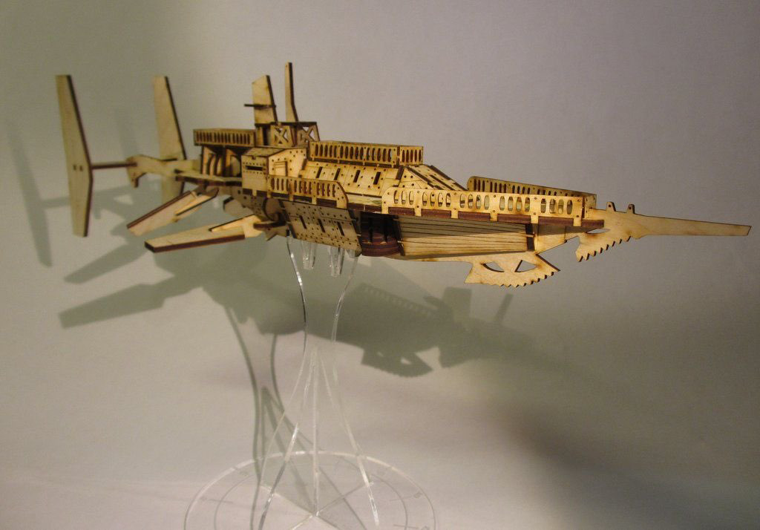
The original advertisement “Welcome aboard the luxury airship ‘R.M.S. Halcyon’ for her maiden voyage from Hong Kong to London. Enjoy fine dining on choice delicacies , dancing in the ballroom , and even a spot of gambling in our floating casino. Enjoy your luxury accommodations in our high quality suites with modern amenities to suit any traveler. Rub shoulders with the best people, knowing that only the best will be with you aboard. Feel secure that you and your valuables will be miles above the world and the lesser classes, safe within the upper Aether . Travel in luxury and comfort unheard of previously. Join us for an event not to be missed. “

Opening Scene: A Meeting in Secret
Players have been sent to speak to Ezekiel Fallon- Agent in Charge of the Office of Supernatural Oversight and In service to the crown.
A former British Military officer now charged with overseeing the rescue mission .
British Agent Ezekiel Fallon
o
The current situation in the Empire is dire. We are struggling with external and internal enemies. The situation we are currently working with in India, could not have come at a poorer time. Not only do we have the daughter of a prominent family, but also an extremely dangerous scientist and his research. I have asked you here because the number of people who I can trust has become questionable.
Professor Barnabas Whiting Has been Working on a device that can convert supernatural power to physical energy and destruction. Theoretically it could drain power from a thaumaturges spell, a Tao mages attack, or a creature imbued with power, such as a werewolf or vampire. The professor has been testing his theories in Hong Kong against the remnants of the Tao mages. Reports also suggest that he has been using his prototype against other supernatural entities in China.

It could be used for an almost limitless power source or the most destructive weapon ever created. Fortunately, the prototype was destroyed in an encounter with one of the Celestial Bureaucracy. But the professor has all of his notes and blueprints to build the next iteration. If this falls into the wrong hands, it could spell disaster for many innocent lives.
It is funded by the Bank of England through the influence of messrs. Lucas Tremaine, esq and Frederick L Hawk, and Lord Cuthbert Raymond Godolphin, 5th Duke of Bridgewater, Marquess of Brackley, Earl of Ellesmere, Baron Egerton.
In the aftermath of the 1857 and 1863 Sepoy insurrection the government attempted to make changes to the Indian army, as well as within the society as a whole. Unfortunately, elements within the government have taken advantage of the situation. The after effects of the magical mucking about with the South China Sea have been felt in British India. After severe monsoons at the end of 1865, nearly 200 million Indian civilians are living through an equally severe drought. The Indian army regiments have been used as support for finishing off the Tao pirates and exterminating the remaining elements of the Taiping Heavenly Kingdom. Additional conscription has been enforced, taking away from the manpower needed to save the remaining crops.

The government has remained unwilling to supply emergency foodstuffs to the beleaguered population and has instituted severe consequences for any protests or riots. They have instituted harsher famine codes then had been used in Ireland. This has led to the current situation. An element of the new Indian Army has been co-opted by Colonel Jwala Muzumdar. He took his regiment into hiding after killing their British advisers and all other Europeans associated with the units. It is believed by British intelligence that his force is in communication with the remnants of the Tao pirates and dispossessed elements of the Taiping Heavenly Kingdom. Notably , ZHONG YAN and Shào Yue are believed to be associated with this insurgency to get revenge for past harms.
Can be fluid as to how they decide to deal with the situation. They will still have surprise and can work that in their favor. They can also attempt to recruit from the locals ( and potentially the bandits) to increase their forces and level the numbers.
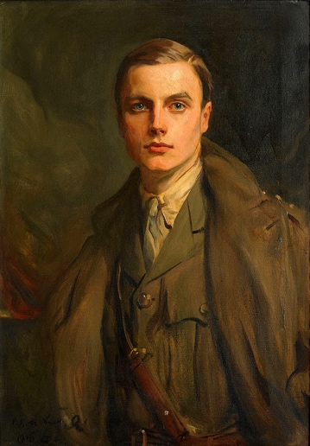
Captain Aleksandar ‘Jack ‘ Playfoot, local intelligence officer.

*Time will be given for any questions to be answered.

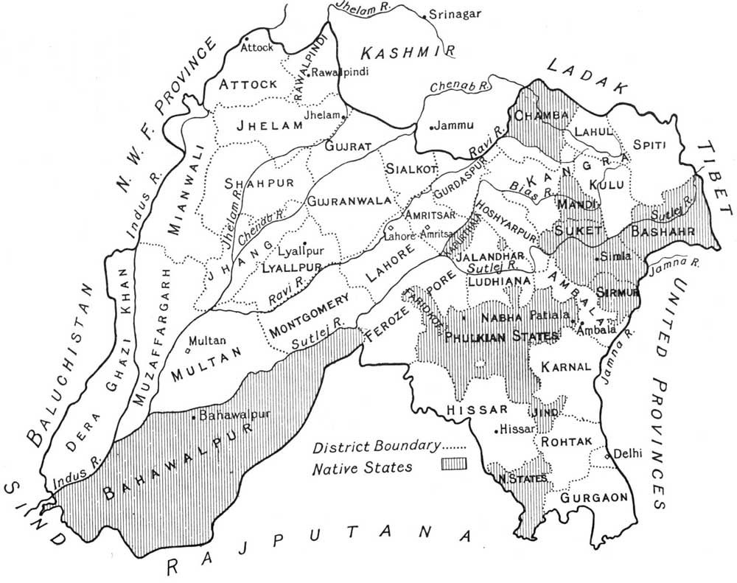

Scene 2: Airship crash location

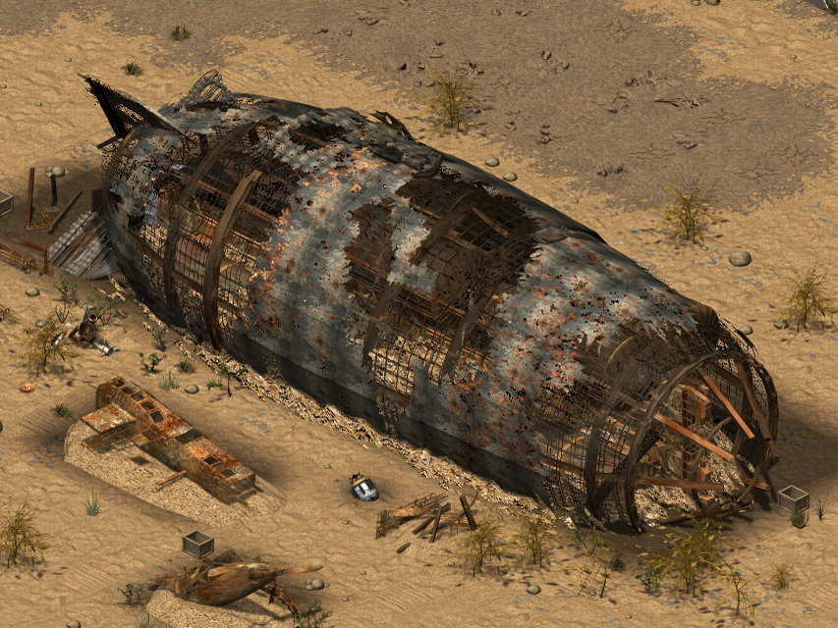

The characters will have some time to explore the location of the crash and to investigate as to the whereabouts of the persons of interest. Perception checks diff 25 will discover that only the bodies of some crew members are in the wreck and that the daughter and the inventor are missing. Befor they can follow an ambush by sepoys will occupy them.
Sepoy Leader: Mental competence: 10 Physical competence: 10 Init: 10+2d6
Health: 55/7 inc greatcoat
Skill picks: Perception (10) , Dodge (10), Intimidate (8)
Combat picks: Sabre(16) for 4d6+6 lethal, Pistol (15) 5d6 Lethal
Sepoy Soldiers with carbines : Mental competence: 6 Physical competence: 10 Init: 8+2d6
Health: 35/7 inc greatcoat
Skill picks: Perception (10)
Combat picks: Carbine (16) for 5d6 lethal, Bayonet (16) for 2d6 lethal
Sepoy Cavalry : Mental competence: 10 Physical competence: 10 Init: 10+2d6
Health: 65/10 inc Curiass
Skill picks: Perception (10) , Dodge (10), Intimidate (8), Ride (15)
Combat picks: Sabre(16) for 5d6+6 lethal, Pistol (15) 5d6 Lethal
Sepoy ambush

Map Key-For PCs
Yellow star-Command post.
Black arrow-artillery
Black lines -entrenched forces
Black circles-villages
Brown line-roads
Red arrow-direction of enemy force

Minor Event : Bandits
Reports come in of a group of bandits encamped nearby. They have no affiliation with either the imperial government or the Sepoys. They can be attacked and driven off or can be left alone, or even recruited.
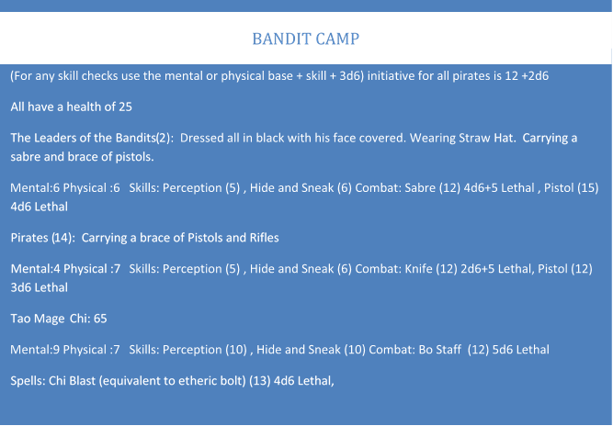

Scene 3: Sepoy Fortification

A perception check diff 20 or a track & scout roll diff 15 to follow the sepoy tracks to their fort.
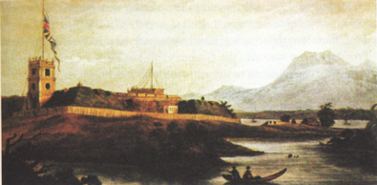

Scene 4: Decisions
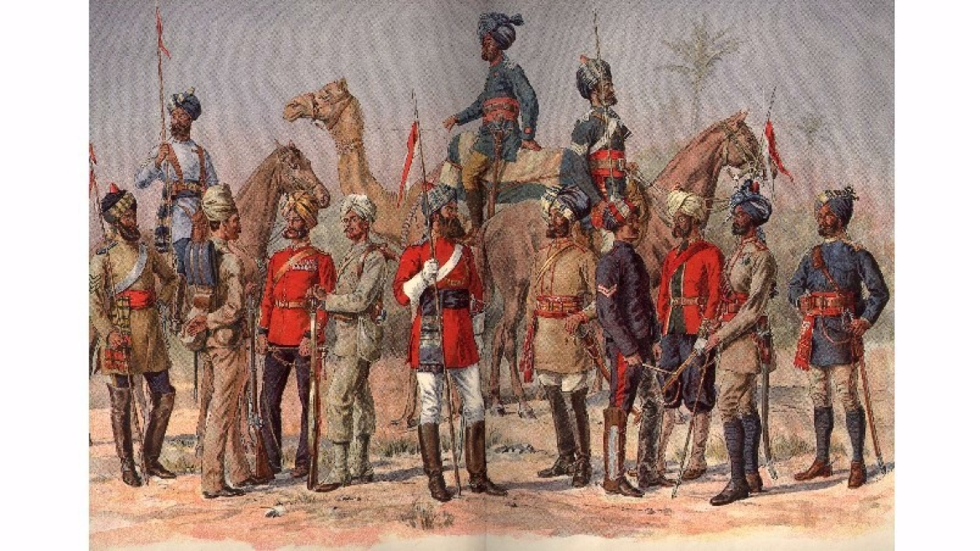
Inside the fort lie a majority of the sepoys in this area. It is a far superior force with this being the one with Prussian support. There are a few Tao Mages, but most are infantry.
*Allow the players to be creative with this challenge.

*In all the battles manipulate the number of enemies for something reasonable for the players to deal with. Unless of course they decide to attack the force unaided. A handful against 10,000 does not work well even for PCs.

Army Officer: Mental competence: 10 Physical competence: 10 Init: 10+2d6
Health:30/7 inc greatcoat
Skill picks: Perception (10) , Dodge (10), Intimidate (8) Bureaucracy (10)
Combat picks: Pistol (15) 3d6 Lethal,
army soldiers (10) : Mental competence: 6 Physical competence: 10 Init: 8+2d6
Health: 25/7 inc greatcoat
Skill picks: Perception (10) Feats of Strength (10)
Combat picks: Rifle (12) 5d6
Tao Mages Mental competence: 16 Physical competence: 6
Health: 15/7 inc greatcoat /magic protection 25
Skill picks: Thaumaturgy (16), occult (18), Necromancy (16), medicine (14), astronomy (16),
Combat picks: etheric bolt (18) for 4d lethal, etheric bludgeon (18) for 4d stun
*Special power: Can use a single Necromantic burst to raise all dead as Zombie to attack party.
Use physical competence and only attacks are either a bite (12) 2d6 lethal or bash (12) 5d6 stun
Health is set at 40 with 5 armour. (only use this if time permits and party is still strong)

Sepoy/Prussian/Tao mage forces

Scene 5: counter attack

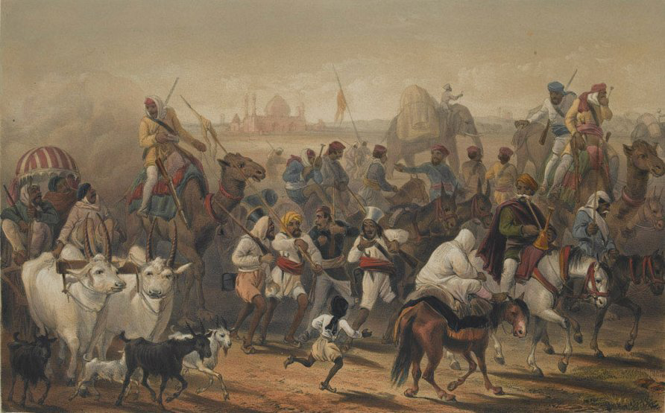

A force of Sepoys and Prussians have returned from raiding. Give the players a perception check diff 25 to get advance notice before they arrive. This could give them the option to set an ambush of their own or they could bull their way through this. It is open for creativity. It will go well until the Characters are recognized by Shao Yue and Zhong Yan.

Play this as a very action movie type scene. Try to make sure everyone can be involved (and should be involved as the opponents are dangerous). As this is the final battle have fun with it and get the players excited. Make sure the battle with the two main opponents is epic.

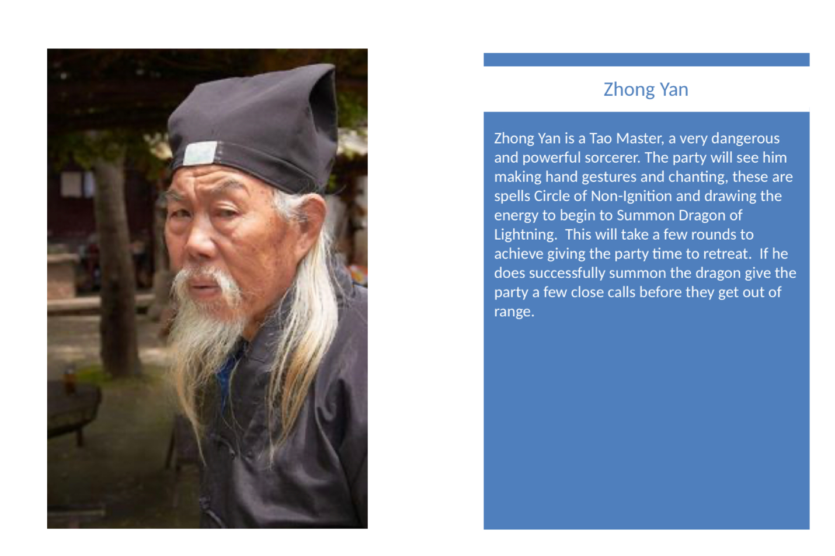
A well-known and feared pirate working the South China Sea near Hong Kong. Shao Yue is part of the Taiping Heavenly Kingdom which is in rebellion with the Qing Empire of China. She is deadly and feared pirate with a supposed fleet of over a hundred armed junks. She has been working this area for the past 5 years and has been a thorn in British side by her attacks on ships transporting opium, even going as far as to have the British ambassador to China captured.
Prussian Captain: Mental competence: 10 Physical competence: 10
Health: 55/7 inc greatcoat
Skill picks: Perception (10) , Dodge (10), Intimidate (8)
Combat picks: Sabre(16) for 4d6+6 lethal, Pistol (15) 5d6 Lethal
Prussian Soldiers with carbines: Mental competence: 6 Physical competence: 10
Health: 35/7 inc greatcoat
Skill picks: Perception (10)
Combat picks: Carbine (16) for 5d6 lethal
Prussian Soldier with Massive Hammer: Mental competence: 6 Physical competence: 16
Health: 55/15 inc greatcoat
Skill picks: Feats of Strength (16)
Combat picks: Massive Warhammer (16) for 6d+12 stun
Prussian Thaumatuge: Mental competence: 16 Physical competence: 6
Health: 15/7 inc greatcoat
Skill picks: Thaumaturgy (16), occult (18), chemistry (16), medicine (14), astronomy (16),
Research (16), linguistics (16)
Combat picks: Walking stick (6) for 3d+3 stun, etheric bolt (16) for 4d lethal, etheric bludgeon (16) for 4d stun,
power of steam (16), heal (16)Tao Mages (15) Chi: 65
Mental:9 Physical :7 Skills: Perception (10) , Hide and Sneak (10) Combat: Bo Staff (12) 5d6 Lethal
Spells: Chi Blast (equivalent to etheric bolt) (13) 4d6 Lethal,
Shao Yue. Mental competence: 16 Physical competence: 9
Health: 55/7 inc greatcoat
Skill picks: Perception (10) , Dodge (10), Intimidate (8)
Combat picks: Sabre(16) for 4d6+6 lethal, Pistol (15) 5d6 Lethal

Tao Mages, Prussians, and Sepoys

Scene 7: Aftermaths
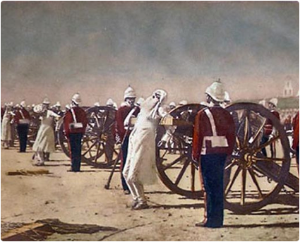
If successful the remnants of the Sepoys are captured and executed. Word of the defeat of the Prussians settles the growing turmoil in Europe with the Prussians fomenting discontent in secret. British operations and trade open up with the final defeat of the Tao Mages and the Taiping Heavenly Kingdom. The empire has much to thank the agents for. But trouble is brewing in Britain and they soon will force choices to be made.

