Blood and Iron: Madness in the Mountains

A Victorian Steampunk Scenario of Adventure and Intrigue using a variation of the Victoriana system.

“Not through speeches and majority decisions will the great questions of the day be decided... but by iron and blood.”
Otto Von Bismarck

Game by Dudley Martin

Game Blurb:
The year is 1863. The French are recovering from their loss to the Prussians. Britannian Intelligence has discovered a French plan for their defence. Information is scarce, but the Seers of the Thaumaturgical Academy have had dark premonitions. Both confirm that the premonitions and intelligence centre on a scientist working on a secret weapons project, Doctor Thaddeus Tober. You must infiltrate French territory and discover what is happening and return Dr. Tober to Britannian control. His secrets must not fall into the hands of anyone but the Empire. The fate of the Empire is once more in your hands. Are you ready?

Contents
Game Blurb: 2
System Basics 4
USING SKILLS 4
Characteristics 4
Effect and damage rolls 5
Combat: 5
INITIATIVE 5
What can I do as an action? 5
Melee & hand-to-hand attacks 6
Making the attack 6
Making the attack 6
Determining damage 6
ALL OUT DODGE 7
Taking cover 7
Diving for cover 7
EXPLOSIONS 7
Special Abilites 8
Sensate abilities 8
Miracles of Faith 8
THAUMATURGY SPELLS 9
Setting mood: 13
The Characters (For your information) 13
Opening Scene: Au Revoir Paris 14
Scene 2: As the Sun sets in Montou 19
Scene 3: A night on the Town 20
Encounter One: Interrupt French Patrol 21
Encounter Two: Interrupt French collecting ‘peasants’ 22
Encounter Three: I’ll Meet you at Midnight 23
24
Scene 4: Murders In The Rue Morgue 24
Scene 5: Welcome to the Lab 28
Scene 6: Here comes the Sun 30

System Basics

USING SKILLS
Whenever your character tries to do something (called taking an action), there’s always the question of whether he’ll succeed or fail. Sometimes the task is so easy that it’s obvious; for instance, taking a step forward without falling down. In those cases you’ll just tell the Gamemaster what you’re doing, and no die roll is needed. But if you’re trying to take a step on the deck of a ship pitching wildly in a driving rainstorm, walking might be very difficult indeed. That’s where task resolution comes in. All tasks in Victoriana are resolved with the same formula: take the relevant characteristic and add to it the relevant skill, then add the result of an action roll of 3d6 to create an ‘action total’. Compare your total to the difficulty of the task. If you equal or exceed the difficulty value, you succeed!

Characteristics
Intellect: for memory recall, problem solving, manipulating tools & instruments

Resolution: for the ability to face danger, fear, and stress

Presence: for interactions with others.

Dexterity: for fighting, dodging, athletics, driving, running, and swimming

Body: for using physical power, resisting pain, disease, shock

Your (characteristic + skill) + 3 dice in an action roll
Vs. The difficulty of the task
DIFFICULTY TABLE (for most rolls use an average difficulty. Use higher or lower depending on situation and action)
Easy | 10
Average | 14
Exasperating | 18
Really? | 22
Very | 26
Extremely | 30
Ridiculously | 34
Impossibly | 38

When you roll your action dice you may roll all sixes, if so then rejoice! This is known as a special success. In combat attacks this generally means that you double the damage done, in
other action rolls the gamemaster will tell you how your special success manifests. Adversely if your dice roll comes up with three 1’s then the attempt automatically failed, this is known as a foul failure.
Example: Mad Eric is fending off a footpad; it’s his turn to attack. He’s using a sword cane, so we add his dexterity 3 and swordplay 4 for a total of 7; the gamemaster tells Mike (Eric’s player)
that he will need to beat a difficulty of 22 to hit the thug. Mike makes his action roll and the dice
come up with a 2,4, and a 6. That’s a total of 19 – Eric Misses!

Effect and damage rolls
Effect rolls follow some action rolls; usually they represent damage done by weapons, or define the effects of a spell. You usually roll a set amount of effect dice and add the results together, just like an action roll. The difference to action rolls is that there are no skill or characteristic
bonuses to effect rolls Once rolled add the results together, this is the effect total, or damage roll as it is often known.

Combat:

INITIATIVE
At the beginning of each round, each character rolls 2 dice and adds their initiative characteristic in an action roll. The character with the highest total acts first for that round
(they are also allowed to hold their action and act later in the round). The character
with the next highest total acts next and so on. Roll an additional die to break ties; high
number goes first.

What can I do as an action?
You can do one thing with each action. In its simplest terms if there is a dice roll required it counts as an action. This
could include:
Combat Actions...
Draw a weapon
Make a single melee attack
Make a single ranged attack
Throw a stone or bomb
Move up to your full combat movement
Non-combat actions…
Make a small speech to intimidate or impress
Perform an athletics feat, such as leaping, or breaking down a door.
Cast a spell
Command an embodiment
Invoke a demon
Maintaining a spell with a concentration roll
Untying a captive
Opening a closed but unlocked door
Get up after being knocked prone
Each one of these things would be considered a single action.

Melee & hand-to-hand attacks
Melee represents up close and personal duels and brawls, opponents might be using swords, clubs, chair legs, frying pans, fists, feet, and perhaps even skill.

As a general rule melee range is considered to be 4yds, the typical reach of an adult arm and a
sword. If you want to start a fight you have to be at least this close.

Making the attack
An opposed action roll between the attacker and defender represents melee combat.
The attacker combines his dexterity, an appropriate weapon skill and an action
roll. He may also have to add or subtract certain modifiers from this action total to
determine the final outcome. The defender combines his dexterity, his dodge! Skill and the result of an action roll, the defender might also have modifiers to his roll before obtaining a final total. The final totals are compared, if the attacker has the higher score then he hit, and
should roll damage, if the defender has the highest total then he evaded the attack – this time. In the event of a tie, the defender always evades.

Making the attack
Unlike melee combat, ranged combat is an unopposed action roll by the attacker against a target number defined by range and possibly a modifier from all out dodge! Attempts.
The attacker combines his dexterity, the appropriate weapon skill and an action
roll. The action total is compared to the difficulty as defined by the range if you equal
or exceed the difficulty of the shot you hit and roll damage.

RANGE & DIFFICULTY TO HIT
Range | Difficulty
Point blank (4yds or less) | 10
Close (10yds or less) | 14
Medium (50yds or less) | 18
Long (out to listed range of weapon) | 22
Extreme (beyond listed range) | 26
+ 2 per + 100yds

(It is suggested that for ease of con play that all rates of fire be limited to 1 or 2)

Determining damage
Once you have made a successful attack the next step is to determine the amount of damage your attack has done to your opponent. Damage rolls are effect rolls, and are dealt with as follows. The weapon used dictates the amount of damage you will do. Few people died from gunshots in this era, most died from infections in the wound days or weeks later. Once you have determined the amount of damage dice to be rolled, roll them and add the results together, this is your damage total. Every character or creature in Victoriana has a fortitude characteristic, some will also possess armour, whether worn or as a natural feature. The defender subtracts
both his fortitude rating, and the rating of any armour he is wearing from the damage
total, the rest is applied to his health scores.

ALL OUT DODGE
Use this action to make yourself harder to hit. As your first action you declare an all out dodge,
and in your initiative order for the first action you make a complementary roll on dexterity + dodge! With a difficulty of 14. The result of this complementary roll is added to each of your automatic defence rolls for that round. See complementary skills in the skills section for more information.

Taking cover
If you don’t want to waste an action racing around to facilitate an all out dodge, you can try
to take cover. By using the environment around you such as trees, walls, and even furniture, you can reduce your opponent’s chances of hitting you in ranged combat, see the modifiers section for examples. You cannot take cover from the environment in melee combat; you and your opponent are too closely engaged to be able to do so, but you can use portable items such as furniture as improvised shields if your gamemaster allows.

Diving for cover
This variant of all out dodge can be used to avoid sudden and unexpected area effect attacks such as explosions and some spells. You make an action roll using athletics against a difficulty based on the distance (base of 14 for 1yd + 1 difficulty for every extra 1yd). If the roll is failed, you didn’t dodge fast and/or far enough and were caught by the attack effects. Diving for cover is usually a free action and once performed is the last action of the round for that character as he then picks himself up from the debris. However a character with enough foresight (or paranoia) can specify diving for cover as an action (just in case), and
characters who do so may then continue to act in the round as normal.

EXPLOSIONS
Attacks that strike an area rather than a character (bombs, grenades, gas and other effects) are known as area effect attacks. The area affected depends on the damage dice of the attack being used, typically this is a 1 yard radius per damage dice of the weapon, and will always be described as part of its description or construction. The outcome of area effect attacks is determined by each defender in the area defending against a single attack total by diving for cover; those who fail take damage. Ground zero of an explosion or area effect takes the full damage of the attack, characters take 2 less points of damage for every yard they are away from the centre of the attack. Character who are outside the area of effect, take no damage at
all.

ENVIRONMENTAL INTENSITIES
Type | Mild | Intense | Deadly
Damage | 1-4 dice | 5-10 dice | 11-20 dice
Electricity | Battery | Generator | Lightning bolt
Illness | Measles | Cholera | Plague
Drug | Alcohol | Opium | Cocaine
Poison | Belladonna | Arsenic | Stonefish venom
Fire | Wood fire | Gas fire | Chemical fire

Special Abilites

Sensate abilities
Sensates have a strong connection to the natural world, and their gifts reflect their super sensitive
nature allowing them to see what others do not.
Ability Difficulty Description
Aura reading 14 A successful medium + presence roll allows the medium
to gauge the mood, temper & intentions of the observed
person. Aura reading is only applied to individuals, not
to groups. One aura reading can be conducted with one
action.
Glimpse 26 By using this power the medium is hit with a powerful
and vivid vision of an event that is due to happen. The
medium has little control over what he sees (you cant try to
see the outcome of this years grand national), but you can
be confident that it is imminent, certainly within the next
week.
Know recent events 22 A successful action roll grants knowledge of recent events
occurring around the person or object being studied. The
nature of the knowledge gleaned from such an observation
is often incomplete and fragmented, often, information is
only trivial and not of obvious use.
Magic sense 18 The games master makes this roll whenever the character
comes within 10 yards of a spell effect; focus, magical
artefact or sorcerer. Magical creatures such as demons are
not detected by this ability. With success the character is
aware of a tingling sensation down the spine, warning the
character of magical presence. An excellent success might
yield information concerning the nature of the magical
presence.
Psychometry 22 The ability to gain information concerning an individual
from their personal effects. Information accessible usually
relates to the individual’s present welfare or location, but
information about the recent well being and transitions of
the items owner may also be gleaned.
Sense the supernatural 14 The medium can sense supernatural beings such as
demons, ghosts and the invisible within 10 yards. Exact
location cannot be discerned, although a good idea of
direction is furnished.
Sixth sense 14 An uncanny & instinctive knowledge of events around the
corner. With use of this ability a medium may finish the
sentences of others. Also sixth sense may be used to avoid

Miracles of Faith
Ability Difficulty Description
Heal 18 The medium can call upon the mercy of heaven
to heal a deadly wound or disease. Heals 3d6 points of damage completely.

THAUMATURGY SPELLS
Botheration
Resolve cost: 1 (18)
Range: touch
Duration: rounds
Once cast the target must be touched, and a opposed roll between resolution
+ thaumaturgy and resolution + concentration ensues. If successful the target
becomes totally confused. A bothered target cannot concentrate on even
simple tasks, represented by a –6 action roll modifier.
Darkness of ages
Resolve cost: 2 (22)
Range: 20 yds
Duration: minutes
Creates a billowing black cloud of absolute darkness. From outside the spells
5 yard radius the cloud appears to be thick roiling smoke. From within there
is absolute darkness, with no suggestion of smoke or a gas of any kind.
Ectoplasmic bonds
Resolve cost: 4 (24)
Range: 40 yds
Duration: hours
Tendrils of Ectoplasmic slime materialise to ensnare the target of this spell.
The bonds may stick a target to a surface such as a wall, floor or ceiling.
Breaking free from the slime requires a body + athletics (32) roll. Winning
breaks free, losing remains entangled. After 2 hours the slime starts to lose
coherence, and the difficulty drops by 4 each half hour from that point until
the end of the duration.
Farspeech
Resolve cost: 1 (20)
Range: sight
Duration: instant
This spell allows whispered conversation to be passed as far as the
eye can see. As long as the target can be seen they can hear the
caster’s words. This spell does not grant two-way communications.

Etheric bolt
Resolve cost: 4 (24)
Range: 20 yds
Duration: instant
Upon completion of the spell, an etheric bolt of green energy forms
around the casters hand, which may then be fired with dexterity + thaumaturgy
in the same manner as mundane ranged attacks. The bolt does
4 dice of lethal damage. Etheric bolt is not resisted with resolution; the
rules for dodging ranged attacks apply. One casting provides one bolt.
Etheric bludgeon
Resolve cost: 2 (22)
Range: 20 yds
Duration: instant
Upon completion of the spell, a pale bolt of energy forms around the
casters hand, which may then be fired with dexterity + thaumaturgy in
the same manner as mundane ranged attacks. The bolt does 4 dice of stun
damage. The bolt is not resisted with resolution; the rules for dodging
ranged attacks apply. One casting provides one bolt.
Firespark
Resolve cost: 1 (20)
Range: self
Duration: instant
A small gas flame appears from the finger or thumb of the caster. The
flame lasts several seconds and is sufficient to light a pipe, cigarette,
lamp, candle or fire.
Etheric barrage
Resolve cost: 6* (26)
Range: 100 yds
Duration: rounds
This spell channels energy around the sorcerer and then through him into
a seething stream of fire, which may then be fired with dexterity + thaumaturgy
in the same manner as mundane ranged attacks. The caster can
throw any amount of barrages from one casting, but each bolt after the
first costs an additional 2 resolve. Should the Thaumaturge foul with any
roll when using this spell, the caster will suffer a full strength barrage hit
himself.
Each barrage does 6 dice of lethal damage. Barrages are not resisted with
resolution; the rules for dodging ranged attacks apply. One casting provides
unlimited bolts for the duration.

Flight of the wyvern
Resolve cost: 3 (22)
Range: self
Duration: minutes
The caster can command ethereal forces to counterbalance the forces of
gravity, thereby granting the power of flight. The caster gains a flying
combat speed of 16 yards/round. As the air is not a native element to
mankind, flight is slow and unsteady at first, with manoeuvres relying on
intellect alone. Frequent flyers however, may study the speciality: flight
skill.
Levitate
Resolve cost: 2 (20)
Range: 10 yds
Duration: rounds
The caster can command ethereal forces to counterbalance the forces
of gravity, allowing the levitation of himself, or other persons and
objects. No object may be raised higher that 6 yards from the ground,
and no more objects than the casters intellect may be raised at one time.
Levitation simply moves objects upwards; it confers no further movement
ability.
Gaslight
Resolve cost: 1 (18)
Range: 4 yds
Duration: minutes
Creates a small
ball of light in
the caster’s hand.
The light has the
power of a good
gas lamp and illuminates
approx
5 yards radius.
The ball can float
and may be mentally
directed by
the caster to any
position within
range.

Groom
Resolve cost: 1 (18)
Range: self
Duration: instant
This spell washes, refreshes, oils and combs hair, trims the moustache,
even dusts down and presses the caster’s clothes. Observers will see
the caster improving in appearance as if tended to by invisible hands,
with creases and folds in clothing ironing out while still worn.
Hair of the dog
Resolve cost: 2 (26)
Range: touch
Duration: hours
The caster must incant the formula to this spell loudly in Latin, upon
completion all the targets hangover symptoms are gone. The spell expels
headache, dizziness, lethargy, curried eyes, and bowel trouble. Note that
none of the above symptoms can be dispelled unless they are symptoms
of a hangover.
Heal
Resolve cost: 4 (22)
Range: touch
Duration: instant
This spell instantly knits flesh and dispels infection, healing 4d6 health.
The application of this spell has made the guild renowned as miracle
healers. Diseases cannot be treated with heal, they must be treated with
cure
Cure
Resolve cost: 6 (26)
Range: touch
Duration: instant
This spell instantly cleanses the target of any resident diseases or infections
that might be afflicting them. Poisons and physical wounds cannot
be treated with cure.
Instant beauty
Resolve cost: 2 (22)
Range: touch
Duration: hours
Increases the desirability of the recipient. No discernible change occurs, but others find the recipient attractive anyway, possibly being puzzled as to why. Presence increases by 2 for the duration.

Magic tobacconist
Resolve cost: 1 (18)
Range: self
Duration: instant
Allows the caster to magically produce a fine cigar or cigarette.
Alternatively the spell might be used to magically fill a pipe bowl.
Power of steam
Resolve cost: 3 (22)
Range: touch
Duration: minutes
The caster may confer the motive power of a steam train into a vehicle. When travelling in such a manner multi hued steam pours from the vehicle, often obscuring sight (-2 to driving rolls).
If applied to a person, their running speed is doubled and they gain +2 body. However, they also go bright red as magical steam gushes from ears, mouth, nose and through the seams of clothing. Living creatures take 1d6 stun each minute as a result of the unnatural exertions the body undergoes in this state.
Scholar’s guard
Resolve cost: 1 (20)
Range: touch
Duration: hours
The caster traces an imaginary perimeter with pointed finger. The perimeter may be up to 3 yards radius. Anything stepping through the perimeter sets off a magical alarm. The nature of the highly audible alarm is left to the caster.
Second sight
Resolve cost: 2 (20)
Range: self
Duration: rounds
Allows the caster to see supernatural effects clearly. Such phenomena include: possessing demons appear as if fully manifested through second sight. Spells effects appear as glowing energy and their nature may be discerned with scrutinise rolls. Creatures such as ghosts are always visible through second sight. While second sight is active, mundane sight is dim and darkened – all perception tests relating to the mundane world are at –4 modifier.

Spyglass eyes
Resolve cost: 1 (20)
Range: self
Duration: minutes
Allows the caster to see with up to x20 magnification, as if using a powerful
spyglass. The spyglass effect may be turned on or off during the
duration.
Steely skin
Resolve cost: 5 (24)
Range: touch
Duration: minutes
The spell weaves an invisible shroud of magical energy about the recipient,
granting an armour value of 10, which is added to any other armour worn.
The emperor’s new spell
Resolve cost: 4 (24)
Range: self
Duration: minutes
Renders the caster totallyinvisible to normal sight. Some creatures and use
of second sight spell will detect the caster. The spell will only render the body
invisible, clothes and items are not invisible unless swallowed or otherwise
enclosed in a body cavity.
True door
Resolve cost: 2 (20)
Range: touch
Duration: hours
This spell is cast upon a portal such as a door, window, box lid or other such scalable opening. The magic of the spell permeates the material of the portal and knits it together with strong, magic glue. The portal can no longer be opened normally, and must be forced.

Setting mood:
This game takes place during a time of change and growth. In this world the British Empire is expanding with the aid of steam power.
The gap between rich and poor is even more pronounced and should be played up. The rich will be light, airy, and clean, while the poor will be dark, dingy and filled with sooty smoke. Poverty abounds and the chances for advancement are not possible, while the upper classes live well beyond their means and utilize the poor as stepping stones to fame and fortune.
This game is all about the story and letting the players become part of that story. Encourage the players to describe their actions and to get into character with their roles. The story is loosely described, but should not be held to strictly. Allow the players to be inventive and if that leads them in different directions use the information here to modify the game and lay to that direction.
Above all have fun.
(For ease of the scenario assume all characters can speak some basic German and French)
*Fill in any dialogue with NPCs as needed using the information provided.

The Characters (For your information)
Hawkeye: An archer extraordinaire. He can hit a half pence piece from half a mile away. He is a loner and doesn’t bathe much, but is a deadly shot.
Alexander D'Amberville: A high class thief and martial artist.
Amelia Carradine: A high class thief, thaumaturge and book lover.
Diana Lann: An excellent if a bit angry engineer.
Ezra Deegan: A smuggler and owner of his own airship.
Elizabeth Riley: A revolutionary and explosives expert.
Dalia Wolhaus: A young Medium/Enchanteress
Rev: A Reverend who solves problems with his fists and his God.

Opening Scene: Au Revoir Paris
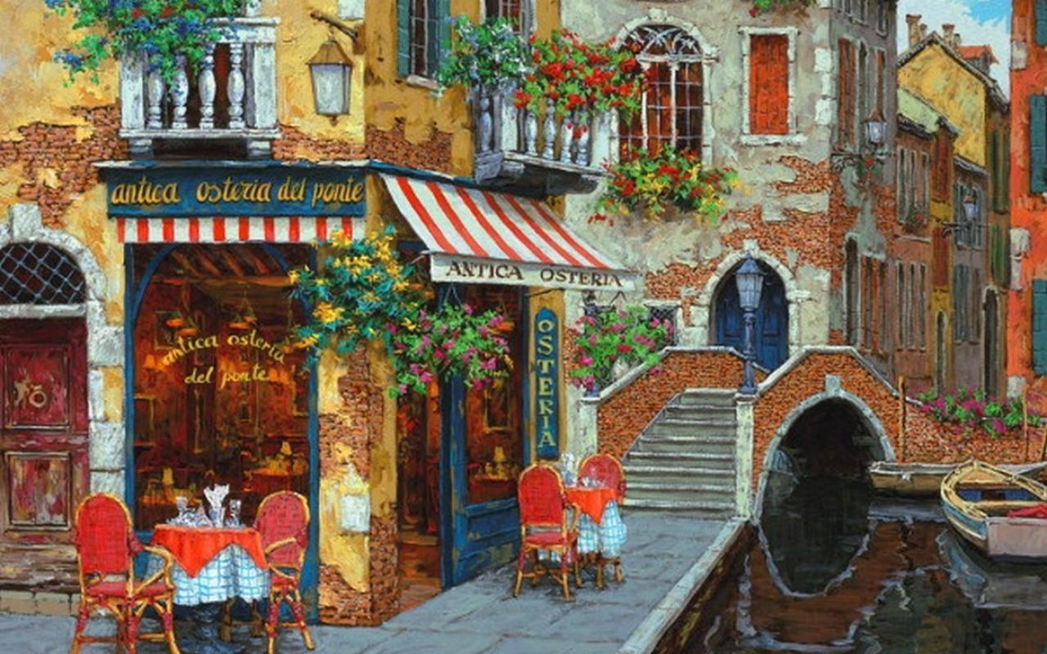
‘You have been enjoying some nice rest and relaxation in Paris after the destruction of the Prussian Command ship and stopping the plots of the Prussian Thaumaturges. It has been four weeks since you were last called upon to defend the Empire. Since then the situation has been quiet as the Prussians have not caused any trouble and the French have been rebuilding their fleet and army. French society is stirring as conscription is full force and industry is trying to meet the military requirements required to defend the nation in the modern age. Brittannia has been observing both sides, and at the request of the French have moved back to British soil. All is peaceful, but you know better than to relax too much. Trouble has to be brewing under the surface.’
The party is relaxing at a small café in Paris. The wine if flowing and there is music and all in all great enjoyment. In the midst of this a cloaked figure moves through the crowd (intelligence + perception diff 20 to see) to stand beside the players table. Once the players notice they can attempt to speak with them, but the noise level will make it very difficult. They have the option of stepping outside or of using a backroom. Either way they will learn that the cloaked person is Michelle Whelan, a spy for Britannia.
Michelle has been working deep cover in France for the past few years, under the codename of the Dove. She has kept track of French military movements as well as Prussian expansions and involvements. She has the ear of many highly placed French officials. Her information is known to be highly important and well supported. She is a skilled and well trained operative. She cannot be moved by players charm/bull*/or seduction. She is skilled with a pistol and at hand to hand combat.
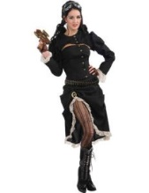
Michelle Whelan

She begins by speaking French, but when she is alone with the party she switches to English. ‘All right chaps, seems we have a bit of a situation. Just got word of some strange things going on in the southwest town of Montou. HQ has the Thaumaturgical Academy looking into it. You chaps are the closest agents, so we need you to investigate. HQ says they will get you more info as you travel there.’
She slides an envelope to them ‘here is a thousand francs for fuel and supplies. I suggest you dress warm as Montou is in the mountains. All the best chaps.’

*With some research or asking about Montou the players can find the following information: (roll presence+bull*/impress/charm diff 15 to get some of the following information)
- Village is isolated, only connected by infrequent airships and by poor roads. But airship service has increased greatly over the past 2 weeks.
- Small population of 15 families. Not many services available. There is an Inn/Tavern, The Whispering Pickle in the town with a few beds and decent ale and local produced pickled produce.
- The basic layout of the village (see picture in next section) with reports of a tower with wires near an isolated house as well as a small area cleared for airship landing.
- The fastest way to get there is by airship. The roads are in poor shape currently. Supplies of food and daily goods would be well received.
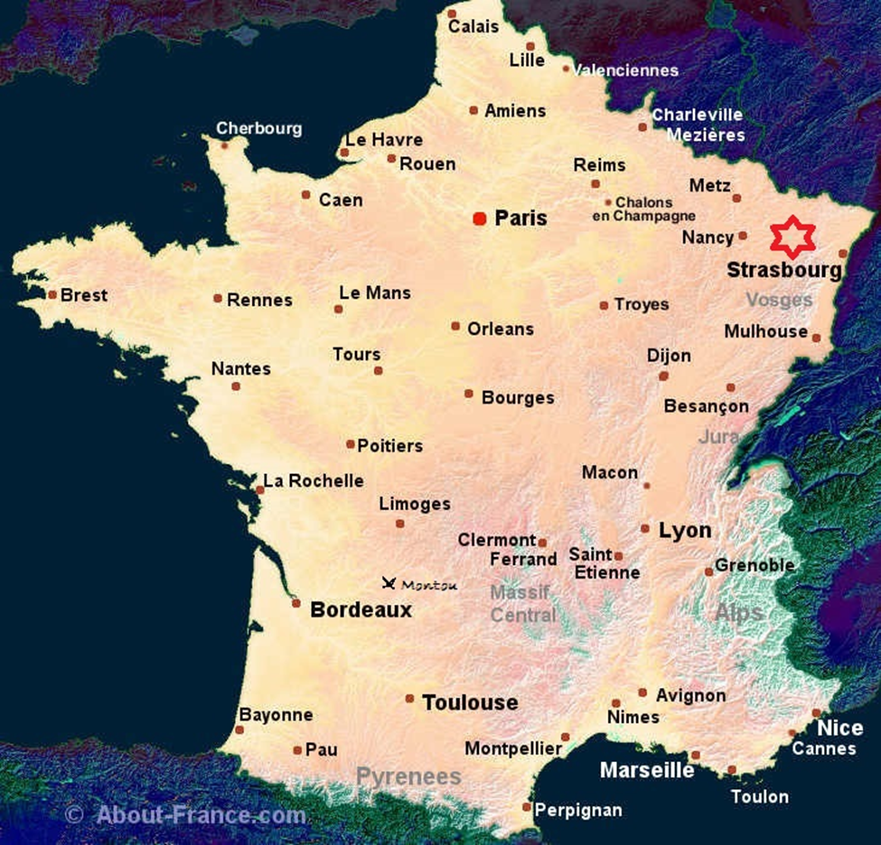
Map of France showing location of village

Scene 2: As the Sun sets in Montou
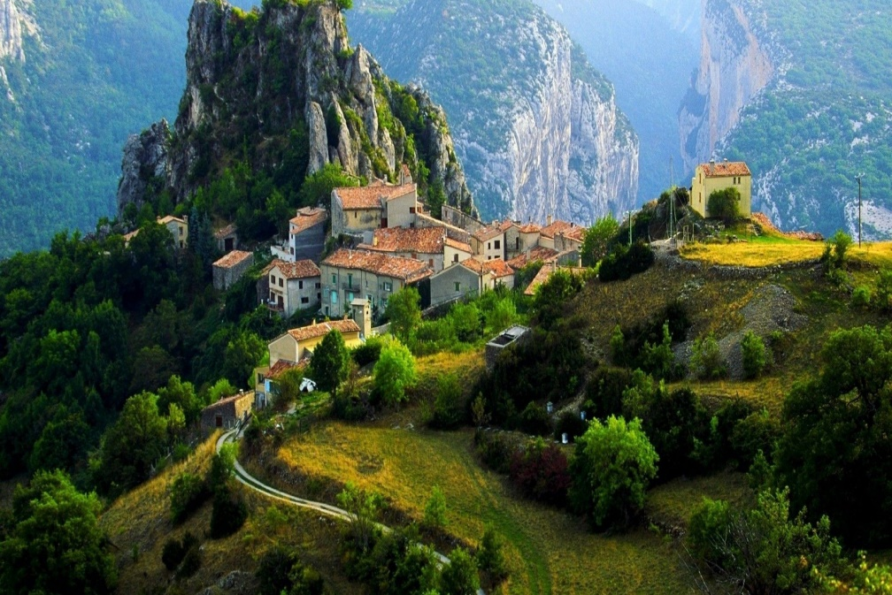

The party arrives in Montou just before sundown. The little village lies quietly in the hills and no modern lights are seen save for the house by the Airship field. There is evidence of some houses having fires, but the streets are becoming empty as people seem to be rushing about and getting indoors. As they do so they are barring their doors and closing their windows behind solid wooden shutters.
If any of the townspeople are spoken to they will be told to hurry to the Inn before full darkness falls.
If they hurry they will make it into the Inn before the doors and windows and sealed. There is an Innkeeper behind the bar, a weary looking woman serving a table of four labourers, and a wizened old man at a table in the corner sipping on a large mug of some steaming drink. As soon as they enter they are met with the smell of ale, pickles and roasting meat and vegetables (have the players roll intelligence+perception diff 25 to detect that there is something else beneath these smells coming from outside).
There are few choices of tables available. There is one in the centre of the tavern and the other just to the side of the front entrance. The innkeeper motions for them to seat themselves and as soon as they do the woman comes over and asks what they want.
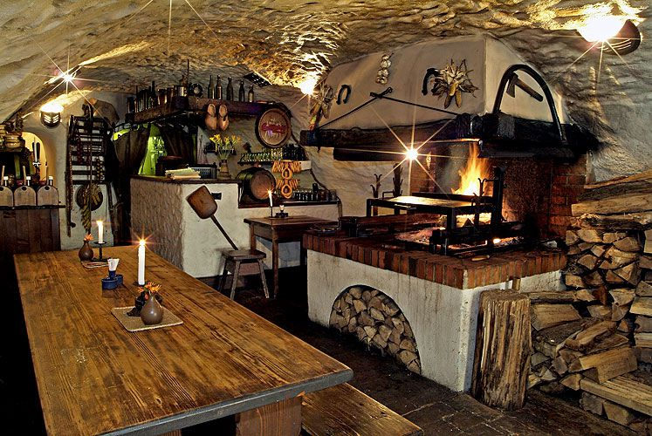
They have a fresh roast mutton with local vegetables, a bit of potato soup and some fresh bread to eat. To drink they have a cask of local ale, some cider, some weak beer and a few bottles of brandy and whiskey (these will be far more expensive.)
Another intelligence+perception/human perception diff 20/15, will gain the knowledge that the Innkeeper and the woman are fearful, glancing quite often to the door and windows. This is much lesser in the other patrons, but they seem to be working to avoid looking, making it a bit more obvious.
The innkeeper (Phillipe) and the woman (his wife Marie) are an older couple in their 50s. They are afraid of the soldiers and the ‘strange’ people that walk around after curfew. If pressed (through any number of means) to talk they will tell the party about the loss of their son a week ago. He was out late with his friends and on the way home went missing. Marie will break down into tears and say that she looked out the window a few days ago and thought she saw him stumbling drunk around town. She tried to go out to him but was stopped by Phillipe before the French patrols caught them out after curfew.
If they speak with the old man (Baxton) he will whisper to them that strange things are happening in the town. If questioned about the atmosphere and locked doors he will say that it is due to curfew the soldiers have put in place and that it all due to ‘that man in the chateau.’
The laborours are from out of town and are here to shore up the airfield. They are unnerved by the town and the curfew. They were promised good pay and good conditions when they were brought here. They have a feeling that something is going on, but are not sure what. They have heard that some townspeople have disappeared over the past week, but find it odd that no one is looking into it.

Scene 3: A night on the Town
Most likely the party will decide to head out to investigate the town. There are three events that will occur, you may choose the order of these events as you see fit.

The party will have rooms on the first floor. The windows open easily enough and there is a trellis that can be climbed down to the alley by the Inn. It is a good vantage to see the patrols and zombies when they are close and plan from there.

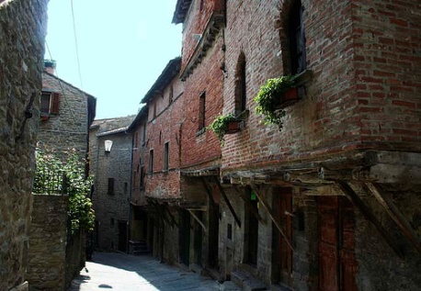

Encounter One: Interrupt French Patrol
As the party explores the quiet streets of Montou, have them roll perception (diff 12) to see the French patrol looking through the village , checking doors and windows that they are securely locked. It is a group of 6 soldiers, 1 captain and a sergeant.
French Officer: Mental competence: 10 Physical competence: 10 Init: 10+2d6
Health: 55/7 inc greatcoat
Skill picks: Perception (10) , Dodge (10), Intimidate (8)
Combat picks: Sabre(16) for 4d6+6 lethal, Pistol (15) 5d6 Lethal
French Soldiers with Rifles (6) : Mental competence: 6 Physical competence: 10 Init: 8+2d6
Health: 35/7 inc greatcoat
Skill picks: Perception (10)
Combat picks: Carbine (16) for 5d6 lethal
French Sergeant: Mental competence: 8 Physical competence: 12 Init: 8+2d6+2
Health: 35/7 inc greatcoat
Skill picks: Perception (10) Dodge (10), Intimidate (10)
Combat picks: Carbine (18) for 5d6 lethal, Dagger 2d6+6 lethal
Possible Loot: Orders to secure the village and to protect the villagers. They are to enforce a nightly curfew and to keep people away from the chateau. They are also to follow any orders given by Dr. Tobber.
French Patrol

Encounter Two: Interrupt French collecting ‘peasants’
As the party explores the village, have them roll perception (diff 12) to see the French patrol corralling some ‘villagers’ into heavy caged carriage. The party can attempt to stop them or they can observe and follow them to the chateau. This is a larger group and should be taken on carefully. There is one French officer, one sergeant and 12 soldiers. They are preoccupied with the 5 zombies that they are trying to recover.
French Officer: Mental competence: 10 Physical competence: 10 Init: 10+2d6
Health: 55/7 inc greatcoat
Skill picks: Perception (10) , Dodge (10), Intimidate (8)
Combat picks: Sabre(16) for 4d6+6 lethal, Pistol (15) 5d6 Lethal
French Soldiers with rifles (12) : Mental competence: 6 Physical competence: 10 Init: 8+2d6
Health: 35/7 inc greatcoat
Skill picks: Perception (10)
Combat picks: Carbine (16) for 5d6 lethal
French Sergeant : Mental competence: 8 Physical competence: 12 Init: 8+2d6+2
Health: 35/7 inc greatcoat
Skill picks: Perception (10) Dodge (10), Intimidate (10)
Combat picks: Carbine (18) for 5d6 lethal, Dagger 2d6+6 lethal
Possible Loot: Orders to secure the village and to collect the study subjects. They are to enforce a nightly curfew and to keep people away from the chateau. They are also to follow any orders given by Dr. Tobber.
*If the party interferes, the zombies will take the opportunity and attack everyone.*
Zombie (5) Mental competence: 8 Physical competence: 12
Health: 30/6 Skill picks: Tracker (12), perception (14), scrutinise via hearing (12)
Combat picks: Smash (10) 4d6 lethal , plus a bite attack (10) for 2d6+6
French Collectors

Encounter Three: I’ll Meet you at Midnight
As the party explores the village, have them roll perception (diff 15) to see a group of Prussians staggering down the street. (Suggest that it looks like a drunken group). As the party gets closer they can make another perception roll (diff 15) to catch a whiff of death coming off them and if any make the roll over 25 they can spot the dark stains of wounds on the uniforms. If they do not make any noise and succeed on a hide & sneak roll (diff 15) they can either avoid the encounter or follow the group as it shambles back to the Chateau.

Zombie Soldiers (5) Mental competence: 8 Physical competence: 12
Health: 30/6 Skill picks: Tracker (12), perception (14), scrutinise via hearing (12)
Combat picks: Sabre (10) 4d6 lethal
, plus a bite attack (10) for 2d6+6
Zombie Soldiers

Dr. Tobber is a brilliant scientist who is attempting to help the French government prepare for another attack by Prussia. They have been transporting in the bodies of the dead taken from battlefields across France for the ‘good’ doctor to experiment on. He has perfected a serum that will return the semblance of unlife to a corpse. They do not show any signs of human intellect but are instinctual hunters and can be given simple orders. He is working on expanding the time limit which the serum is effective for (currently 2 hours). Note he will not come quietly and if pressed will order his zombies and guards to attack. While this is going on he will attempt to esacpe.
Dr Thaddeus Tobber

Scene 4: Murders In The Rue Morgue

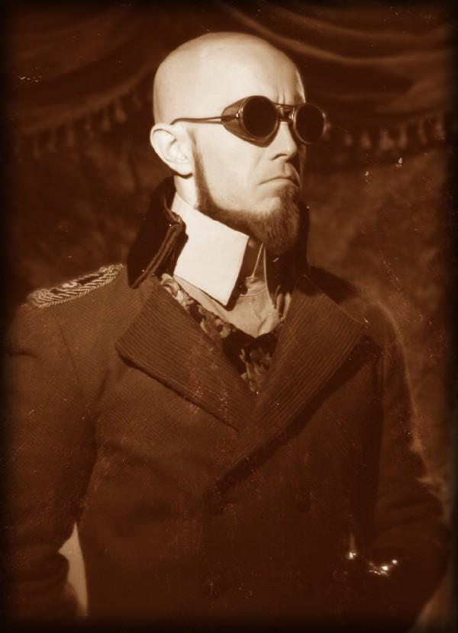
From a distance the party can view the Chateau on a rocky outcrop by a river. It is an isolated position and they can see the line of shambling zombies returning to a strange greenish light cast by a lantern being held in the doorway of an outbuilding of the chateau.
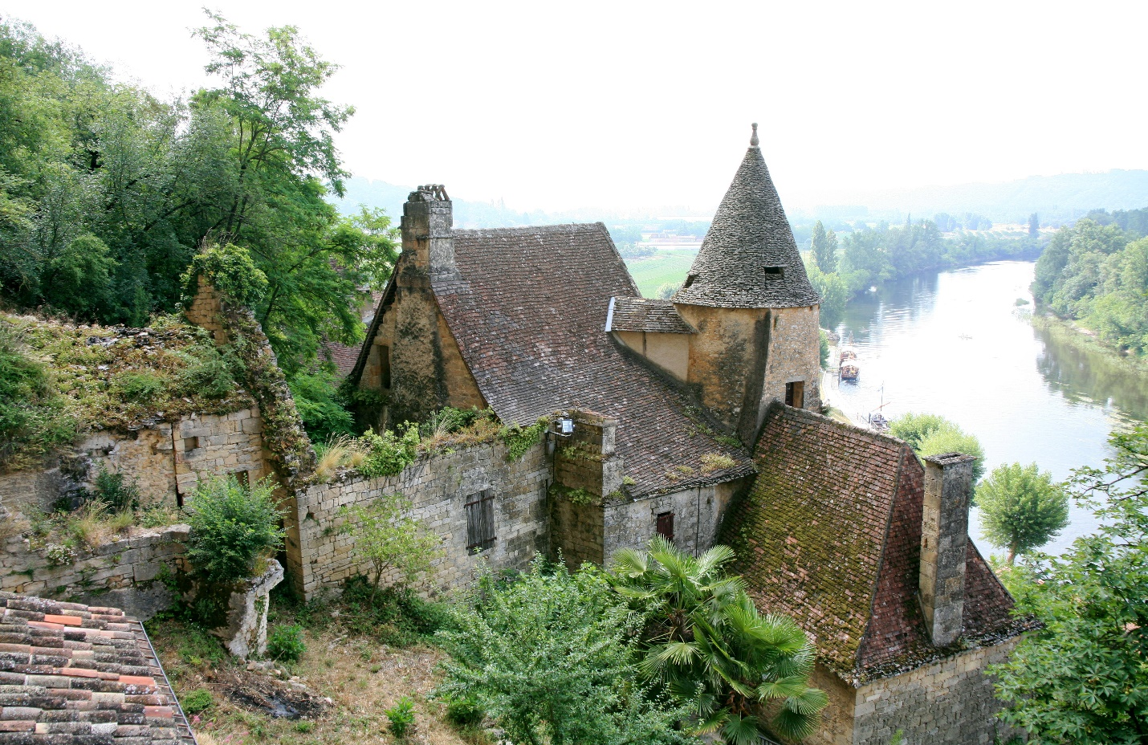
As the party moves closer to the Chateau they spot Dr. Tobber leading a group of zombies (25) into a stone building. With a perception check (diff 20) they can make out the French defence forces in positons around the entrance to the Chateau. There a few ways this can go:
- The party attacks. Use the stats below for the zombies and French defence forces. Dr. Tobber will escape into the dungeon.
- The party will let the zombies enter the dungeon and then deal with the French forces. Use the stats below for the defenders. Try to make the characters describe their actions. Play this with as much of an action movie feel as you can manage.
- The party sneaks around and finds the hidden entrance to the chateau.
- If they come up with something else, roll with it (if it seems viable).
After these move to the next part…

This mass of undead soldiers moves forward emitting moans and reaching for the party. They will reach the characters in groups of 7 with an additional 5 arriving every round until all are disabled or destroyed.
Fortified Zombie Soldiers (25) Mental competence: 8 Physical competence: 12
Health: 60/16 Skill picks: Tracker (12), perception (14), scrutinise via hearing (12)
Combat picks: Sabre (10) 4d6 lethal
, plus a bite attack (10) for 2d6+6
*Give a roll of 10+3d6 diff 25 to resist any attempts to use faith to harm.*
Zombie Horde

Scene 5: Into the Chateau
The French are in positons around the party, they will attempt to pin them down and let the zombies finish them. They will not shoot to kill unless they are shot at or all the zombies are destroyed.

French Officer: Mental competence: 10 Physical competence: 10 Init: 10+2d6
Health: 55/7 inc greatcoat
Skill picks: Perception (10) , Dodge (10), Intimidate (8)
Combat picks: Sabre(16) for 4d6+6 lethal, Pistol (15) 5d6 Lethal
French Soldiers with rifles (12) : Mental competence: 6 Physical competence: 10 Init: 8+2d6
Health: 35/7 inc greatcoat
Skill picks: Perception (10)
Combat picks: Rifle (16) for 5d6 lethal
French Sergeant : Mental competence: 8 Physical competence: 12 Init: 8+2d6+2
Health: 35/7 inc greatcoat
Skill picks: Perception (10) Dodge (10), Intimidate (10)
Combat picks: Carbine (18) for 5d6 lethal, Dagger 2d6+6 lethal
French Defense Force

[Grab your reader’s attention with a great quote from the document or use this space to emphasize a key point. To place this text box anywhere on the page, just drag it.]
The players can make hide & sneak rolls (diff 15) to sneak in the rear servant’s entrance to the chateau. There are no lights on and no signs of anyone in the building. They must be cautious when exploring or they may draw attention from the guards outside. Have them make luck checks (3d6 anything over 12 is a positive luck roll) to see if they are able to find anything of interest while searching. See the list below for items that can be found here:
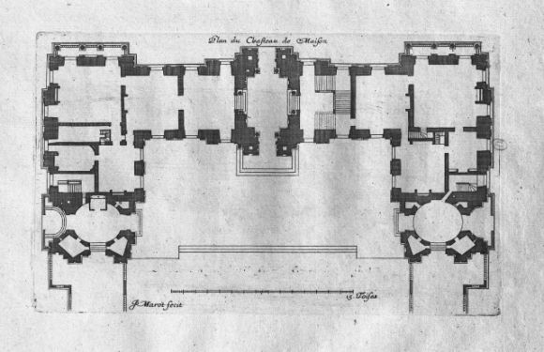
- Correspondence between Tobber and the French government regarding the shipments of bodies being delivered.
- A manual on biothaumaturgical reanimation by a V.F.
- A cheap paper penny novel depicting a large Amazonian woman wielding a very large wrench smashing Prussian heads in. It is titled The Mad Mechanic: Saviour of Suffering.
- Handwritten notes (look like journal pages) they talk about a success with a subject, but expresses frustration with another project.
- Shipping notes regarding a variety of chemicals and thaumaturgical implements ordered.
- Notes on the numbers of soldiers killed in the recent war. Illegible notes in the margins.

Scene 6: Welcome to the Lab
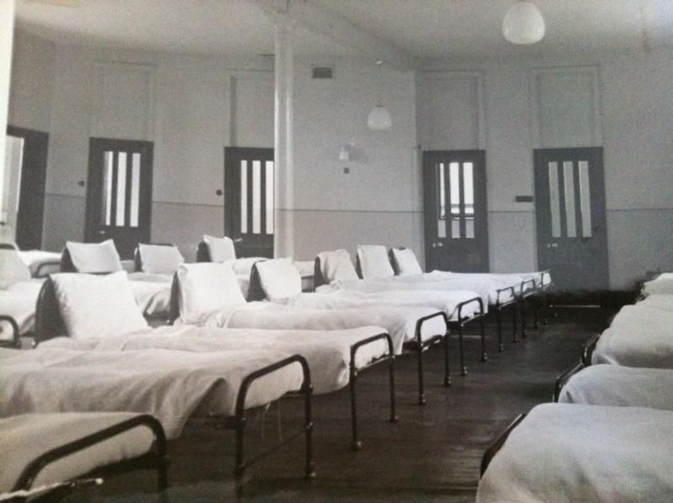
The stone steps covered in wet moss and damp from the nearby river lead the party into the secret dungeon beneath the Chateau. When they reach the bottom they emerge into a large medical ward. They see the zombies climbing into beds directed by black coated technicians. With a perception roll (diff 15) they can note the electrical devices embedded in the roof of the chamber over the beds.
They will also notice Dr. Tobber going through a door on the opposite side of the chamber. It is up the party as to how they will get across the room. A successful hide & sneak roll (diff 20) will get them through the zombies and servitors successfully. If they make too much noise they will draw the attention of the zombies who will get up to attack. They will have power to attack for only 2 rounds. They will then fall down, completely drained.
Entering through the door will bring the party face to face with Dr Tobber and his creation Elijah. The room is only 50 feet across so both groups are fairly close to one another.
Eljah is Dr. Tobber’s greatest creation. Once many men he is now a new ‘man’. He has great strength and speed. He is very protective of Dr. Tobber and will defend him. He does have a few weakness. As some of his parts are mechanical in origin and are powered by thaumaturgy he can be stunned by etheric energy overloading his equipment for a round. If his health goes too low he goes into a blind rage and his damage modifier doubles. He is intelligent and can be reasoned with, but it needs to be done carefully or he will react poorly and attack. He will not listen to anything bad being said about Dr. Tobber.

Elijah: Mental competence: 10 Physical competence: 15 Init: 10+2d6
Health: 95/12
Skill picks: Perception (10) , Dodge (10), Intimidate (12)
Combat picks: Sledgehammer(16) for 6d6+6 lethal, Smash (16) 4d6+6, Hurl equipment (12) 5d6

Elijah

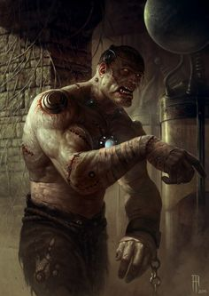
Given the chance Dr. Tobber will be willing to speak with the players:
‘Ah Elijah, we seem to have visitors. Now, now relax my friend. Perhaps we can conduct a civilised discourse and avoid any potential issues. Now my good people I would surmise that you are here for me? Or are you just interested in my little project here? Have you run into some of my test subjects? Don’t look so squeamish. They have been dead and we are just putting them to a decent use, nay we are performing a service in defence of this great nation. Why should more lives be lost when we can use the dead to defend the living? They had already sacrificed themselves, now they can do so for a greater purpose. Can you not see my dream?’
If asked about Elijah
‘ Ah this is my greatest creation , Elijah. A marvel of the biothaumaturgical arts, we are working to create a new era. Elijah here will be my gift to the world. Stronger, faster and with such a brain. My ubermensch will be greater than those that cringe and cry in fear. Together we will … (the rant continues until interrupted.)’
Elijah will answer questions, but will be terse and focused on protecting the doctor.
The party can deal with this in any number of ways. But they must make a choice, will they let this information with Dr. Tobber and his creation survive and work for the British or is it too dangerous for anyone to possess?

Scene 7: Here comes the Sun

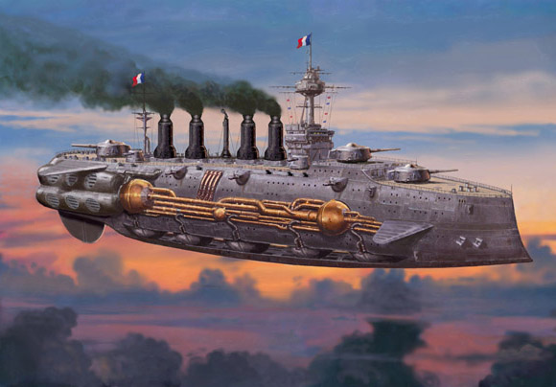

As the party emerges from the dungeon, the sun rises and a peace descends upon the village. You have dealt with Dr. Tobber and have stopped the French from continuing his plans at reanimation. As you make it to your ship you spot a French Airship heading for the village. You make it back to your ship and take off, gliding behind the hills just as it comes in for a landing. You have earned your payment and you are still flying.

