Blood and Iron: The Vengeance of Heaven -
A Victorian Steampunk Scenario of Adventure and Intrigue using a variation of the Victoriana system.

“Not through speeches and majority decisions will the great questions of the day be decided... but by iron and blood.”
Otto Von Bismarck

Game by Dudley Martin

Game Blurb:
The year is 1865 and all is not well with the Empire. An influential merchant, Augustus Elliot Whittock, III, associated with the Exchequer’s office has gone missing in the South China Sea while enroute to a meeting with the officials of the Qing Dynasty regarding trade concessions. Intelligence is pointing to the pirate Shào Yue who is known to hunt in that area, regularly attacking western shipping. She is associated with the Taiping Heavenly Kingdom and is both influential and dangerous. Whittock must be rescued and delivered to his appointed meeting. Once more the empire is counting on you!

Contents
Game Blurb: 2
System Basics 4
USING SKILLS 4
Characteristics 5
Effect and damage rolls 5
Combat: 6
INITIATIVE 6
What can I do as an action? 6
Melee & hand-to-hand attacks 6
Making the attack 6
Making the attack 7
Determining damage 7
ALL OUT DODGE 7
Taking cover 7
Diving for cover 8
EXPLOSIONS 8
Special Abilites 8
Sensate abilities 8
Miracles of Faith 9
THAUMATURGY SPELLS 9
TAOIST SPELLS 13
Setting mood: 15
Opening Scene: In the House of the Proconsul 16
Information for players on Shào Yue 20
Scene 2: Encounter at the docks 21
Scene 3: Into the Leaning Monkey 22
Scene 4: Let’s visit Sanmen Island 23
Scene 5: Into the Mouth of the Dragon 26
Fight to Live Another Day 27
Retreat and Regroup 30

System Basics

USING SKILLS
Whenever your character tries to do something (called taking an action), there’s always the question of whether he’ll succeed or fail. Sometimes the task is so easy that it’s obvious; for instance, taking a step forward without falling down. In those cases you’ll just tell the Gamemaster what you’re doing, and no die roll is needed. But if you’re trying to take a step on the deck of a ship pitching wildly in a driving rainstorm, walking might be very difficult indeed. That’s where task resolution comes in. All tasks in Victoriana are resolved with the same formula: take the relevant characteristic and add to it the relevant skill, then add the result of an action roll of 3d6 to create an ‘action total’. Compare your total to the difficulty of the task. If you equal or exceed the difficulty value, you succeed!

Characteristics
Intellect: for memory recall, problem solving, manipulating tools & instruments

Resolution: for the ability to face danger, fear, and stress

Presence: for interactions with others.

Dexterity: for fighting, dodging, athletics, driving, running, and swimming

Body: for using physical power, resisting pain, disease, shock

Your (characteristic + skill) + 3 dice in an action roll
Vs. The difficulty of the task
DIFFICULTY TABLE (for most rolls use an average difficulty. Use higher or lower depending on situation and action)
Easy | 10
Average | 14
Exasperating | 18
Really? | 22
Very | 26
Extremely | 30
Ridiculously | 34
Impossibly | 38

When you roll your action dice you may roll all sixes, if so then rejoice! This is known as a special success. In combat attacks this generally means that you double the damage done, in
other action rolls the gamemaster will tell you how your special success manifests. Adversely if your dice roll comes up with three 1’s then the attempt automatically failed, this is known as a foul failure.
Example: Mad Eric is fending off a footpad; it’s his turn to attack. He’s using a sword cane, so we add his dexterity 3 and swordplay 4 for a total of 7; the gamemaster tells Mike (Eric’s player)
that he will need to beat a difficulty of 22 to hit the thug. Mike makes his action roll and the dice
come up with a 2,4, and a 6. That’s a total of 19 – Eric Misses!

Effect and damage rolls
Effect rolls follow some action rolls; usually they represent damage done by weapons, or define the effects of a spell. You usually roll a set amount of effect dice and add the results together, just like an action roll. The difference to action rolls is that there are no skill or characteristic
bonuses to effect rolls Once rolled add the results together, this is the effect total, or damage roll as it is often known.

Combat:

INITIATIVE
At the beginning of each round, each character rolls 2 dice and adds their initiative characteristic in an action roll. The character with the highest total acts first for that round
(they are also allowed to hold their action and act later in the round). The character
with the next highest total acts next and so on. Roll an additional die to break ties; high
number goes first.

What can I do as an action?
You can do one thing with each action. In its simplest terms if there is a dice roll required it counts as an action. This
could include:
Combat Actions...
Draw a weapon
Make a single melee attack
Make a single ranged attack
Throw a stone or bomb
Move up to your full combat movement
Non-combat actions…
Make a small speech to intimidate or impress
Perform an athletics feat, such as leaping, or breaking down a door.
Cast a spell
Command an embodiment
Invoke a demon
Maintaining a spell with a concentration roll
Untying a captive
Opening a closed but unlocked door
Get up after being knocked prone
Each one of these things would be considered a single action.

Melee & hand-to-hand attacks
Melee represents up close and personal duels and brawls, opponents might be using swords, clubs, chair legs, frying pans, fists, feet, and perhaps even skill.

As a general rule melee range is considered to be 4yds, the typical reach of an adult arm and a
sword. If you want to start a fight you have to be at least this close.

Making the attack
An opposed action roll between the attacker and defender represents melee combat.
The attacker combines his dexterity, an appropriate weapon skill and an action
roll. He may also have to add or subtract certain modifiers from this action total to
determine the final outcome. The defender combines his dexterity, his dodge! Skill and the result of an action roll, the defender might also have modifiers to his roll before obtaining a final total. The final totals are compared, if the attacker has the higher score then he hit, and
should roll damage, if the defender has the highest total then he evaded the attack – this time. In the event of a tie, the defender always evades.

Making the attack
Unlike melee combat, ranged combat is an unopposed action roll by the attacker against a target number defined by range and possibly a modifier from all out dodge! Attempts.
The attacker combines his dexterity, the appropriate weapon skill and an action
roll. The action total is compared to the difficulty as defined by the range if you equal
or exceed the difficulty of the shot you hit and roll damage.

RANGE & DIFFICULTY TO HIT
Range | Difficulty
Point blank (4yds or less) | 10
Close (10yds or less) | 14
Medium (50yds or less) | 18
Long (out to listed range of weapon) | 22
Extreme (beyond listed range) | 26
+ 2 per + 100yds

(It is suggested that for ease of con play that all rates of fire be limited to 1 or 2)

Determining damage
Once you have made a successful attack the next step is to determine the amount of damage your attack has done to your opponent. Damage rolls are effect rolls, and are dealt with as follows. The weapon used dictates the amount of damage you will do. Few people died from gunshots in this era, most died from infections in the wound days or weeks later. Once you have determined the amount of damage dice to be rolled, roll them and add the results together, this is your damage total. Every character or creature in Victoriana has a fortitude characteristic, some will also possess armour, whether worn or as a natural feature. The defender subtracts
both his fortitude rating, and the rating of any armour he is wearing from the damage
total, the rest is applied to his health scores.

ALL OUT DODGE
Use this action to make yourself harder to hit. As your first action you declare an all out dodge,
and in your initiative order for the first action you make a complementary roll on dexterity + dodge! With a difficulty of 14. The result of this complementary roll is added to each of your automatic defence rolls for that round. See complementary skills in the skills section for more information.

Taking cover
If you don’t want to waste an action racing around to facilitate an all out dodge, you can try
to take cover. By using the environment around you such as trees, walls, and even furniture, you can reduce your opponent’s chances of hitting you in ranged combat, see the modifiers section for examples. You cannot take cover from the environment in melee combat; you and your opponent are too closely engaged to be able to do so, but you can use portable items such as furniture as improvised shields if your gamemaster allows.

Diving for cover
This variant of all out dodge can be used to avoid sudden and unexpected area effect attacks such as explosions and some spells. You make an action roll using athletics against a difficulty based on the distance (base of 14 for 1yd + 1 difficulty for every extra 1yd). If the roll is failed, you didn’t dodge fast and/or far enough and were caught by the attack effects. Diving for cover is usually a free action and once performed is the last action of the round for that character as he then picks himself up from the debris. However a character with enough foresight (or paranoia) can specify diving for cover as an action (just in case), and
characters who do so may then continue to act in the round as normal.

EXPLOSIONS
Attacks that strike an area rather than a character (bombs, grenades, gas and other effects) are known as area effect attacks. The area affected depends on the damage dice of the attack being used, typically this is a 1 yard radius per damage dice of the weapon, and will always be described as part of its description or construction. The outcome of area effect attacks is determined by each defender in the area defending against a single attack total by diving for cover; those who fail take damage. Ground zero of an explosion or area effect takes the full damage of the attack, characters take 2 less points of damage for every yard they are away from the centre of the attack. Character who are outside the area of effect, take no damage at
all.

ENVIRONMENTAL INTENSITIES
Type | Mild | Intense | Deadly
Damage | 1-4 dice | 5-10 dice | 11-20 dice
Electricity | Battery | Generator | Lightning bolt
Illness | Measles | Cholera | Plague
Drug | Alcohol | Opium | Cocaine
Poison | Belladonna | Arsenic | Stonefish venom
Fire | Wood fire | Gas fire | Chemical fire

Special Abilites

Sensate abilities
Sensates have a strong connection to the natural world, and their gifts reflect their super sensitive
nature allowing them to see what others do not.
Ability Difficulty Description
Aura reading 14 A successful medium + presence roll allows the medium
to gauge the mood, temper & intentions of the observed
person. Aura reading is only applied to individuals, not
to groups. One aura reading can be conducted with one
action.
Glimpse 26 By using this power the medium is hit with a powerful
and vivid vision of an event that is due to happen. The
medium has little control over what he sees (you cant try to
see the outcome of this years grand national), but you can
be confident that it is imminent, certainly within the next
week.
Know recent events 22 A successful action roll grants knowledge of recent events
occurring around the person or object being studied. The
nature of the knowledge gleaned from such an observation
is often incomplete and fragmented, often, information is
only trivial and not of obvious use.
Magic sense 18 The games master makes this roll whenever the character
comes within 10 yards of a spell effect; focus, magical
artefact or sorcerer. Magical creatures such as demons are
not detected by this ability. With success the character is
aware of a tingling sensation down the spine, warning the
character of magical presence. An excellent success might
yield information concerning the nature of the magical
presence.
Psychometry 22 The ability to gain information concerning an individual
from their personal effects. Information accessible usually
relates to the individual’s present welfare or location, but
information about the recent well being and transitions of
the items owner may also be gleaned.
Sense the supernatural 14 The medium can sense supernatural beings such as
demons, ghosts and the invisible within 10 yards. Exact
location cannot be discerned, although a good idea of
direction is furnished.
Sixth sense 14 An uncanny & instinctive knowledge of events around the
corner. With use of this ability a medium may finish the
sentences of others. Also sixth sense may be used to avoid

Miracles of Faith
Ability Difficulty Description
Heal 18 The medium can call upon the mercy of heaven
to heal a deadly wound or disease. Heals 3d6 points of damage completely.

THAUMATURGY SPELLS
Botheration
Resolve cost: 1 (18)
Range: touch
Duration: rounds
Once cast the target must be touched, and a opposed roll between resolution
+ thaumaturgy and resolution + concentration ensues. If successful the target
becomes totally confused. A bothered target cannot concentrate on even
simple tasks, represented by a –6 action roll modifier.
Darkness of ages
Resolve cost: 2 (22)
Range: 20 yds
Duration: minutes
Creates a billowing black cloud of absolute darkness. From outside the spells
5 yard radius the cloud appears to be thick roiling smoke. From within there
is absolute darkness, with no suggestion of smoke or a gas of any kind.
Ectoplasmic bonds
Resolve cost: 4 (24)
Range: 40 yds
Duration: hours
Tendrils of Ectoplasmic slime materialise to ensnare the target of this spell.
The bonds may stick a target to a surface such as a wall, floor or ceiling.
Breaking free from the slime requires a body + athletics (32) roll. Winning
breaks free, losing remains entangled. After 2 hours the slime starts to lose
coherence, and the difficulty drops by 4 each half hour from that point until
the end of the duration.
Farspeech
Resolve cost: 1 (20)
Range: sight
Duration: instant
This spell allows whispered conversation to be passed as far as the
eye can see. As long as the target can be seen they can hear the
caster’s words. This spell does not grant two-way communications.

Etheric bolt
Resolve cost: 4 (24)
Range: 20 yds
Duration: instant
Upon completion of the spell, an etheric bolt of green energy forms
around the casters hand, which may then be fired with dexterity + thaumaturgy
in the same manner as mundane ranged attacks. The bolt does
4 dice of lethal damage. Etheric bolt is not resisted with resolution; the
rules for dodging ranged attacks apply. One casting provides one bolt.
Etheric bludgeon
Resolve cost: 2 (22)
Range: 20 yds
Duration: instant
Upon completion of the spell, a pale bolt of energy forms around the
casters hand, which may then be fired with dexterity + thaumaturgy in
the same manner as mundane ranged attacks. The bolt does 4 dice of stun
damage. The bolt is not resisted with resolution; the rules for dodging
ranged attacks apply. One casting provides one bolt.
Firespark
Resolve cost: 1 (20)
Range: self
Duration: instant
A small gas flame appears from the finger or thumb of the caster. The
flame lasts several seconds and is sufficient to light a pipe, cigarette,
lamp, candle or fire.
Etheric barrage
Resolve cost: 6* (26)
Range: 100 yds
Duration: rounds
This spell channels energy around the sorcerer and then through him into
a seething stream of fire, which may then be fired with dexterity + thaumaturgy
in the same manner as mundane ranged attacks. The caster can
throw any amount of barrages from one casting, but each bolt after the
first costs an additional 2 resolve. Should the Thaumaturge foul with any
roll when using this spell, the caster will suffer a full strength barrage hit
himself.
Each barrage does 6 dice of lethal damage. Barrages are not resisted with
resolution; the rules for dodging ranged attacks apply. One casting provides
unlimited bolts for the duration.

Flight of the wyvern
Resolve cost: 3 (22)
Range: self
Duration: minutes
The caster can command ethereal forces to counterbalance the forces of
gravity, thereby granting the power of flight. The caster gains a flying
combat speed of 16 yards/round. As the air is not a native element to
mankind, flight is slow and unsteady at first, with manoeuvres relying on
intellect alone. Frequent flyers however, may study the speciality: flight
skill.
Levitate
Resolve cost: 2 (20)
Range: 10 yds
Duration: rounds
The caster can command ethereal forces to counterbalance the forces
of gravity, allowing the levitation of himself, or other persons and
objects. No object may be raised higher that 6 yards from the ground,
and no more objects than the casters intellect may be raised at one time.
Levitation simply moves objects upwards; it confers no further movement
ability.
Gaslight
Resolve cost: 1 (18)
Range: 4 yds
Duration: minutes
Creates a small
ball of light in
the caster’s hand.
The light has the
power of a good
gas lamp and illuminates
approx
5 yards radius.
The ball can float
and may be mentally
directed by
the caster to any
position within
range.

Groom
Resolve cost: 1 (18)
Range: self
Duration: instant
This spell washes, refreshes, oils and combs hair, trims the moustache,
even dusts down and presses the caster’s clothes. Observers will see
the caster improving in appearance as if tended to by invisible hands,
with creases and folds in clothing ironing out while still worn.
Hair of the dog
Resolve cost: 2 (26)
Range: touch
Duration: hours
The caster must incant the formula to this spell loudly in Latin, upon
completion all the targets hangover symptoms are gone. The spell expels
headache, dizziness, lethargy, curried eyes, and bowel trouble. Note that
none of the above symptoms can be dispelled unless they are symptoms
of a hangover.
Heal
Resolve cost: 4 (22)
Range: touch
Duration: instant
This spell instantly knits flesh and dispels infection, healing 4d6 health.
The application of this spell has made the guild renowned as miracle
healers. Diseases cannot be treated with heal, they must be treated with
cure
Cure
Resolve cost: 6 (26)
Range: touch
Duration: instant
This spell instantly cleanses the target of any resident diseases or infections
that might be afflicting them. Poisons and physical wounds cannot
be treated with cure.
Instant beauty
Resolve cost: 2 (22)
Range: touch
Duration: hours
Increases the desirability of the recipient. No discernible change occurs, but others find the recipient attractive anyway, possibly being puzzled as to why. Presence increases by 2 for the duration.

Magic tobacconist
Resolve cost: 1 (18)
Range: self
Duration: instant
Allows the caster to magically produce a fine cigar or cigarette.
Alternatively the spell might be used to magically fill a pipe bowl.
Power of steam
Resolve cost: 3 (22)
Range: touch
Duration: minutes
The caster may confer the motive power of a steam train into a vehicle. When travelling in such a manner multi hued steam pours from the vehicle, often obscuring sight (-2 to driving rolls).
If applied to a person, their running speed is doubled and they gain +2 body. However, they also go bright red as magical steam gushes from ears, mouth, nose and through the seams of clothing. Living creatures take 1d6 stun each minute as a result of the unnatural exertions the body undergoes in this state.
Scholar’s guard
Resolve cost: 1 (20)
Range: touch
Duration: hours
The caster traces an imaginary perimeter with pointed finger. The perimeter may be up to 3 yards radius. Anything stepping through the perimeter sets off a magical alarm. The nature of the highly audible alarm is left to the caster.
Second sight
Resolve cost: 2 (20)
Range: self
Duration: rounds
Allows the caster to see supernatural effects clearly. Such phenomena include: possessing demons appear as if fully manifested through second sight. Spells effects appear as glowing energy and their nature may be discerned with scrutinise rolls. Creatures such as ghosts are always visible through second sight. While second sight is active, mundane sight is dim and darkened – all perception tests relating to the mundane world are at –4 modifier.

Spyglass eyes
Resolve cost: 1 (20)
Range: self
Duration: minutes
Allows the caster to see with up to x20 magnification, as if using a powerful
spyglass. The spyglass effect may be turned on or off during the
duration.
Steely skin
Resolve cost: 5 (24)
Range: touch
Duration: minutes
The spell weaves an invisible shroud of magical energy about the recipient,
granting an armour value of 10, which is added to any other armour worn.
The emperor’s new spell
Resolve cost: 4 (24)
Range: self
Duration: minutes
Renders the caster totallyinvisible to normal sight. Some creatures and use
of second sight spell will detect the caster. The spell will only render the body
invisible, clothes and items are not invisible unless swallowed or otherwise
enclosed in a body cavity.
True door
Resolve cost: 2 (20)
Range: touch
Duration: hours
This spell is cast upon a portal such as a door, window, box lid or other such scalable opening. The magic of the spell permeates the material of the portal and knits it together with strong, magic glue. The portal can no longer be opened normally, and must be forced.

TAOIST SPELLS
Create Sparks
Chi cost: 2 (12)
Range: Self
Duration: Four melee rounds.
By setting up a magical interference between the Chi in the body and the Chi of the environment, the caster can generate sparks at the tips of his fingers. Although these are relatively harmless (at a touch they can inflict one point of damage per melee round maximum), they can be used as illumination, start fires or to ignite any flammable substance by touch.
Invoke Chi Zoshiki (invisibility)
Chi cost: 9 (25)
Range: Self
Duration: Four melee rounds
The character uses Chi to cloud the minds of observers, so that character can stand in full view, stare into the eyes of the enemy, and simply cease to exist!
Circle of Non-Ignition
Range: 120 feet (36.6m)
Duration: Three minutes.
Cost: 12 (25)
Creates a circle about 25 feet (7.6 m) in diameter, where fires can't be started. It becomes impossible to light a match, fire a bullet, or run a steam engine.
Summon Dragon of Lightning
Chi cost: 10 (27) (To summon)
Range: 120 feet (36.6m)
Duration: Six melee rounds
The Tao Master summons a dragon of electrical energy which can be made to attack enemies. With a Resolution + Tao Magic (diff 20) roll to attack if it hits the dragon will do 6d6 + 10 damage and can attack once per round. Targets can roll dodge to avoid damage. The dragon can be disrupted by a Thaumaturges etheric bolt spell cast against it. This will release the stored energy and will do 4d6 to those close to the explosion.
Shield the Fleet
Chi cost: 10 (27)
Range: 120 feet (36.6m)
Duration: 10 minutes
The Tao Master summons a powerful field of magical force that is resistant to all damage. It is used by the pirates to protect their ships from European firepower.
Crush the Mortal Frame
Chi cost: 5 (20)
Range: 120 feet (36.6m)
Duration: Four melee rounds
The Tao Mage focuses their powers of telekinesis on harming an enemy by crushing them. They are helpless as long as they maintain focus on the spell. The spell does 5d6 damage per round (ignoring fortitude and armour) and is resisted with a resolution + constitution roll (diff 20) for half damage. The spell can be disrupted if the Tao Mage is attacked and damaged while focusing on the spell.

Setting mood:
This game takes place during a time of change and growth. In this world the British Empire is expanding with the aid of steam power.
The gap between rich and poor is even more pronounced and should be played up. The rich will be light, airy, and clean, while the poor will be dark, dingy and filled with sooty smoke. Poverty abounds and the chances for advancement are not possible, while the upper classes live well beyond their means and utilize the poor as stepping stones to fame and fortune.
This game is all about the story and letting the players become part of that story. Encourage the players to describe their actions and to get into character with their roles. The story is loosely described, but should not be held to strictly. Allow the players to be inventive and if that leads them in different directions use the information here to modify the game and lay to that direction.
Above all have fun.

Opening Scene: In the House of the Proconsul
Players have been sent to speak to the British Proconsul Commander Herbert Melchick in Hong Kong.
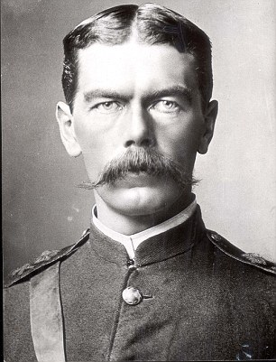
A former British Military officer now charged with overseeing British interests in the Orient.
British Proconsul Commander Herbert Melchick
“Welcome Ladies and Gentlemen, thank you for responding so quickly for my request of assistance. I have a very serious problem. An envoy from the Queen is due to meet with the Chinese emperor in two weeks to deal with important trade issues between China and the Empire. My problem is that the envoy, one AUGUSTUS ELLIOT WHITTOCK, III, has gone missing. As a matter of fact, the entire military convoy he was traveling with has bloody well disappeared. As far as I can tell the convoy had refueled in Singapore and was two days south of Hong Kong all communication was lost. I have sent what ships I can to search the area, but they have not found anything yet. Tried to get the damn locals to help out but they won’t. Some tosh about some bloody woman pirate. Scared they say, Nonsense. I need you to help find our man. He must make it to this meeting. So chaps, can I count on you?
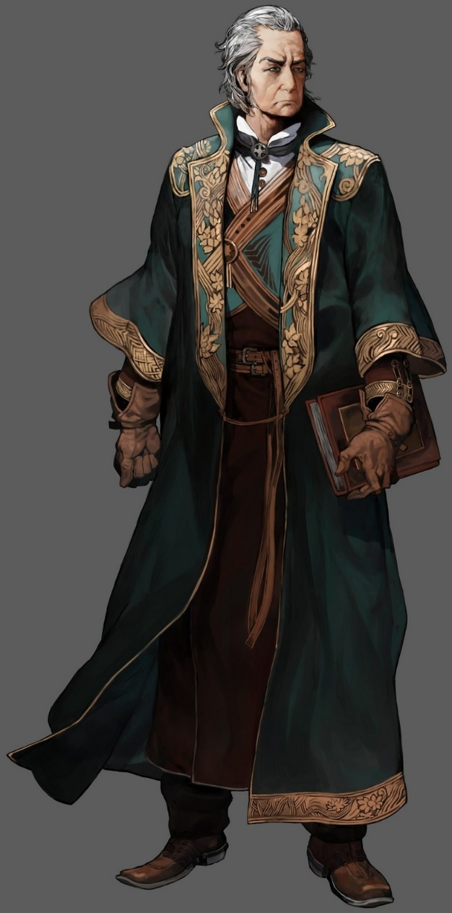
A trade envoy (with powers plenipotentiary) from the Crown bringing demands (regarding the continued sale and import of opium from the British India) from the Queen to the Chinese emperor. He was travelling with a British military convoy of the HMS Caligula (Frigate), HMS Sutherland (Corvette) and HMS Nonsuch (Gunboat).
Augustus Elliot Whittock, III

Sources to be questioned for Information
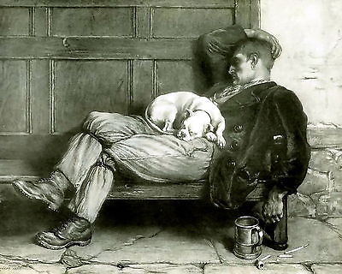
- Patrick Hennery -has served on numerous merchant vessels and served in the Royal Navy. He has been in the Hong Kong area for the past 5 years. Knows many of the local ships and routes.
- Owen Jones- A retired sailor, knows many stories (all long and rambling and none of any use for this investigation.) Jones is only interested in drink and will only give assistance if plied with it.
Rumours that can be gained
- The ship The Bishop of Shepby has docked nearby. Scuttlebutt has it that they saw some strange things on their way in.
- Be cautious in the area outside of Hong Kong. The pirate Shào Yue has a base nearby and preys on merchant ships.
- Fu Cao the bartender has mysteriously disappeared.
- Grumblings about crime rates.
- The locals around the docks know a lot more than they are letting on about what is going on in the area. They must be in league with the pirates. Can be found after hours in the Leaning Monkey.
British Sailors knowledgable about the area
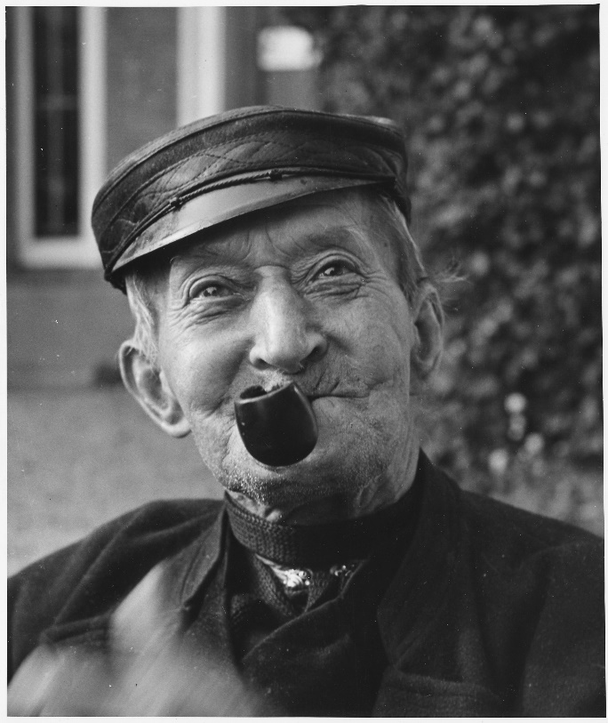

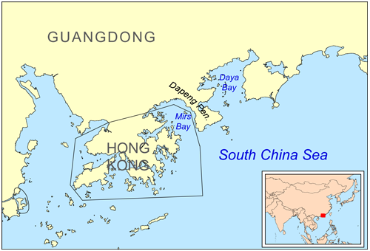

Information for players on Shào Yue

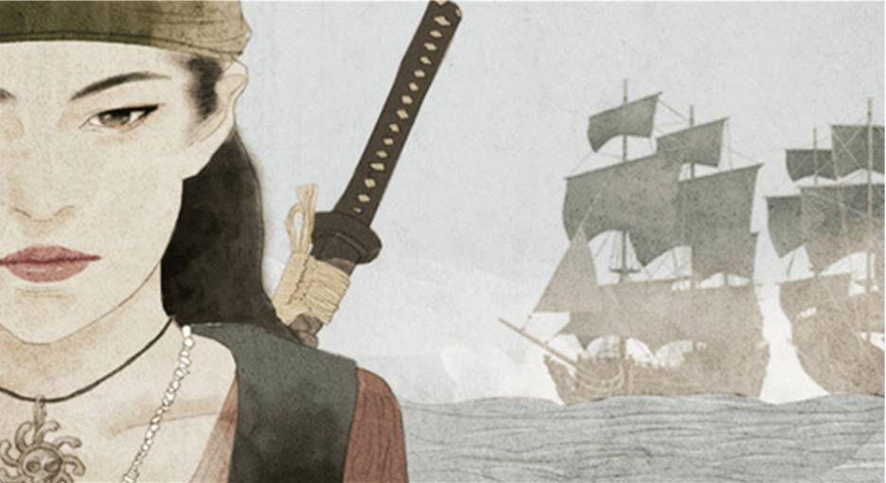
Shào Yue Gender: F Age: 27 Class: Lower Race: Human
Affiliation: Taiping Heavenly Kingdom
Description: 5'10", 130lbs, Black hair, Brown eyes
Known history: A well-known and feared pirate working the South China Sea near Hong Kong. She is part of the Taiping Heavenly Kingdom which is in rebellion with the Qing Empire of China. She is deadly and feared pirate with a supposed fleet of over a hundred armed junks. She has been working this area for the past 5 years and has been a thorn in British side by her attacks on ships transporting opium. She is supposed to have a base somewhere in Daya Bay, but the Proconsul does not have enough of a military force to crush her.

Scene 2: Encounter at the docks
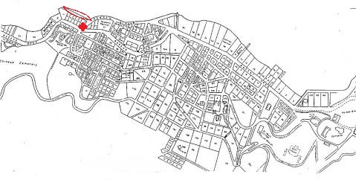
- Red areas are the docks in question and the location of the Leaning Monkey.
The party makes their way to the docks to continue their investigation. Soon they are surrounded by the busy docks. Ships are being loaded and unloaded. Then a thick mist moves in and the sound disperses leaving the party alone on the docks. Have the players make perception checks (diff 15) to detect the figures moving in the mist. Any attacks sent into the mist will miss and if the party moves they will still be outside of range and moving about, just visible. The figures will not respond to attempts to communicate. Let this go on for a minute or two and then have the pirates attack.

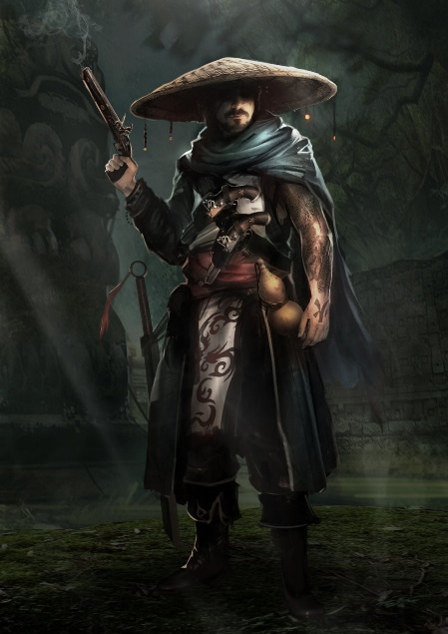
(For any skill checks use the mental or physical base + skill + 3d6) initiative for all pirates is 12 +2d6
All have a health of 25
The Leader of the Pirates: Dressed all in black with his face covered. Wearing Straw Hat. Carrying a sabre and brace of pistols.
Mental:6 Physical :6 Skills: Perception (5) , Hide and Sneak (6) Combat: Sabre (12) 4d6+5 Lethal , Pistol (15) 4d6 Lethal
Five Assassins: Carrying a brace of Pistols.
Mental:4 Physical :7 Skills: Perception (5) , Hide and Sneak (6) Combat: Knife (12) 2d6+5 Lethal, Pistol (12) 3d6 Lethal
Tao Mage (perched in top of Warehouse to the left of party) Chi: 65
Mental:9 Physical :7 Skills: Perception (10) , Hide and Sneak (10) Combat: Bo Staff (12) 5d6 Lethal
Spells: Chi Blast (equivalent to etheric bolt) (13) 4d6 Lethal, Eyes of the Dragon (allows Tao Master to view through the mages eyes)
*Note: all will fight to the death, save the mage. If things turn bad he will run for the Leaning Monkey
Pirates

Scene 3: Into the Leaning Monkey

After dealing with the pirates, the party must go after the mage. If the party hesitates have any thaumturges make an intellect + Thaumaturgy roll (diff 15) to determine that the magic used is different from theirs and they really should investigate.
The mage can be traced to the Leaning Monkey. As soon as they enter the patrons stop talking and turn to look at them. Have them make a perception check (diff 20) or a human perception check (15) to work out that everyone here is subservient to a well-dressed Chinese woman at the rear of the place. She sees the party and has them escorted back to her.
“Ah so you are the troubleshooters that the Proconsul has brought in. Very interesting. What has brought you to my establishment?” (if asked about the mage who came in earlier she will only say that he has gone and is far from here now.)
If treated with some respect she is willing (for a price) to give the party, the information they seek. She has numerous bodyguards amongst the patrons, so she is not concerned about being attacked. She is a non-combatant and will attempt to flee is attacked (she has a bolt hole nearby). If she is attacked her monkey will defend her, leaping onto the face of the closest attacker and clawing at their eyes (athletics (16), Claw/Bite (12) 2d6/3d6).
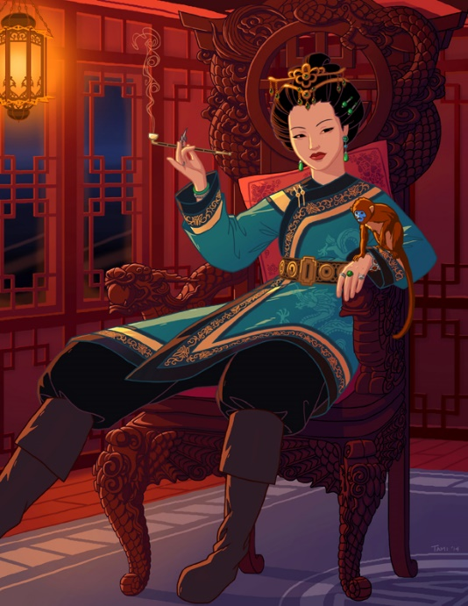
Madam Wang is the proprietor of the Leaning Monkey and an influential woman in Hong Kong. She is the undisputed leader of the docks and everything that goes on there.
Madam Wang

After either a polite conversation or an after-battle interrogation the party will learn that Shào Yue’s base is on Sanmen Island in Daya Bay. They will also learn that it is heavily defended and not open to an easy attack. If the party has been respectful she will also tell them that Shào Yue’s pirates have a number of Tao Mages working with her and that they are very dangerous. This is where the mage has gone. But that there is a small isolated beach at the rear of the island that can be used to infiltrate the island.
If asked about the lost ship and the envoy, she will say that they have been taken. Shào Yue’s mages could have destroyed the ships and taken the envoy. She will hint that Chinese magic is stronger than western guns and steam. And that Tao mages have powers to weaken their enemies.

Scene 4: Let’s visit Sanmen Island

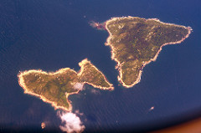
An island at the mouth of Daya Bay. A heavily defended pirate base it is a hive of scum and villainy working against the Qing Dynasty and British interests in China.
Sanmen Island

The party will encounter only one junk and a few fast attack vessels on their way into the island. This will be an isolated incident that will not bring any attention from other pirate forces.
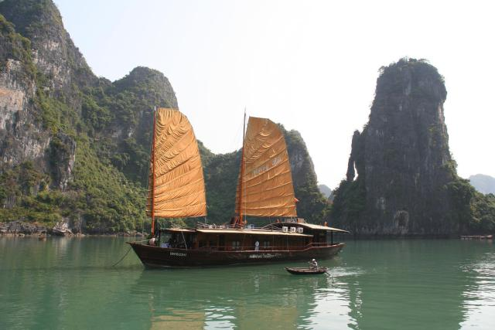

[Grab your reader’s attention with a great quote from the document or use this space to emphasize a key point. To place this text box anywhere on the page, just drag it.]
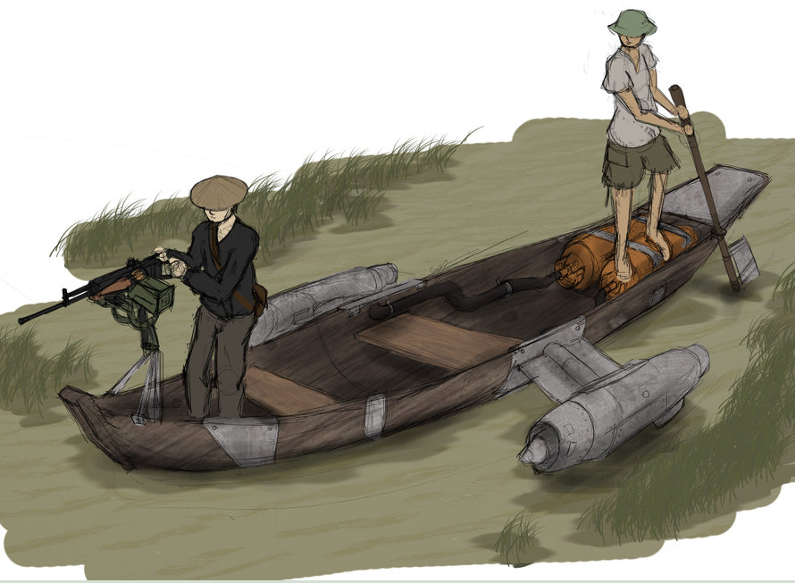
The Pirate Junk has a crew of 20 and six small guns that can be trained on the airship. (Gunnery (15) hits on the airship will shake the ship and have the chance to do 2d6 damage to people on the deck (dodge diff 15 for only 1d6 damage.)) Health of guns is 20 with an armour of 5. The ship is slow moving and cannot dodge. Doing 100 points of damage will sink the junk.

The fast attack vessels (5) have a forward mounted machinegun (Rifle marksmanship (15) 6d6 Lethal damage)
They are very fast and difficult to hit. All attacks have a -5 to them due to this speed. Doing25 points of damage to the boat will sink them.
Pirate Junk and fast Attack vessels

Scene 5: Into the Mouth of the Dragon

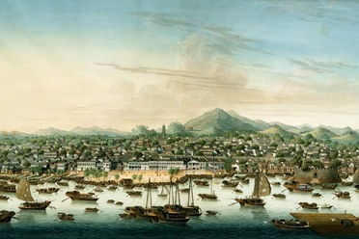

The party finds themselves on an isolated beach in an unguarded cove. There is a small rocky path that leads up the island proper and the pirate base. Have the players make hide and sneak rolls (diff 15) to avoid drawing attention to themselves. Failure draws the attention of the pirates, move along to the final battle as they will drawn themselves into sooner than expected.

Fight to Live Another Day
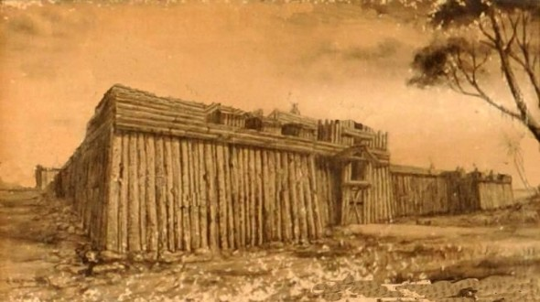
Play this as a very action movie type scene. Try to make sure everyone can be involved (and should be involved as the opponents are dangerous). As this is the final scene have fun with it and get the players excited.
When the party finds themselves within sight of the pirate fortress they view an old Chinese man chanting and making hand gestures while a guard pushes along the British envoy bound and gagged. A horde of pirates are all around him and moving towards to party.
‘Insignificant worms! You dare to challenge the might of the Heavenly Kingdom? Witness the fate of all those who challenge us. ‘

He gestures to a subordinate who approaches the envoy with a drawn pistol. He places the gun to his head and unless the party acts immediately shoots him, killing him.
If the party acts they have a chance to try to free the envoy. While firearms will not work, bows, swords, enchantments and thaumaturgy will all work. If they stand and fight they will all die. Make them feel the threat from the group before them. Encourage creativity and use of their abilities to grab the envoy and make their escape.
The area around them is rocky ground with some potential cover. If they do not get the hint to get away have them make perception checks (diff 15) to see that the guns in the fort are being trained on them.
(For any skill checks use the mental or physical base + skill + 3d6) initiative for all pirates is 12 +2d6
All have a health of 25
The Leaders of the Pirates (6): Dressed all in black with his face covered. Wearing Straw Hat. Carrying a sabre and brace of pistols.
Mental:6 Physical :6 Skills: Perception (5) , Hide and Sneak (6) Combat: Sabre (12) 4d6+5 Lethal , Pistol (15) 4d6 Lethal
Pirates (100): Carrying a brace of Pistols.
Mental:4 Physical :7 Skills: Perception (5) , Hide and Sneak (6) Combat: Knife (12) 2d6+5 Lethal, Pistol (12) 3d6 Lethal
Tao Mages Chi: 65
Mental:9 Physical :7 Skills: Perception (10) , Hide and Sneak (10) Combat: Bo Staff (12) 5d6 Lethal
Spells: Chi Blast (equivalent to etheric bolt) (13) 4d6 Lethal,
Pirates

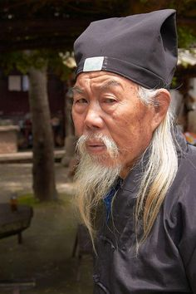
Zhong Yan is a Tao Master, a very dangerous and powerful sorcerer. The party will see him making hand gestures and chanting, these are spells Circle of Non-Ignition and drawing the energy to begin to Summon Dragon of Lightning. This will take a few rounds to achieve giving the party time to retreat. If he does successfully summon the dragon give the party a few close calls before they get out of range.
Zhong Yan

Retreat and Regroup
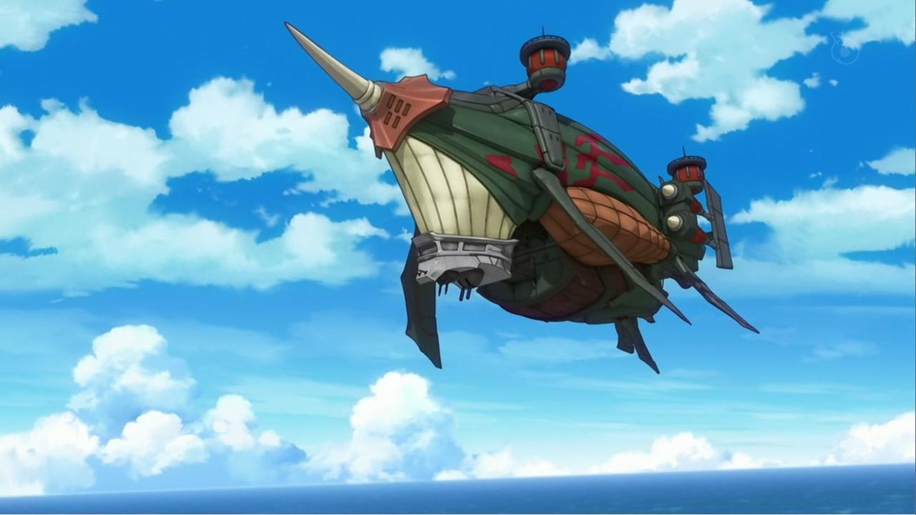
The party makes their way back to the ship under fire from the pirates. They quickly lift off (have Ezra make an airship piloting roll (diff 20) to avoid the giant energy dragon attacking them) as they do a massive energy dragon launches itself at the airship causing the ship to shudder and those on board to make dex + athletics checks (diff 10) to keep their feet. The pirates are firing on them and a pirate airship is launching, leaving the party with little choice but to retreat.
Returning to the Proconsul they can report in on the situation. He tells them that this news is disturbing and that they need to come up with a way to defeat this Chinese sorcery. He suggests finding the hermit Egg Chen to see if he can help.

