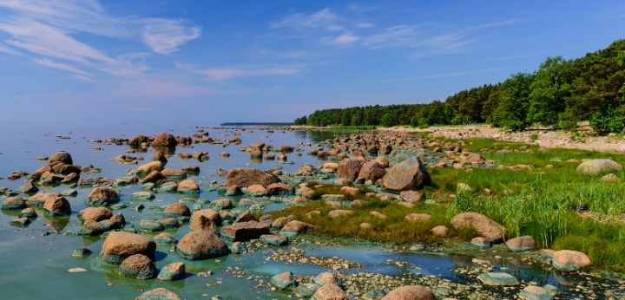
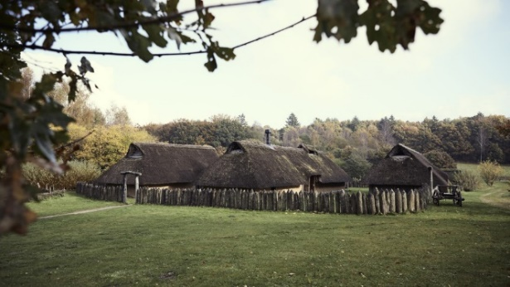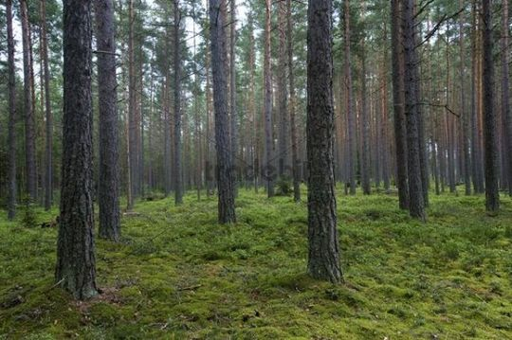

6, 3, 3: doubled Rbaja in Famberge

Limited usable shoreline between cliffs, substantial lake, dense highland forest, circle with stones
- Inland community: Osrode
- Raiders from the west, typical for the region
Draugr + wizard
- Draugr wolves
  - Brawn 6, Quickness 6; damage to Brawn only
- Edith (outdoorsman, wizard): old woman
  - Brawn 8, Quickness 2, Wits 5, Charm 4
  - Gifts: Summon Nightmare, Taste Blood, Ancient Lich, Breathe Disease
  - White spells: Cure, Beast 2
  - The lich only operates as influence, not an active character – but very powerful
People
- Ludger, raider (threat); kin ties to the region
  - Brawn 5, Quickness 8, Wits 2, Charm 4
  - High Martial
- Ingeborg, young woman, barely holding community together
  - Brawn 2, Quickness 5, Wits 4, Charm 8
  - Artisan
- Horst, inclined to aid Ludger if Ingeborg is spared
  - Brawn 8, Quickness 4, Wits 5, Charm 2
  - Outdoorsman, Low Martial
Dangerous terrain: the high-ground woods
- Not the standing stones (they’re no big deal, everyone ignores them)
- General Trailtwister effect
- Wolves
  - Brawn 6, Quickness 6, Wits 3; group effects
  - No aversion to draugr, and they’ll Walk if killed
Tripwire
- Major Amboriyon activity: Wrath, Eidolon, three-point enchantment, acquiring a Gift
- The lich awakens with a massive Sacrifice + Distort enchantment

